Creature: Whale  Name: Willie  Problem: whale gets tangled in fishing netting  Solution: Carefully drive a boat to get close to the whale. Use a long hook on the end of a rope to throw to the whale where the hook will attach to the net. Gently pull the net free from the whale.  Sketch of my solution  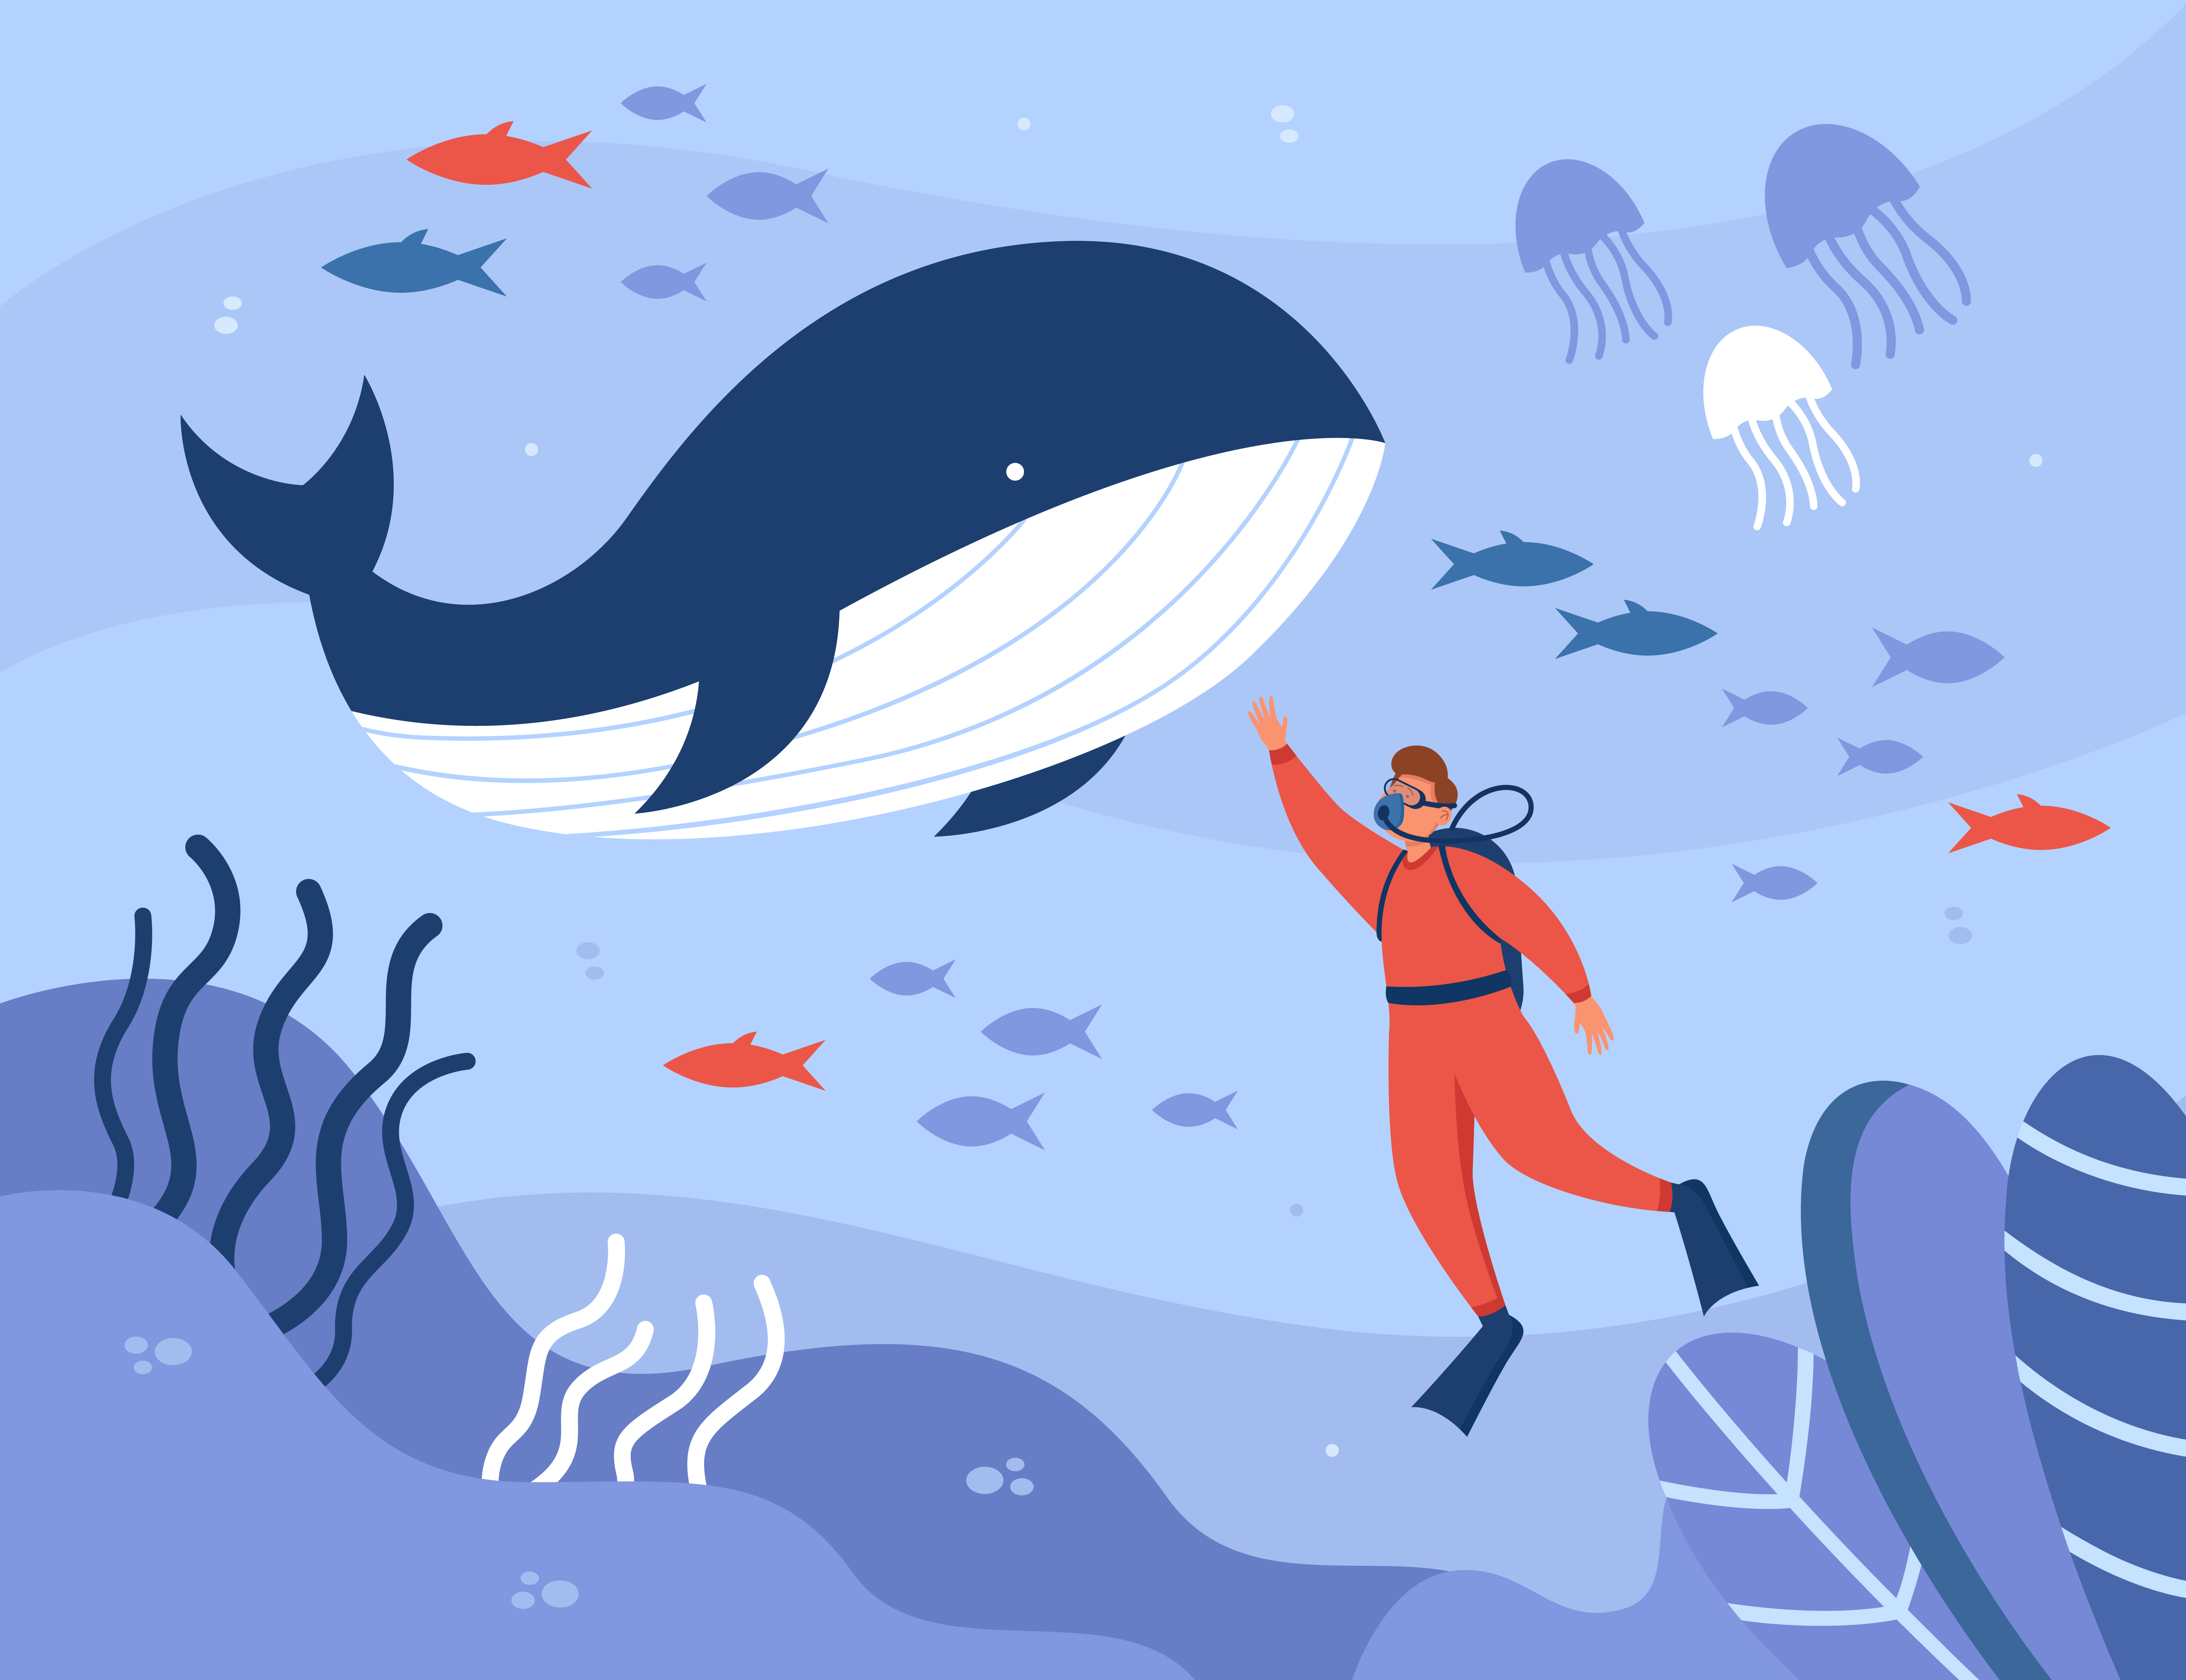 | Creature:  Name:  Problem:  Solution:  Sketch of your solution
Creature:  Name:  Problem:  Solution:  Sketch of your solution | Creature  Name:  Problem:  Solution:  Sketch of your solution

