Understand the Importance of Organic Farming

Subject(s) Agricultural Science, English

Year(s) 10

Learning Intention
Understand the importance of organic farming and gardening in developing sustainable agriculture.

Teaching Activity
Note: This activity is adapted from FAO 2009, Setting up and Running a School Garden: Teaching Tool kit, p. 27.

Materials required
- Poster paper – 1 sheet per pair

Activity 1: Introducing Organic Farming and Gardening
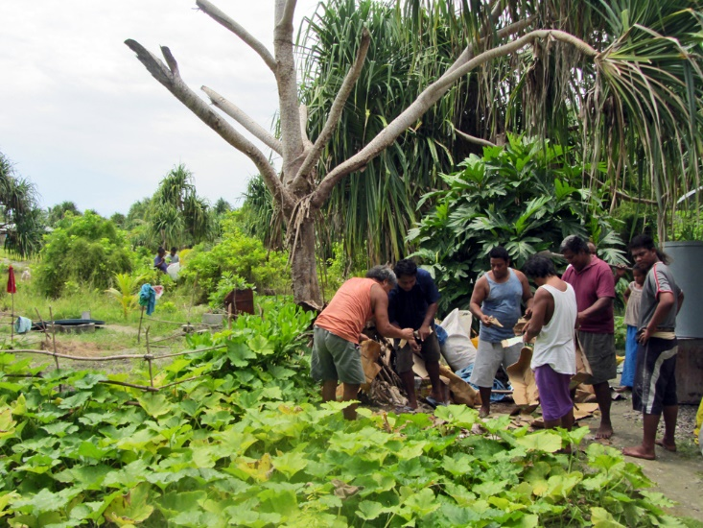
- Introduce the concept of organic gardening/farming. Elicit students' current understanding of organic gardening – what examples of organic gardening have they seen practiced at school or at home?
Credit: Flickr (ACIAR, CC BY-NC-SA 2.0)
- Introduce and define key terms:
  - composting
  - green manure
  - crop rotation
  - insecticides and pesticides
  - mulching
  - watering
Ensure students write the terms and definitions in their workbooks

Activity 2: Researching Organic Farming and Gardening
- Arrange students into pairs or small groups to complete the research activity.
- Choose the structure of the activity:
- Each pair or group researches and answers all the questions.
- Each pair or group researches and answers one question and presents their findings to the class.
- Assign the question(s) to each pair. Student research may include:
  - school library
  - internet
  - family discussion
  - interviews with local farmers and gardeners.

Activity 3: Posters and Presentations
Student pairs create and display a poster answering their question(s). Optionally, pairs present their work to the class.

