Identify items for composting
Subject(s): English and Environment, Science and Technology
Grade(s): 1–6
Key Stage: 1, 2, 3

Learning intention(s):
Students will investigate what materials decompose by identifying organic (natural) and inorganic (man-made) materials. They will observe how bacteria and fungi (decomposers) break down organic materials and how these materials change over time.

Mapping to curriculum:

English Key Stage 1
- Write and create representations of a range of information texts for a variety of purposes using words or sentences, text features and multimodal elements.
- Write and create representations of a wide range of information texts for a variety of purposes using sentences, text features and multimodal elements.
- Write and create representations of a wide range of information texts for a variety of purposes and audiences using sentences, text features and multimodal elements.

English Key Stage 2
- Create a variety of informational texts and representations for a range or purposes and audiences

Science Key Stage 1, Grade 1
- SIS102 Participate in guided investigations
- SIS103 Use non-standard measurements to collect data and make simple statements/generalisations based on the information
- SSIS104 Talk about observations and share ideas in a variety of ways
- ST101 Recognise that science involves being curious, making observations, and asking questions about familiar objects and events

Science Key Stage 1, Grade 2
- MM201 Classify objects according to their use and material type
- MM202 Investigate that materials can be changed by different means
- SIS201 Ask questions and make predictions about familiar objects and events
- SIS202 Follow instructions to carry out guided investigations
- SIS203 Use non-standard/standard measurements to collect data, represent them and interpret data to find patterns
- SIS2024 Talk about the findings and share them in a variety of ways
- ST201 Recognise that science involves making observations, asking questions about events and describing them
- ST203 Discuss ideas and present the design idea, select materials to make a product

Science Key Stage 1, Grade 3
- SIS301 Formulate questions with guidance in familiar context that can be investigated and make and make predictions
- SIS302 Plan and carry out investigation with guidance, considering the safe use of equipment and materials
- SIS303 Use standard measurements to collect, record data using tables/bar chart to interpret them to find trends and patterns
- SIS304 Reflect on the procedure and discuss measures taken to make it a fair test
- SIS301 Recognise that science involves making predictions, identifying and describing patterns
- ST303 Discuss ideas and present the design idea, select materials to make a product and evaluate the product

Science Key Stage 2, Grade 4
- Formulating ideas and implementing designs.
- Follow scientific methods to make informed decisions
- Observational skills and communicates their observations in various means and methods.
- Conducts simple investigations with guidance.
- Take care of themselves, others and respects others viewpoints.

Science Key Stage 2, Grade 5
- Implements designs and communicating of findings
- Applies the knowledge gained to make informed decisions
- Makes observations to provide supporting evidence
- Conducts simple investigations
- Take care of themselves, others and respects others viewpoints.

Science Key Stage 2, Grade 6
- Implements designs and communicating of findings
- Applies the knowledge gained to make informed decisions
- Makes observations to provide supporting evidence
- Conducts simple investigations
- Take care of themselves, others and respects others viewpoints.

Lesson Instructions

Who can do this activity
- Grades 1 to 2: Students will set up and observe the decomposition process with guidance.
- Grades 3 to 6: Students will work in pairs to conduct the investigation and engage in more advanced discussions and reporting.

Time required
- Set-up and starting the activity: About 1 hour
- Observations: Over 4 weeks or more
- Final observations and discussion: About 1 hour
- Optional: Extra time for writing a scientific report or completing the extension activity.

Materials required
- 5 clear jars with wide openings
- Organic items: examples include orange peel, apple core, tea bag, cardboard, newspaper or a leaf
- Inorganic items: examples include a piece of plastic, glass or brick
- Soil (or finished compost, if available)
- Spray bottle for watering

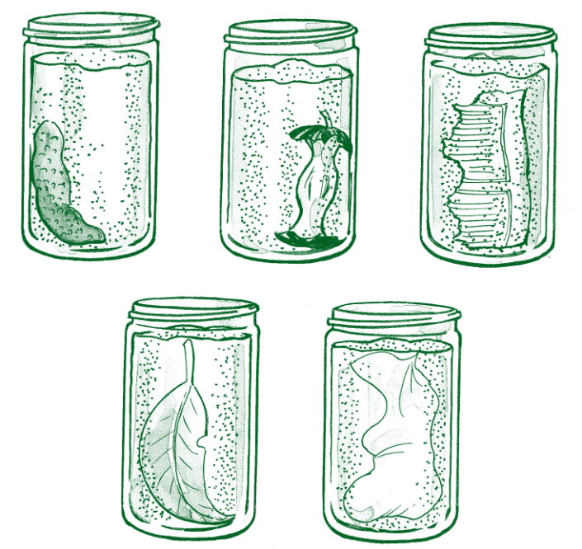
Activity 1: for Grades 1 to 2

Investigation Instructions
- Set the scene: Start by discussing the differences between organic and inorganic materials.
- Select 2-3 pieces of organic material and 2-3 pieces of inorganic material.
- Fill jars with soil or compost, placing each material against the side for observation.
- Lightly spray the soil to keep it damp, not soggy.
- Record initial observations with photos or drawings.
- Observe changes weekly for four weeks, keeping the soil moist.

Predictions
Source: https://www.wasteauthority.wa.gov.au/images/resources/forms/Compost_Activity_Guide_2020.pdf
- Ask students to predict what will happen to each material after four weeks in the jar.
- Observations
- Observe jars weekly.
- Record changes (or lack of changes), using the observation worksheet.
- Compare final observations to the initial ones.
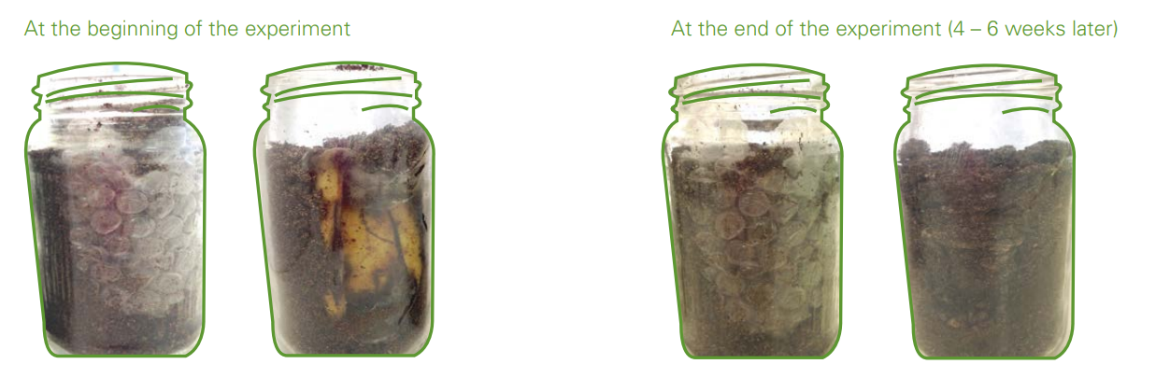
Source: https://www.wasteauthority.wa.gov.au/images/resources/forms/Compost_Activity_Guide_2020.pdf

Discussion
- Which items changed? How?
- Were predictions correct?
- What caused changes?
- Why did some items not change?
- Group items into organic (decomposed) and inorganic (did not decompose).
- Identify compostable and recyclable materials.

Application question
Composting is a good way to reduce most organic waste going to landfill – name several items of waste from your lunch, or someone else’s lunch, that you could compost.

Activity 2: for Grades 3 to 6
In pairs, students will conduct the investigation outlined above (Activity for Grades 1 to 2).

Investigation Instructions
- Provide the list of materials and equipment.
- Ask students to design their investigation to test which materials decompose.
- Discuss their designs and suggest improvements.
- Identify hazards and establish safety rules.
- Students will set up the investigation as planned or based on the Grades 1 to 2 instructions.

Predictions
- Students predict which set of jars will show more decomposition over four weeks and why.

Observations
- Over four weeks, observe and record changes in both sets of jars weekly, using the observation worksheet. See the example provided below.

Discussion Questions
- Were your predictions correct?
- Which items do you think are organic? Why?
- Suggest possible reasons for why some materials decomposed while others didn’t.
- Do you think the changes are reversible?

Application Questions
- Composting is a good way to reduce most organic waste going to landfill. Name five items from your lunch that could be composted.
- What happens to inorganic materials in landfill, like metal, plastic, and glass?
- Discuss alternatives to landfill for inorganic materials (reduce, reuse, recycle).

Scientific Reporting
- Students will use their observations to write a scientific report summarising their findings and answering the discussion questions.

Observation Worksheet
Name _______________________
Record changes (or lack of changes) in all jars weekly. You can also include illustrations to show what the material in your jars looks like.
Week | Jar 1  Material:  Organic or Inorganic (circle) | Jar 2  Material:  Organic or Inorganic (circle) | Jar 3  Material:  Organic or Inorganic (circle) | Jar 4  Material:  Organic or Inorganic (circle) | Jar 5  Material:  Organic or Inorganic (circle)
1
2
3
4

