Understand how meaning is created in picture books
Subject(s): Language and Communication
Grade(s): 1-2
Key Stage: 1

Learning intention(s):
Students read a garden-themed picture book to understand how words and images combine to create meaning.

Mapping to curriculum:
English:
- Read with some understanding familiar texts with prompt and support using phonics and sight words.
- Use features of short texts and illustrations with prompt and support to identify and locate information.
- Engage in reading/viewing a range of texts for pleasure, to improve fluency and to develop a positive attitude towards reading.

Lesson Instructions

Resources
The following collection of stories can be used to teach students about gardening, community and composting. For each garden-related story, a lesson plan, Powerpoint and worksheet are provided. More stories and teaching materials related to sustainability themes can be found at the Sustainability and Stories website.

Instructions
- Use the recording of the story provided in the provided materials.
- Read the book together with the class and talk about how the pictures and words work together.
- Ask the students how the pictures help them understand the words.
For example, with The Curious Garden by Peter Brown, start by just looking at the pictures without reading. Ask the students:
- What was Liam doing when he found the garden?
- Why did Liam decide to take care of the plants?
- How did the garden change from the beginning to the end of the story?
- How did the pictures help show the garden’s transformation?
- What clues in the pictures showed that the garden was growing?
- What do you think might happen next in the story?
- How did the garden make Liam and others feel?
- Does this remind you of any gardens you’ve seen?
- After reading The Curious Garden together, discuss whether the words added to the story and how they influenced the meaning. Ask students how the book’s text helped explain the garden's transformation and Liam’s journey. Encourage them to reflect on their own experiences with plants or gardens—did this personal knowledge help them understand the book better? For example, have they ever cared for a plant? How did that experience help them connect to Liam's actions in the story?
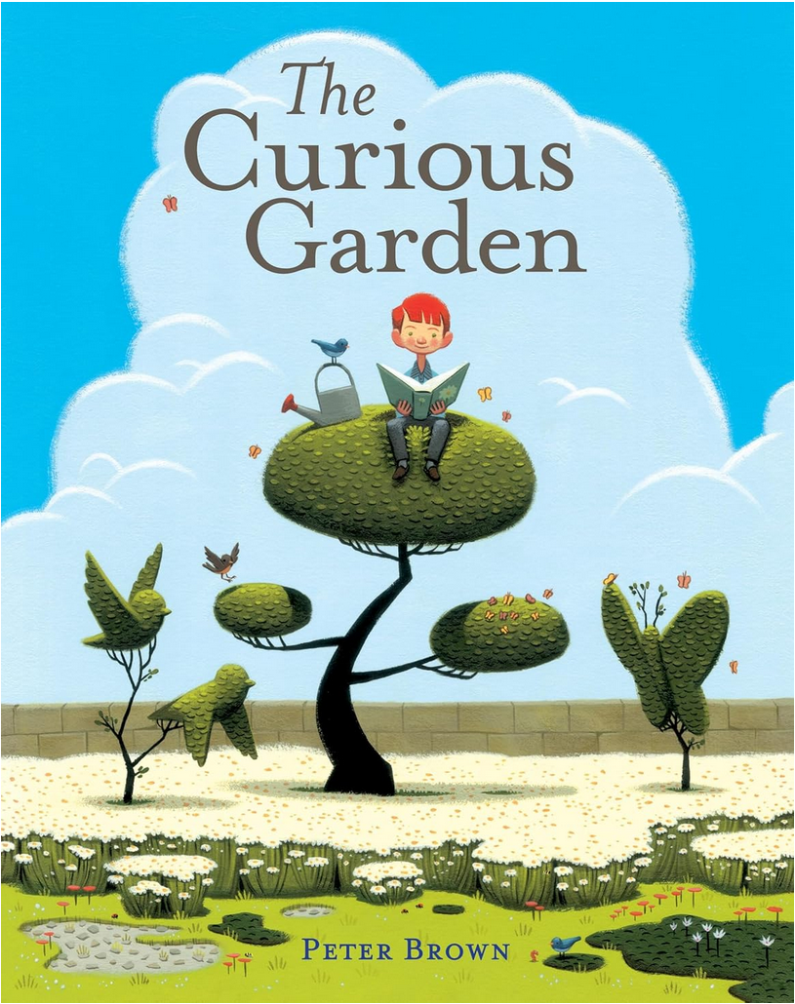 | The Curious Garden by Peter Brown  Topic: Garden/nature  Summary: The Curious Garden tells the story of how this young boy discovers a door that leads up to abandoned railroad tracks where he finds a forgotten garden. He nurtures the plants into a beautiful garden and other people in his city are inspired to create their own gardens.  Link to teaching materials and recording of the book:  https://sustainability-and-stories.org/the-curious-garden/
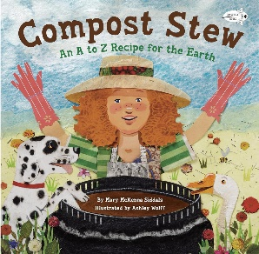 | Compost Stew by Mary McKenna Siddals  Topic: Compost  Summary: The book provides a playful and rhyming A to Z guide on how to create a compost pile, turning everyday household waste into nutrient-rich soil. It emphasizes the importance of recycling organic waste, promoting environmental awareness and sustainable practices in a fun and accessible way for kids.  Link to teaching materials and recording of the book:  https://sustainability-and-stories.org/compost-stew-an-a-to-z-recipe-for-the-earth/
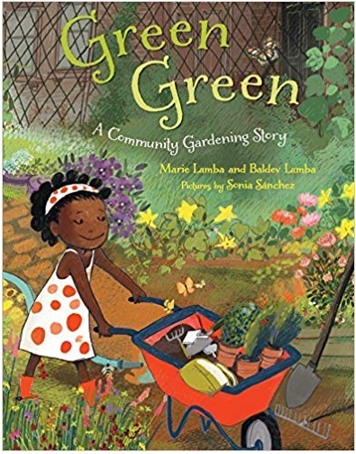 | Green, Green by Baldev Lamba and Marie Lamba  Topic: Community & Gardening  Summary: This story celebrates urban gardening and the transformation of city spaces into green, communal areas. It emphasizes the importance of nature, community involvement, and environmental stewardship.  Link to teaching materials and recording of the book:  https://sustainability-and-stories.org/green-green/
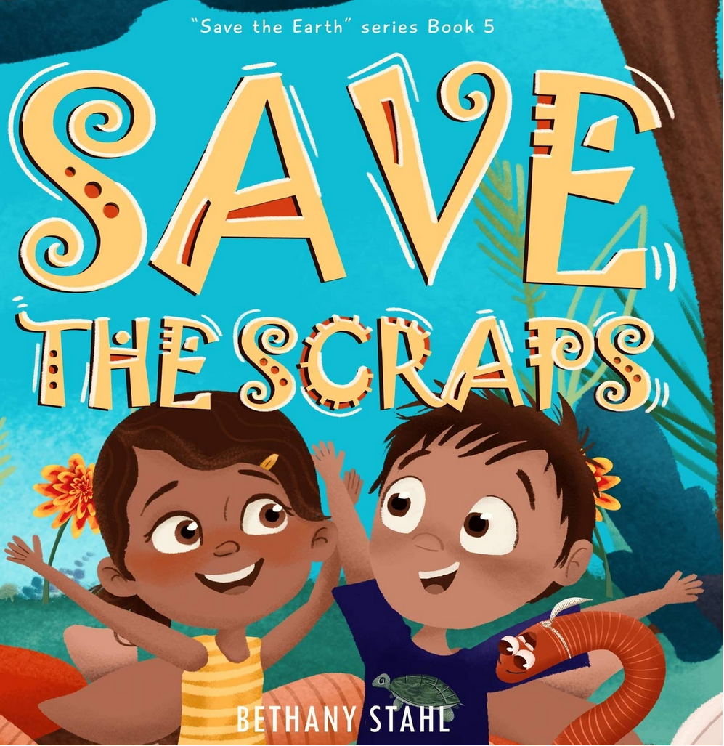 | Save the Scraps by Bethany Stahl  Topic: Compost  Summary: This story emphasizes environmental conservation through an  engaging and educational story. It tells the story of two children who learn  how to compost with the help of their wiggly worm friend.  Link to teaching materials and recording of the book:  https://sustainability-and-stories.org/green-green/

