Write an acrostic poem: Food
Subject(s): Language and Communication
Grade(s): 1–3
Key Stage: 1

Learning intention(s):
Students write an acrostic poem influenced by the garden.

Mapping to curriculum:

English
- Creates texts using correct sentence-level grammar, word choice, spelling, punctuation and language devices encountered in texts.

Lesson Instructions

Instructions:
An acrostic poem is a type of poetry where the first, last or other letters in a line spell out a particular word or phrase. The most common and simple form of an acrostic poem is where the first letters of each line spell out the word or phrase.
- Pick a topic: Have students choose a one-word topic for their poem and write it vertically down the page. Take students to the garden to think of ideas for their vertical word.
- Write lines: For each letter of the vertical word, students write a word or short sentence starting with that letter. It should relate to the topic or describe it.
Example of an acrostic poem for FOOD:
Fruit  Orange  Onion  Dates | 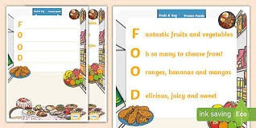
Other examples: VEGETABLES, SEEDS, PLANTS, HARVEST, GROWING, COMPOST (and lots more).
Extension activity: For a harder activity, encourage students to think of words or sentences that fit a theme. For example, if the word is “compost,” they can write about what can and can’t go in the compost. Students can turn their acrostic poem into a poster and display it as a reminder of what belongs in the compost.
This is a fun writing activity and a good way to introduce poetry to students. It helps students learn about the kitchen, garden, or any other topic you choose.

