Write an acrostic poem: Weather
Subject(s): Language and Communication
Grade(s): 1-2
Key Stage: 1

Learning intention(s):
Students write an acrostic poem influenced by the garden.

Mapping to curriculum:

English
- Recognize common word transformations and language devices used in texts.

Lesson Instructions
An acrostic poem is a type of poetry where the first, last or other letters in a line spell out a particular word or phrase. The most common and simple form of an acrostic poem is where the first letters of each line spell out the word or phrase.
- Pick a topic: Have students choose a one-word topic for their poem and write it vertically down the page. Take students to the garden to think of ideas for their vertical word.
- Write lines: For each letter of the vertical word, students write a word or short sentence starting with that letter. It should relate to the topic or describe it.

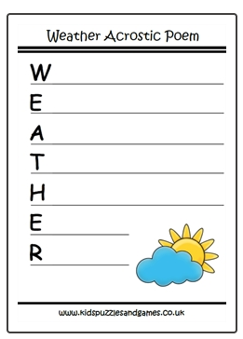
Example of an acrostic poem for WEATHER
Warm
Evaporation
Air pressure
Thunder
Hot
Environment
Rain

Other examples: VEGETABLES, HARVEST, GROWING, COMPOST, NATURE (and many more).

Extension activity
For a harder activity, encourage students to think of words or sentences that fit a theme. For example, if the word is “compost,” they can write about what can and can’t go in the compost. Students can turn their acrostic poem into a poster and display it as a reminder of what belongs in the compost.
This is a fun writing activity and a good way to introduce poetry to students. It helps students learn about the kitchen, garden, or any other topic you choose.

