Write an acrostic poem: Weather
Subject(s): Language and Communication
Grade(s): 4
Key Stage: 2

Learning intention(s):
Students write an acrostic poem influenced by the garden.

Mapping to curriculum:

English
- Create a variety of clear personal and imaginative writing and representations for a variety of purposes.

Lesson Instructions

Instructions:
An acrostic poem is a type of poetry where the first, last or other letters in a line spell out a particular word or phrase. The most common and simple form of an acrostic poem is where the first letters of each line spell out the word or phrase.
- Pick a topic: Have students choose a one-word topic for their poem and write it vertically down the page. Take students to the garden to think of ideas for their vertical word.
- Write lines: For each letter of the vertical word, students write a word or short sentence starting with that letter. It should relate to the topic or describe it.
Example of an acrostic poem for WEATHER and SPRING:
Warm  Evaporation  Air pressure  Thunder  Hot  Environment  Rain | 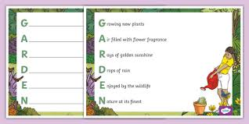

Other examples: VEGETABLES, SEEDS, PLANTS, HARVEST, GROWING, COMPOST (and lots more).

