Use data to plan a garden
Subject(s): Mathematics
Grade(s): 1–2
Key Stage: 1

Learning intention(s):
Students answer yes or no questions to gather and use data to help inform planning decisions for their garden beds.

Mapping to curriculum
Scope and Sequence Statement | How it is Addressed in the Activity

Mathematics Process Skills
- MPS 1 - Describes mathematical situations using everyday/mathematical language, diagrams, symbols | - Students create a chart with columns, record yes/no votes, and use numbers to compare crops.
- MPS 1 - Explains the process and supports conclusions | - Students tally and count votes, then choose the most popular crops, explaining which were selected and why.
- MPS 2 - Applies concepts and skills to solve real-life problems | - Students use data to decide what to plant in a real garden – applying maths to a practical, real-world situation.
- MPS 2 - Interprets the solution; checks reasonableness | - Students assess popularity of crops, which indirectly asks them to make reasonable planting decisions.
- MPS 3 - Classifying, comparing, sequencing, generalising | - Students compare crops by votes, sequence them from most to least popular, and can generalize preferences.

Chance and Data Handling
- Collect and sort data | - Students collect yes/no votes for each crop and organize them in a chart.
- Display data in table form | - The chart used to record votes is a simple table.
- Interpret data | - Students count yes/no votes and identify the five most popular crops.

Lesson Instructions
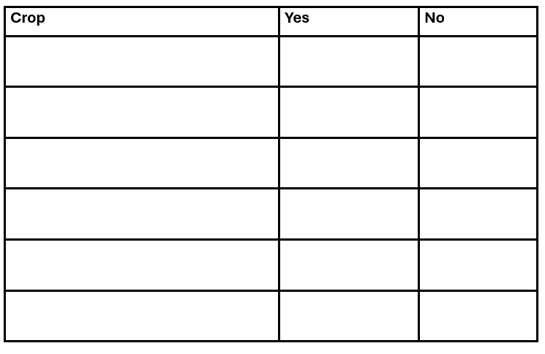
This activity is a useful way to introduce students to statistics, including how to gather data and interpret that data to help inform decision making.
- Set up a chart with three columns
You will use this chart to plan what to plant for the next season.
Add headings to the columns:
- Crop
- Yes
- No
- Brainstorm different crops
In the first column, write down all the crops you could plant, based on your climate and the season.
- Vote on crops
Ask the class if they want to plant each crop. Students vote by raising their hands for Yes or No.
Write the number of Yes and No votes in the second and third columns.
- Count the votes
See how many Yes and No votes each crop gets. Then calculate which crops have the most Yes votes.
- Choose the top crops to plant
Pick the five most popular crops based on the votes. Use this information to decide what to plant.

