Construct a pot pyramid for the garden
Subject(s): Mathematics
Grade(s): 5–6
Key Stage: 2

Learning intention(s):
Construct a 3D pyramid structure to support plants in the garden.

Mapping to curriculum:

Mathematics
- Recognise, name, sort, and make models of 3D objects.
- Describe them using everyday language.
- Make skeleton models of 3D shapes and identify 3D shapes from pictures.
- Make double layered solids, as in pictures, using cubes.
- Begin to identify the cross sections of prisms.
- Visualise 3D from 2D drawings.
- Identify and sketch different nets

Visual Art
- Create 3D objects from a variety of available materials.

Lesson Instructions

Materials required
- 3–4 long bamboo canes or sticks
- heavy twine
- scissors

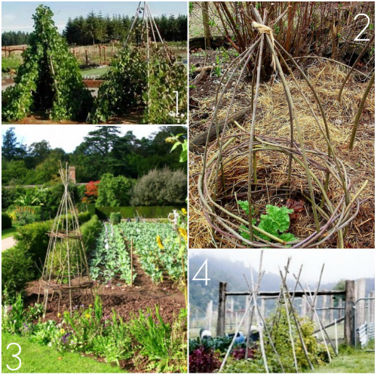
Source: https://www.17apart.com/2012/03/pinterest-challenge-diy-bean-teepee.html

Instructions:
- Get materials: You need 3–4 long bamboo canes or sticks, heavy twine, and scissors.

- Arrange the canes/sticks: Place the canes on the ground, parallel and touching each other.

- Tie the canes/sticks: Tie the canes together about 30 cm from one end.

- Put in position: Pick up the canes by the tied end, stand them up in the garden, and spread the untied ends apart to form a pyramid.

- Make the structure stable: Push the ends of the canes deep into the ground, then weave twine between them to make the structure sturdy.

- Plant around it: Sow climbing plant seeds or plant seedlings around the base. Over time, they’ll grow up and around the structure.

- Optional step: If you want, you can have students measure the canes and twine to make sure everything is evenly spaced.
This activity teaches students about measurement and construction while creating a structure that supports plants and adds height to the garden.

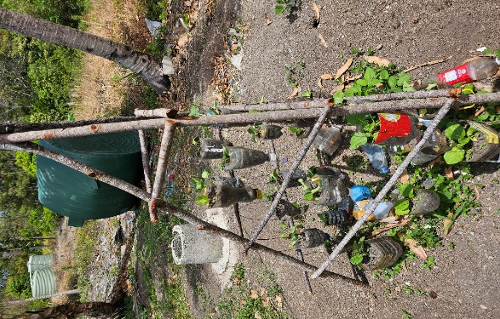 | 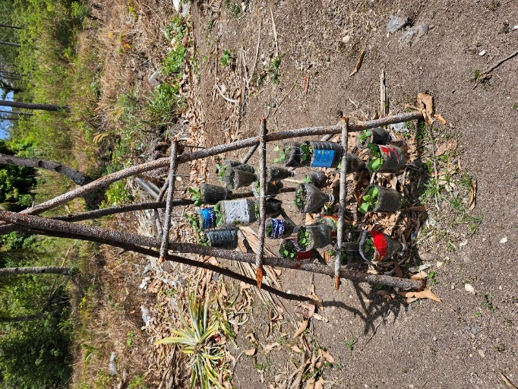
Photos: Rhonda Di Biase

