Make a 3D model of a garden structure
Subject(s): Mathematics
Grade(s): 4
Key Stage: 2

Learning intention(s):
Students make a 3D model of structure for the garden.

Mapping to curriculum:

Mathematics
- Recognise, name, sort, and make models of 3D objects. Describe them using everyday language.
- Make skeleton models of 3D shapes and identify 3D shapes from pictures and sketch all faces of 3D shapes on paper.
- Make double layered solids, as in pictures, using cubes.
- Begin to identify the cross section of prisms. Visualise 3 dimensions from 2D drawings. Make cubes and cuboids from nets.

Visual Art
- Create 3D objects from a variety of available materials

Lesson Instructions
- Students are tasked with designing a new structure for the school’s garden. Their design must include a 3D model. Examples include a dome-shaped greenhouse, a cone-shaped plant trellis, a cube-shaped compost bin, or a spherical garden sculpture. Encourage students to use their knowledge of shapes.
- Students sketch their chosen structure in their workbooks.
- Along with the sketch, students write a short paragraph highlighting the key feature of their design (e.g., dome, cone, cube).
- Using modelling clay or other available materials, students build a 3D version of their structure.
- Display the finished models safely in the classroom for everyone to see.

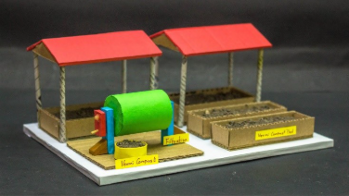
Source: https://www.youtube.com/watch?v=t-Giuapyncc

