Measure the area and perimeter of leaves
Subject(s): Mathematics
Grade(s): 4
Key Stage: 2

Learning intention(s):
Students will explore and compare the area and perimeter of leaves. They will collect leaves, trace them onto graph paper, and measure their area and perimeter. They will compare these measurements and discuss how shape affects area and perimeter.

Mapping to curriculum:

Measurement (Perimeter, Area and Volume)
- Recognise and use relationships between familiar units and draw lines and measure accurately using appropriate equipment, suitable units and solve problems.
- Estimate and record length/distance to a suitable degree of accuracy.

Lesson Instructions

Materials
- Graph paper with 1cm squares
- String
- Pencil/pen
- Centimeter ruler
- Scissors

Key Concepts
- Perimeter: The distance around the edge of a shape (measured in cm).
- Area: The space inside a shape (measured in square cm).

Preparation
- Student collect leaves of various sizes and shapes. Avoid hard-to-measure leaves, like very jagged or tiny ones.
- On the whiteborad, draw some leaves and label their area and perimeter as examples.

Instructions

1. Getting Started
- Discuss:
  - What is the distance around the leaf called? [Perimeter]
  - What is the space inside the leaf called? [Area]
- Use the whiteboard to show examples and define these terms together.

2. Measuring Area
- Explain that area is measured in square units (e.g. square centimetres).
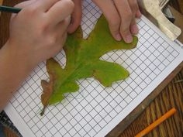
- Demonstrate tracing a leaf onto graph paper.
- Count the squares inside the tracing, including partial squares, to find the area.
  - Example: Area = __ square centimeters.
- Students work with a partner to trace their own leaves and calculate the area.
- Compare results by organising tracings from smallest to largest area. Discuss:
  - Were you surprised by the order?
  - What do leaves with large areas have in common?
  - What shapes help plants survive?
Source: https://resources4rethinking.ca/en/resource/area-and-perimeter-of-leaves

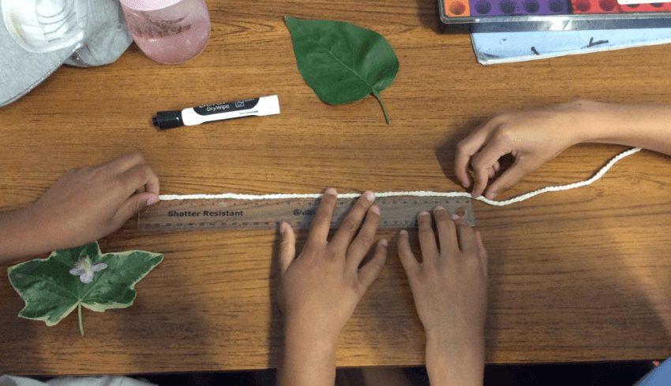
3. Measuring Perimeter
- Demonstrate how to use string to measure the perimeter of a leaf. Wrap the string around the edge, cut it, and measure its length with a ruler.
  - Example: Perimeter = __ centimeters.
- Students work in pairs to measure and record the perimeter of their leaves.
- Compare perimeters by organising string from shortest to longest. Discuss:
  - Does the leaf with the longest perimeter always have the largest area? Why or why not?
Source: https://www.teachwire.net/news/area-and-perimeter-worksheets-and-resources-for-ks2-maths/
- Show that different shapes can have the same perimeter but different areas by reshaping a loop of string.

4. Creative Challenges

Maximising Area
Use a string perimeter to create a shape with the largest area and another with the smallest area. What patterns do you notice?

Comparing Perimeters
Use the same area to create shapes with different perimeters. What shapes work best?

Reflection
Discuss what students learned about the relationship between shape, area and perimeter. How might this knowledge help us understand plants and their environment?

