Measure the perimeter of garden beds
Subject(s): Mathematics
Grade(s): 5–6

Learning intention(s):
Students choose a relevant measuring device to calculate the perimeter of a garden bed.

Lesson Instructions
- Discuss with the class why knowing the perimeter of garden beds is important. For example:
  - planning garden space
  - knowing how many plants can fit.
- Students will visit a square or rectangular garden bed, and choose the most appropriate measuring tool (e.g. measuring tape, ruler, string) and unit (centimetres or metres) to measure the garden’s perimeter.
- In groups of three, have students estimate the perimeter of the garden bed:
  - Student 1 measures the length and width
  - Student 2 checks the measurement
  - Student 3 writes down the measurements.
Students then work together to calculate the perimeter of the garden bed.
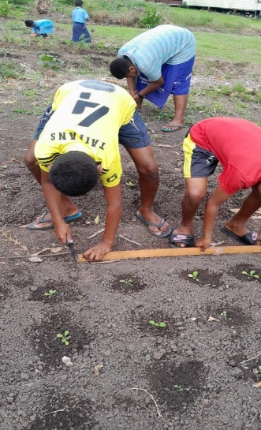
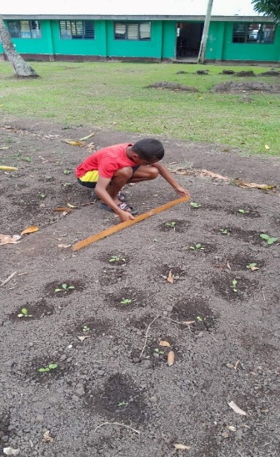
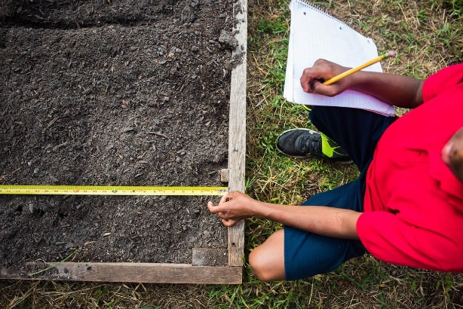
- In their group of three, students measure a second garden bed:
  - Estimate whether the perimeter is larger or smaller than the first
  - Swap roles to measure, check and write down the measurements.
Students then work together to calculate the perimeter of the garden bed.

Source: https://getthekidsoutside.com/square-foot-gardening-for-kids/

Extension activity
Calculate the area of the garden beds by multiplying length and width, and discuss why knowing the area is useful, like determining how much soil or mulch is needed.

