Identify items for composting
Subject(s): Science, Social Science, English
Grade(s): 1–6

Learning intention(s):
Students will investigate what materials decompose by identifying organic (natural) and inorganic (man-made) materials. They will observe how bacteria and fungi (decomposers) break down organic materials and how these materials change over time.

Lesson Instructions

Who can do this activity
- Grades 1 to 2: Students will set up and observe the decomposition process with guidance.
- Grades 3 to 6: Students will work in pairs to conduct the investigation and engage in more advanced discussions and reporting.

Time required
- Set-up and starting the activity: About 1 hour
- Observations: Over 4 weeks or more
- Final observations and discussion: About 1 hour
- Optional: Extra time for writing a scientific report or completing the extension activity.

Materials required
- 5 clear jars with wide openings
- Organic items: examples include orange peel, apple core, tea bag, cardboard, newspaper or a leaf
- Inorganic items: examples include a piece of plastic, glass or brick
- Soil (or finished compost, if available)
- Spray bottle for watering

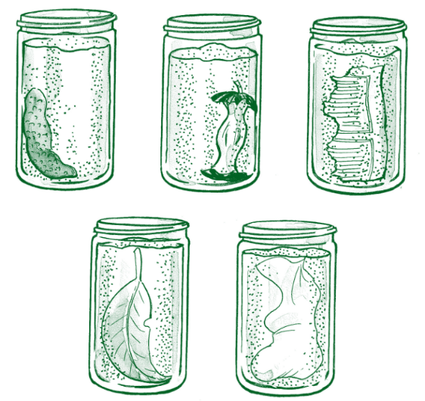
Activity 1: for Grades 1 to 2

Investigation Instructions
- Set the scene: Start by discussing the differences between organic and inorganic materials.
- Select 2-3 pieces of organic material and 2-3 pieces of inorganic material.
- Fill jars with soil or compost, placing each material against the side for observation.
- Lightly spray the soil to keep it damp, not soggy.
- Record initial observations with photos or drawings.
- Observe changes weekly for four weeks, keeping the soil moist.

Predictions
Source: https://www.wasteauthority.wa.gov.au/images/resources/forms/Compost_Activity_Guide_2020.pdf
- Ask students to predict what will happen to each material after four weeks in the jar.
- Observations
- Observe jars weekly.
- Record changes (or lack of changes), using the observation worksheet.
- Compare final observations to the initial ones.
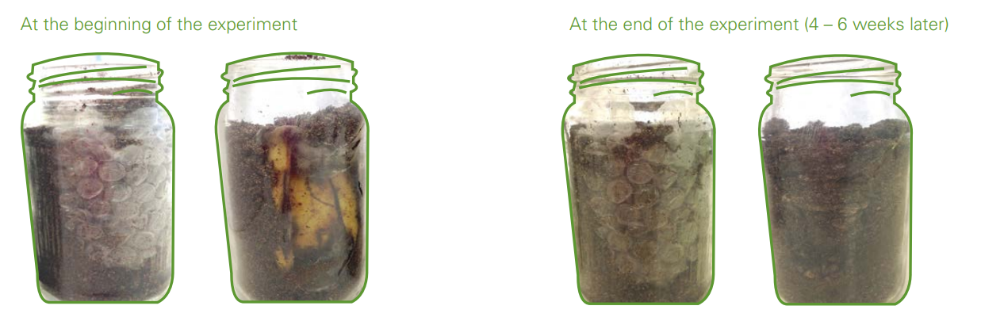
Source: https://www.wasteauthority.wa.gov.au/images/resources/forms/Compost_Activity_Guide_2020.pdf

Discussion
- Which items changed? How?
- Were predictions correct?
- What caused changes?
- Why did some items not change?
- Group items into organic (decomposed) and inorganic (did not decompose).
- Identify compostable and recyclable materials.

Application question
Composting is a good way to reduce most organic waste going to landfill – name several items of waste from your lunch, or someone else’s lunch, that you could compost.

Activity 2: for Grades 3 to 6
In pairs, students will conduct the investigation outlined above (Activity for Grades 1 to 2).

Investigation Instructions
- Provide the list of materials and equipment.
- Ask students to design their investigation to test which materials decompose.
- Discuss their designs and suggest improvements.
- Identify hazards and establish safety rules.
- Students will set up the investigation as planned or based on the Grades 1 to 2 instructions.

Predictions
- Students predict which set of jars will show more decomposition over four weeks and why.

Observations
- Over four weeks, observe and record changes in both sets of jars weekly, using the observation worksheet. See the example provided below.

Discussion Questions
- Were your predictions correct?
- Which items do you think are organic? Why?
- Suggest possible reasons for why some materials decomposed while others didn’t.
- Do you think the changes are reversible?

Application Questions
- Composting is a good way to reduce most organic waste going to landfill. Name five items from your lunch that could be composted.
- What happens to inorganic materials in landfill, like metal, plastic, and glass?
- Discuss alternatives to landfill for inorganic materials (reduce, reuse, recycle).

Scientific Reporting
- Students will use their observations to write a scientific report summarising their findings and answering the discussion questions.

Observation Worksheet
Name _______________________
Record changes (or lack of changes) in all jars weekly. You can also include illustrations to show what the material in your jars looks like.
Week | Jar 1  Material:  Organic or Inorganic (circle) | Jar 2  Material:  Organic or Inorganic (circle) | Jar 3  Material:  Organic or Inorganic (circle) | Jar 4r  Material:  Organic or Inorganic (circle) | Jar 5  Material:  Organic or Inorganic (circle)
1
2
3
4

