Plan and Cost a Garden Bed

Subject(s) Basic Science, Basic Technology

Year(s) 9

Learning Intention(s)
Students will apply their knowledge of area, perimeter, volume and cost calculations to design a productive garden bed. They will use mathematical reasoning to optimise space and budget while considering practical gardening constraints.

Teaching Activity

Materials required
This activity is centred on planning so materials are not required. However, if the designs are to be implemented, the materials would be determined by student planning, and are likely to include:
- Construction materials (e.g. logs, bricks, tyres)
- Soil, compost and potting mix
- Seeds
- Fencing (if required)

Task Description for Students
You have been given a space in the school garden to design a vegetable garden bed. Your goal is to create a functional and cost-effective design while considering space, soil requirements, and budget constraints.

Student Instructions

Step 1: Choosing the Shape of Your Garden Bed
Select a shape for your garden bed:
- rectangle
- square
- triangle
- circle
Calculate the area and perimeter of your chosen shape. When planning the shape and size, consider how you would reach into the middle of the garden bed. Plan for a garden that is less than 6 square metres in size.

Step 2: Determining Soil Volume
Your garden bed will need 30cm of soil depth.
Calculate the volume of soil required.
- Example: If soil is sold in bags of 50 litres for $25 each, determine how many bags are needed and the total cost.

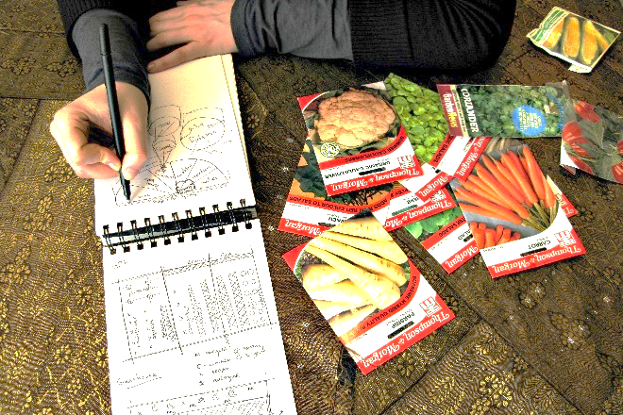
Step 3: Selecting Plants
Credit: Flickr (Phil and Pam Gradwell CC BY 2.0)
Choose three different types of vegetables to grow.
- Research the recommended spacing for each plant (e.g. 30cm apart).
- Calculate how many plants of each type can fit in your garden bed.

Optional Step: Fencing the Garden Bed
If you want to fence your garden bed:
- Calculate the total length of fencing needed based on the perimeter.
- Example: If fencing costs $12 per metre, determine the total fencing cost.

Reflection
Write a short paragraph explaining your design choices. Consider:
- Why you chose a particular shape
- How you optimised space and cost
- Any challenges or improvements for your design

Assessment Criteria
✔ Accurate calculations of area, perimeter, and volume.
✔ Correct budgeting and cost analysis.
✔ Logical and realistic plant spacing.
✔ Clear and well-reasoned reflection.

