Construct a mini greenhouse
Subject(s): Environment, Science & Technology
Grade(s): 2–3
Key Stage: 1

Learning intention(s):
Students will understand how a greenhouse functions to support plant growth by creating a mini greenhouse using a plastic bottle. They will learn how temperature, moisture, and light contribute to plant development, and observe the germination process and early plant growth in a controlled environment. Through this activity, students will also develop observation and inquiry skills by recording changes in the plants over time and exploring how different variables affect growth.

Mapping to curriculum:

Science
- LL202 Explore that living things grow and change
- SIS202 Follow instructions to carry out guided investigations
- SIS204 Talk about the finding and share them in a variety of ways
- LL301 Investigate observable characteristics of living things (living and nonliving)

Lesson Instructions

Materials required
- Clear plastic bottle (2-liter size is ideal)
- Sharp scissors (for teachers to use)
- Potting soil
- Seeds (e.g. sunflowers, beans, peas)
- Water

Steps
- Clean the Bottle
  - Remove the label from your plastic bottle and rinse it out to make sure it's clean.
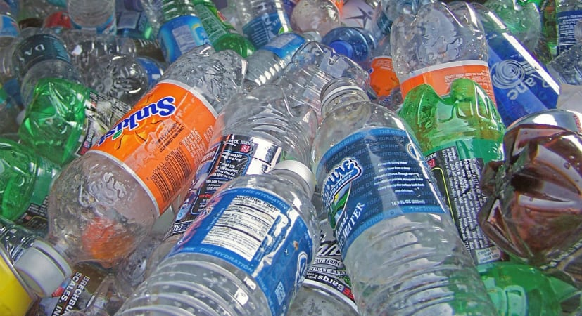
Source: https://blog.cuyahogarecycles.org/properly-recycle-plastic/
- Cut the Bottle
Ask your teacher to cut the plastic bottle in half using sharp scissors.
  - Poke a few small drainage holes in the bottom of the bottle.
  - Cut small slits along the edges of the top half of the bottle so it fits snugly over the bottom half. (See the image below for reference.)
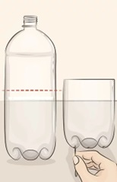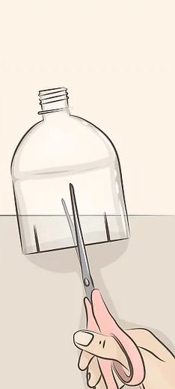
Source: https://www.wikihow.com/Make-a-Mini-Greenhouse
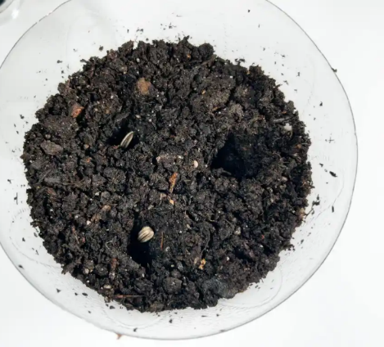
- Add Soil and Seeds
Source: https://intheplayroom.co.uk/diy-miniature-greenhouse/
  - Fill the bottom part of the bottle with soil.
  - Make 1-3 small holes in the soil and place a seed in each hole. Cover the seeds with soil and lightly water the soil.
- Cover with Top Half of Bottle
  - Put the top part of the bottle on the bottom to form your greenhouse.
- Find a Sunny Spot
  - Place your mini greenhouse on a windowsill with good sunlight. You can put a plastic tray under the greenhouse to catch any water that drains.
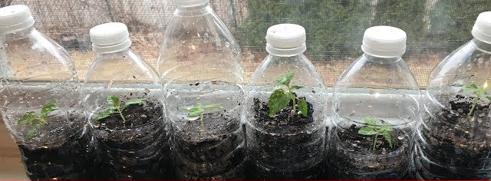
Source: https://www.youtube.com/watch?v=G4sColu-aFE
- Watch and Wait
  - Over the next few days, check the soil moisture and look for signs of growth! Keep a journal of daily observations and drawing pictures of the plant’s growth.
- Transplant Seedlings
  - Once your plants are big enough, you can carefully move them to a larger pot or an outdoor garden to keep growing.

Reflection
- What changes did you observe in your plants over time, and what do you think caused these changes?
- How did the mini greenhouse help create a better environment for your plant to grow compared to the outside?
- If you were to grow another plant, what would you change in your mini greenhouse to help it grow even better?

Mini Greenhouse
Plant Growth Observation Sheet

Name:
Day 1
Day 2
Day 3
Day 4
Day 5

