Observe the role of light in plant growth
Subject(s): Environment, Science & Technology
Grade(s): 1
Key Stage: 1

Learning intention(s):
Students will learn how light affects the growth of seeds by conducting an experiment to observe the differences between seeds grown in light and in darkness. Through this experiment, student will understand the role of light in seed germination and plant development, particularly in the formation of leaves.

Mapping to curriculum:

Science
- LL103 Identify that living things live in different places to meet their basic needs.
- SIS102 Participate in guided investigations
- SIS103 Use non-standard measurements to collect data and make simple statements/generalisations based on the information
- SIS104 Talk about observations and share ideas in a variety of ways

Lesson Instructions

Materials required
- 2 plastic cups
- Dirt or potting soil
- Seeds
- Water
- A small box (large enough to hold one cup)
- Labels or marker (to label the cups ‘light’ and ‘dark’)
- Table near a window or another spot with natural light

Steps
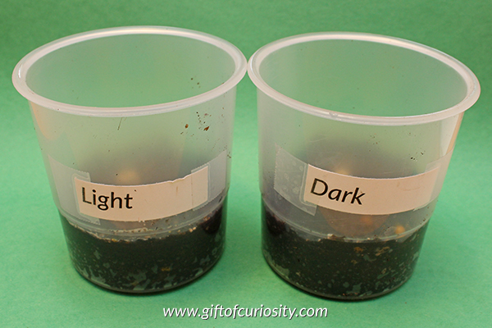
- Prepare the Cups
Source: www.giftofcuriosity.com
- Take two plastic cups and fill them with equal amounts of dirt or potting soil.
- Label one cup ‘light’ and the other ‘dark’.
- Plant the Seeds
- In each cup, plant three seeds. Make sure the seeds are planted at the same depth in both cups.
- Set Up the Light and Dark Conditions
- Place the ‘dark’ cup inside a box, sealing the box tightly to prevent any light from getting in.
- Leave the ’light’ cup uncovered.
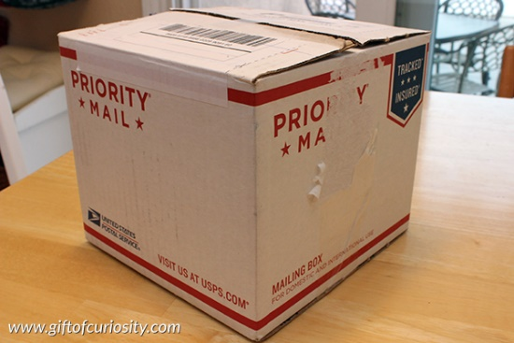
- Position the Cups
Source: www.giftofcuriosity.com
- Place both the ’light’ cup and the sealed box (containing the ‘dark’ cup) on a table near a window or in an area that receives natural light.
- Water the Seeds
- Water both cups as needed, ensuring the soil stays moist but not soaked. Check every few days to see if more water is needed.
- Wait and Observe
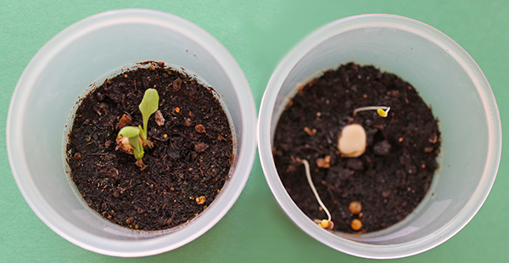
- After one week, open the box and compare how the seeds in the ’light’ and ‘dark’ cups have grown.
- Record your observations using words and/or drawings, noting any differences in sprouting, height, and whether leaves have formed.
- Conclude the Experiment
- After observing the plants in both cups, expose the ‘dark’ cup to light. Check to see if the seeds develop leaves once, they have access to light and record any changes over the next 24 hours.
- Analyse the Results
Source: www.giftofcuriosity.com
- Discuss or write about the findings. Did the seeds sprout in both cups? What happened to the leaves in each condition? What does this experiment teach about the importance of light for growing plants?

Books to Read about Growing Seeds
- The Tiny Seed by Eric Carle: https://www.youtube.com/watch?v=LlDOMQPptOM
- From Seed to Plant by Gail Gibbons: https://www.youtube.com/watch?v=TLEns2oCd6U

Observation Sheet: The role of light in plant growth

Light Cup After 1 Week
Dark Cup After 1 Week
Dark Cup After 24 Hours Exposed to Light

