Grow seeds and record data
Subject(s): Environment, Science & Technology
Grade(s): 5–6
Key Stage: 2

Learning intention(s):
Students will learn to observe, measure, and analyse how environmental factors affect the germination and growth of seeds so that we can understand the best conditions for growing plants.

Mapping to curriculum:

Science

Life and Living
- Basic needs of living things interaction with each other and the environment
- Living things undergo changes as they grow and develop

Working Scientifically
- Makes observations to provide supporting evidence
- Conducts simple investigations
- Take care of themselves, others and respects others’ viewpoints

Mathematics
- Chance and handling data
- Solve a given problem by organising, representing and interpreting data in simple tables or diagrams

Lesson Instructions

Materials required

Materials for planting
- Small pots e.g. reused plastic bottles (3–5 pots, depending on the number of locations)
- Seeds (quick-growing plants such as cucumber, radish, lettuce, tomato)
- Soil
- Garden tools (e.g. small trowel)
- Labels and markers (to identify each pot and location)

Materials for experiment setup
- Access to different growing environments (e.g., sunny spots, shaded areas, indoors)
- Ruler or measuring tape (for measuring plant height)
- Pre-prepared worksheets (Student Worksheet 1 & 2)
- Pencils or pens (for recording observations)
- Calendar (to track observation dates)

Materials for presenting results
- Large paper or poster board (to create charts or visual displays)
- Coloured markers or pencils (to make data charts more engaging)
- Computer or tablet (if creating digital presentations)

Optional extra materials
- Camera or tablet (to take photos of plant growth as evidence)
- Thermometer (to measure temperature in different locations)
- Graph paper or software for charting data
- A magnifying glass (to observe details of seedlings)

Steps
- Choosing and Planting Seeds
- Choose Your Plant: Decide on a quick-growing plant, such as cucumbers, lettuce, or tomatoes.
- Plant Seeds:
  - Use a few pots to plant your seeds.
  - Place the pot in different locations (e.g., under shade, in direct sunlight, indoors).
  - Label each pot clearly with the plant type and location.
- Predict Germination Rates
- Estimate: Predict how many seeds will germinate.
For example, do you expect 50% or 70% to sprout?
- Record Your Prediction: Write your estimates on Student Worksheet 1.
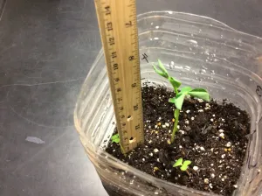
- Observing Germination
- Allow 1-2 weeks for the seeds to germinate.
- At the end of 2 weeks:
- Count how many seeds have sprouted.
- Measure the height of the seedlings.
- Record the date and measurements on your worksheet.
- Monitoring Growth
- Every 2 weeks for 6-8 weeks:
  - Check your plants.
  - Measure the growth (height or other noticeable changes).
Source: https://teachingapscience.com/cheap-ecocolumns-and-cool-i-have-some-ecocolumns/measuring-height-of-plants-1/
  - Record the data for each tray on Student Worksheet 2.
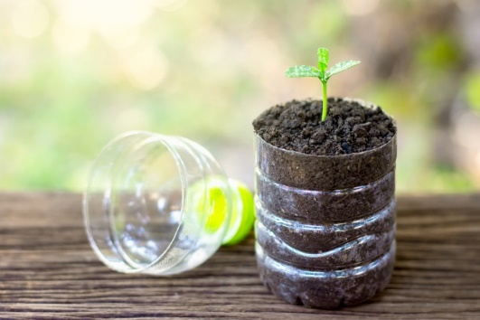
- Analysing Data
- After 8 weeks:
  - Organise all the data you’ve collected.
  - Create charts or graphs to show how your plants grew over time.
  - Think about what might have caused differences in growth (e.g. amount of sunlight, water, temperature).
- Presenting Findings
- Share your results with your class:
Source: https://discoveryplace.org/stay-at-home-science/explore-sustainability-with-this-self-watering-seed-starter-activity/
- Explain how the environment affected germination and growth.
- Highlight any surprising or disappointing results.
- Use your data to draw conclusions about the best conditions for planting your seeds in the future.

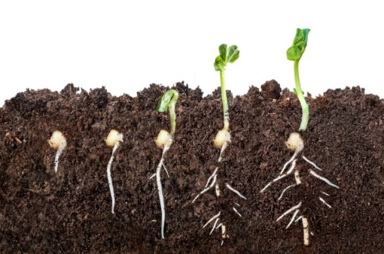
Tips for Success
- Be consistent with watering and care for each tray.
- Take careful measurements to make sure your data is accurate.
- Have fun experimenting and learning about how plants grow!
Student Worksheet 1
Name: ____________________ Date: ________ Estimate of seed germination: ________
Collect weekly or fortnightly observation data of the seeds’ germination process

Week | Observations  Write down the height of your plants and any other noticeable changes.  You can also include illustrations to show what your plants look like.
1-2
3-4
5-6
7-8

Overall observations and conclusions:

Student Worksheet 2
Name: __________________________

Collate the data and create a graph or chart

[insert a graph/chart]
Explain your findings/observations
[think about the factors in the environment that affected the germination and growth]

