Measure photosynthesis with floating leaves
Subject(s): Science
Grade(s): 7–8
Key Stage(s): 3

Learning intention(s)
Students will understand how plants use sunlight, water, and carbon dioxide to carry out photosynthesis and produce oxygen. By conducting a leaf floatation experiment, students will observe how oxygen is created during photosynthesis and explore the factors that influence the process.

Mapping to curriculum
Scope and Sequence Statement | How it is Addressed in the Activity
- Photosynthesis – factors necessary for photosynthesis (G7) | - Students observe the effect of light, carbon dioxide (baking soda), and water on photosynthesis by measuring leaf disk floatation.
- Importance of photosynthesis to living things (G7) | - The experiment visually demonstrates oxygen production, highlighting photosynthesis’ role in sustaining plant and animal life.
- Interactions within food chains and food webs (G8) | - Activity illustrates how oxygen produced by plants supports other organisms, reinforcing ecological relationships.
- Adaptation in organisms to their environment (G8) | - Students explore how environmental variables (light intensity, temperature, CO₂ concentration) influence photosynthesis rate.
- Gathering, processing and analysing data (G7 and G8) | - Students record time and number of floating leaf disks, analysing data to draw conclusions about photosynthesis rates.
- Planning and carrying out investigations (G7 and G8) | - Students follow a scientific procedure, control variables, and can modify the experiment to test effects of different factors.

Lesson Instructions
Plants use sunlight, water, and carbon dioxide to make food and produce oxygen. This experiment shows how oxygen made during photosynthesis can make small pieces of leaves float in water.

Materials
- Ingredients: Baking soda, water, dish soap, spinach/ivy leaves
- Tools: Straw or hole punch, syringe (no needle), clear cup or beaker, lamp, timer, notebook
- Optional: Thermometer, foil, ice, hot water, coloured filters
Video demonstration: https://www.exploratorium.edu/snacks/photosynthetic-floatation

Steps
- Prepare the solution
- Mix 0.5g of baking soda with 500mL of water
- Add a few drops of dish soap. Mix gently to avoid bubbles.
- Make leaf disks
- Use a straw or hole punch to cut 10 small circles from the leaves.
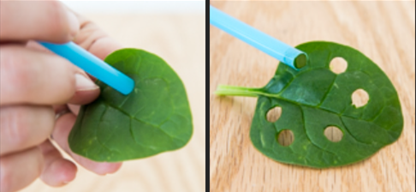Source: https://www.exploratorium.edu/snacks/photosynthetic-floatation
- Use the syringe
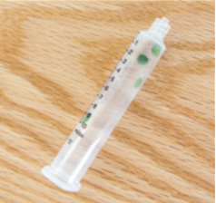
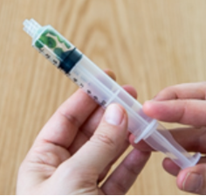
  - Remove the plunger and place the leaf disks inside.
Source: https://www.exploratorium.edu/snacks/photosynthetic-floatation

  - Draw about 6-8mL of bicarbonate solution into the syringe. The leaf disks should float in the solution.
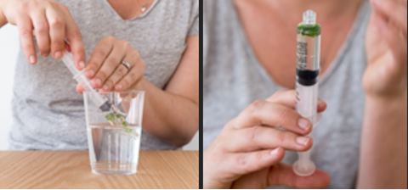
Source:https://www.exploratorium.edu/snacks/photosynthetic-floatation
  - Carefully push all the air out of the syringe.
  - Close the opening of the syringe with a finger and draw back on the plunger to create a vacuum. Hold the vacuum for 10-15 seconds and swirl the leaf disks to suspend them in the solution.
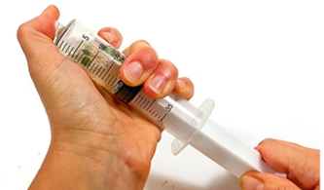
Source: https://www.sciencebuddies.org/stem-activities/photosynthesis-floating-leaves?from=Blog
- Bubbles will come out of the disk, causing them to sink. Repeat the steps until all the leaf disks have sunk to the bottom of the solution.

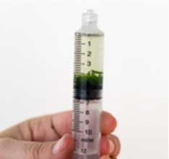
Source: https://www.exploratorium.edu/snacks/photosynthetic-floatation
- Set up the experiment
  - Pour the disks and solution into a clear cup. Fill the cup with baking soda solution, up to a depth of about 3 cm
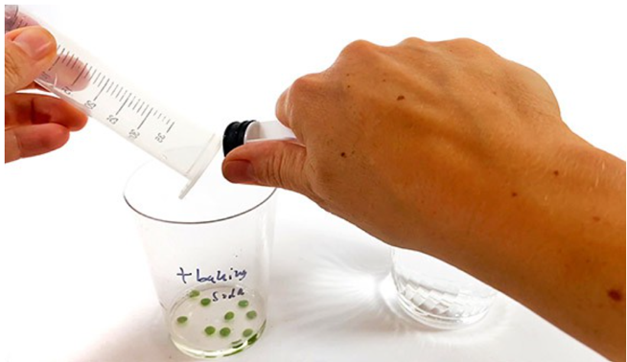
Source: https://www.sciencebuddies.org/stem-activities/photosynthesis-floating-leaves?from=Blog
  - Place it under a light source about 30 cm above the table.
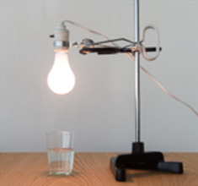
Source: https://www.exploratorium.edu/snacks/photosynthetic-floatation

- Observe and record
  - Turn on the light and start the timer.
  - Watch for bubbles forming on the leaf disks. Over time, the disks will float to the top as oxygen is produced.
  - Record how many disks float every minute until all are floating.
- Experiment further
  - Move the cup to a dark place and check after 15 minutes. The disks will sink since photosynthesis stops in the dark.

What’s Happening?
- Photosynthesis: Plants use sunlight to make food and release oxygen. The oxygen collects on the leaf disks, making them float.
- Respiration: Plants also use oxygen to produce energy, even in the dark, which causes the disks to sink when no more oxygen is produced.

This experiment shows how fast the leaves produce oxygen, which tells us how fast photosynthesis is happening.

At first, the leaf pieces floated because leaves naturally have tiny air pockets to help them exchange gases. When you created a vacuum in the syringe, the air was removed, and the spaces filled with the solution. This made the leaves sink.

Once you put the cup with the leaf pieces under the light, photosynthesis began. The chloroplasts in the leaves used the light to create oxygen. Tiny bubbles of oxygen formed on or inside the leaves. These bubbles showed that photosynthesis was happening.

The oxygen bubbles made the leaves lighter, so they started to float. The more bubbles there were, the higher the leaves floated—like how a diver floats when they add air to their vest.

If you used baking soda in the solution, the first leaves should have floated in just a few minutes. Baking soda provides carbon dioxide, which is necessary for photosynthesis. Without baking soda, no leaves would float because photosynthesis can’t happen without carbon dioxide.

How fast the leaves floated depended on different factors. If you tried variations (like more light, higher temperature, or more baking soda), you likely saw photosynthesis happen faster. Leaves with more chlorophyll (the green pigment) also photosynthesize better than others.

Try These Variations
- Use different light sources or temperatures.
- Change the concentration of baking soda.
- Test how different coloured lights affect photosynthesis.

Acknowledgement: This experiment was originally described in Steucek, Guy L., Robert J. Hill, and Class/Summer 1982. 1985. “Photosynthesis I: An Assay Utilizing Leaf Disks.” The American Biology Teacher, 47(2): 96–99.

