Understand the process of photosynthesis
Subject(s): Science
Grade(s): 7–8
Key Stage(s): 3

Learning intention(s)
Students will learn how plants make their food using light energy, water, and carbon dioxide through the process of photosynthesis.

Mapping to curriculum: Scope and sequence, linked to the activity

Biology
- Factors necessary for photosynthesis (G7 and G8)
- Students identify light, water, and carbon dioxide as essential inputs through diagrams, descriptions, and discussion.
- Importance of photosynthesis to living things (G7)
- This item is addressed in the review discussion and video, with links to oxygen release and glucose for energy.
- External structural adaptation of the leaf for photosynthesis (G7)
- The leaf diagram task involves labelling and describing stomata and leaf structure (arrows and flap model).
- Internal structural adaptation of the leaf for photosynthesis (G8)
- The flap diagram and arrow activity helps students visualize internal movement of molecules during photosynthesis.
- Photosynthesis equation and molecular structure (G8 implied through cross-topic integration)
- Writing and modelling the chemical equation using molecular cards and atom disks deepens understanding of atomic rearrangement.

Chemistry
- Basic structure of matter as atoms and molecules (G7 and G8)
- Students use model cards and atom disks to build and break apart molecules (H₂O, CO₂, O₂, C₆H₁₂O₆).
- Use of periodic table and symbols
- Interactive Periodic Table Activity lets students locate H, C, and O and understand formulas.
- Formation of molecules using atoms
- Model-building task demonstrates atomic recombination and molecule formation in a visual, hands-on way.

Lesson Instructions

Materials
- Photosynthesis handout
- Exercise book
- Scissors and glue sticks
- A flashlight per group
- Molecular model cards
- Atom disks
- Interactive Periodic Table: https://elements.wlonk.com/ElementsTable.htm
- Photosynthesis video: https://www.youtube.com/watch?v=7tuEC_j4P_o

Key vocabulary
- By-product: Something extra that is made while creating or making something else.
- Digestion: The process of breaking down food into smaller parts so the body can use it.
- Energy: The power that comes from using physical or chemical resources.
- Nutrient: A substance that helps the body grow and stay healthy.
- Photosynthesis: How plants use sunlight, water, and carbon dioxide to make food and oxygen; the reverse of how cells release energy.
- Respiration: How a plant takes in and releases oxygen and carbon dioxide.

Steps
- Introduction and Discussion
- Ask students: "Why is light important for plants?". After listening to the students' responses, explain that they are going to explore this question.
- Explain that plants use light energy to make food through photosynthesis.
- Activity
- Provide students with a Photosynthesis handout.
- Cut out the ‘Plant Diagram Cards’ and glue the plant card onto a exercise book page.
- Fold and attach the four label cards (light, water, oxygen, carbon dioxide) around the plant card in the correct positions.
- Under each label, write a description of its role in photosynthesis and draw arrows to show how each interacts with the plant:
  - Light: Absorbed by chlorophyll in leaves.
  - Water: Absorbed by roots and sent to leaves.
  - Carbon Dioxide: Enters through stomata in leaves.
  - Oxygen: Released into the atmosphere.
- Reading and Vocabulary
  - Read the ‘Photosynthesis in Plants’ passage. Discuss any unfamiliar words.
  - Glue the reading onto the next exercise book page.
- Leaf Diagram and Arrows
  - Cut out and glue the bottom leaf diagram onto the next page. Attach the top leaf over it with glue along the stem.
  - Add arrows to show how light, water, and carbon dioxide enter the leaf and how oxygen leaves it.
- Periodic Table and Molecules
  - Use the Interactive Periodic Table to locate hydrogen (H), oxygen (O), and carbon (C).
  - Explain that atoms combine to form molecules. Identify the formulas for water (H₂O), carbon dioxide (CO₂), glucose (C₆H₁₂O₆), and oxygen (O₂). Clarify that the number in the formula indicates the number of atoms of that element in the molecule. For example, H₂O contains two atoms of hydrogen.
- Molecular Model Activity
  - Student work in small groups with Molecular model cards (6 carbon dioxide cards, 6 water cards, 6 oxygen cards, and 1 glucose card) and Atom disks (12 hydrogen atoms, 6 carbon atoms, and 18 oxygen atoms).
  - Assemble water and carbon dioxide molecules. Use flashlights to simulate light energy.
  - Explain that, using light energy, the water molecules are split into hydrogen and oxygen. Hydrogen is combined with carbon dioxide to form glucose and oxygen. Instruct the students to transfer the atoms from the water and carbon dioxide molecules to the glucose and oxygen molecules.
- Write the Photosynthesis Equation
  - Record the balanced equation:
6CO₂ + 6H₂O —Light Energy→ C₆H₁₂O₆ + 6O₂
- Review and Summarize
  - Discuss key points:
    - Chlorophyll absorbs light energy.
    - Light splits water into hydrogen and oxygen.
    - Hydrogen combines with carbon dioxide to form glucose.
    - Glucose provides energy or is stored by the plant.
    - Oxygen is released into the atmosphere.
  - Watch the Photosynthesis video to reinforce understanding.

Photosynthesis Handout

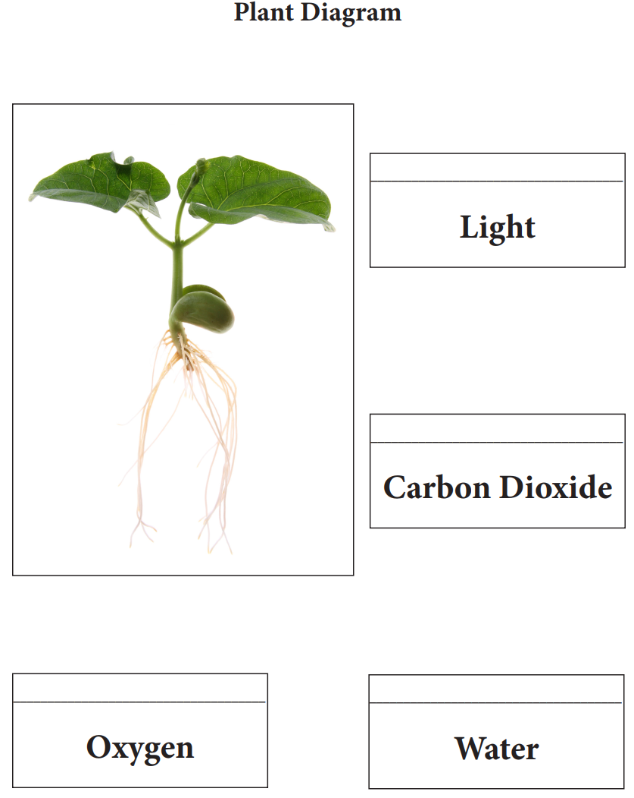

Source: https://agclassroom.org/matrix/lesson/854/

Photosynthesis in Plants
Plants perform photosynthesis to make the food and energy they need for healthy growth and development. Photosynthesis is the process by which green plants transform light energy into chemical energy. Photosynthesis takes place in the leaves of plants.
Plants need water, carbon dioxide, and light to perform photosynthesis. The roots of the plant absorb water. The water travels through the stems to the leaves. Carbon dioxide is absorbed from the atmosphere through microscopic holes in the leaf called stomata. The leaves are made up of cells. Inside these cells are structures called chloroplasts. Each chloroplast contains chlorophyll, a chemical that gives leaves their green colour.
Chlorophyll absorbs energy from light which is used to split water molecules into hydrogen and oxygen. Hydrogen is combined with carbon dioxide to form glucose, a sugar that is used as food for the plant. The glucose that is not immediately used is stored in the leaves, roots, and fruits of the plant for later use. Oxygen, a byproduct of the photosynthesis process, is released through the stomata into the atmosphere.

Source: https://agclassroom.org/matrix/lesson/854/

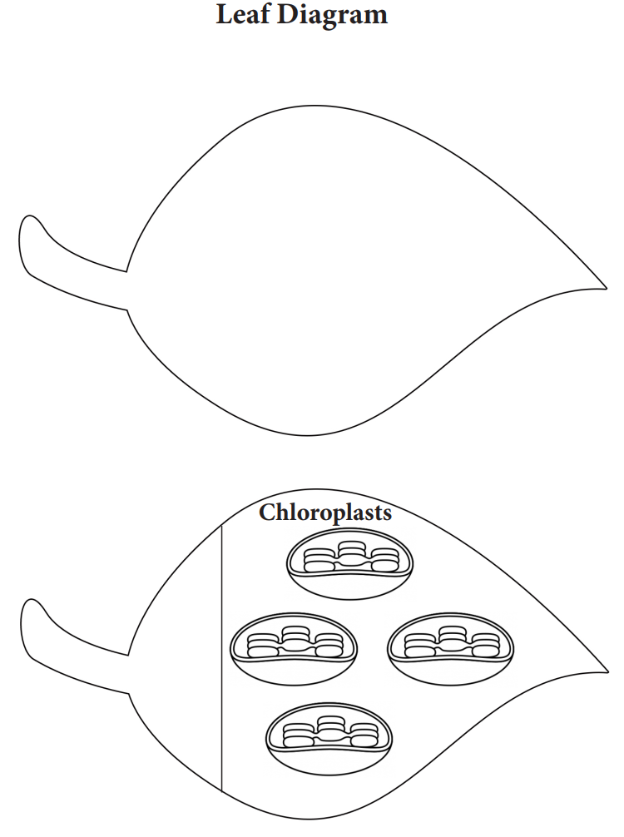

Source: https://agclassroom.org/matrix/lesson/854/

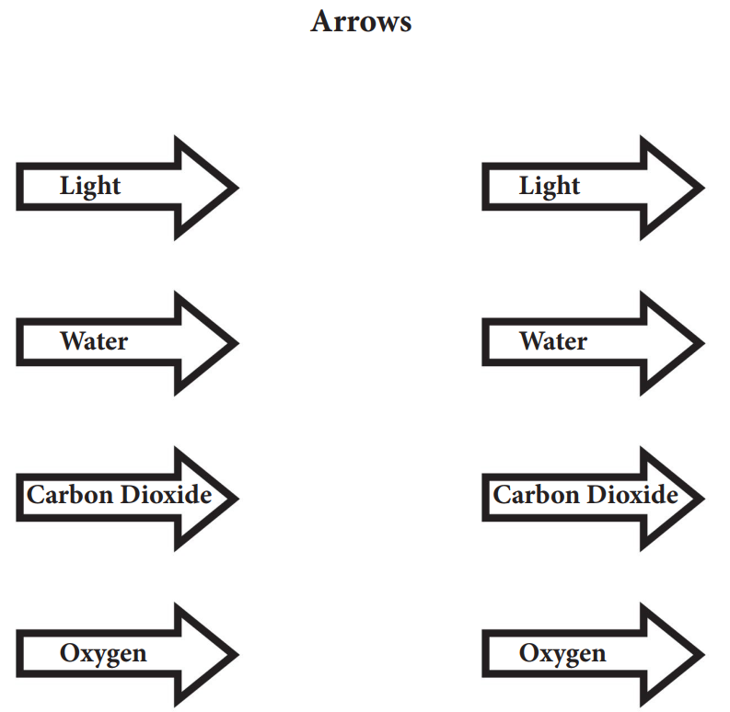
Source: https://agclassroom.org/matrix/lesson/854/

Molecular Model Cards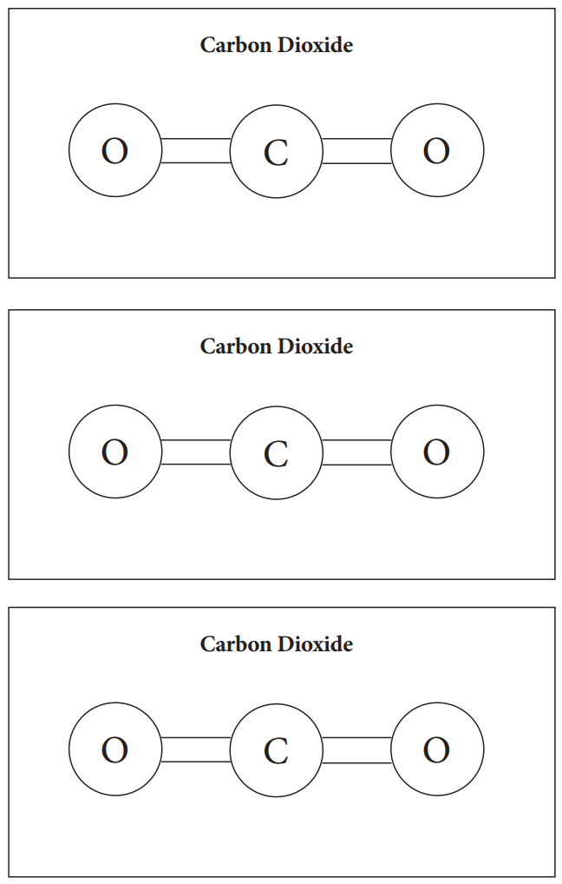
Source: https://agclassroom.org/matrix/lesson/854/
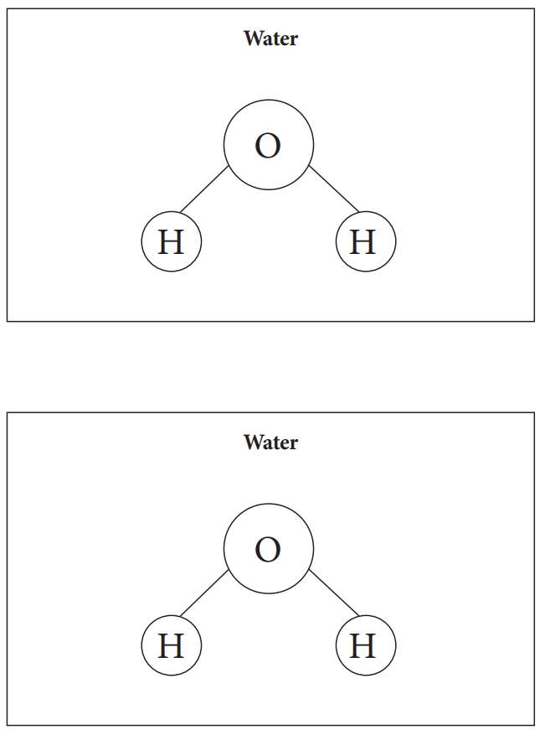
Source: https://agclassroom.org/matrix/lesson/854/

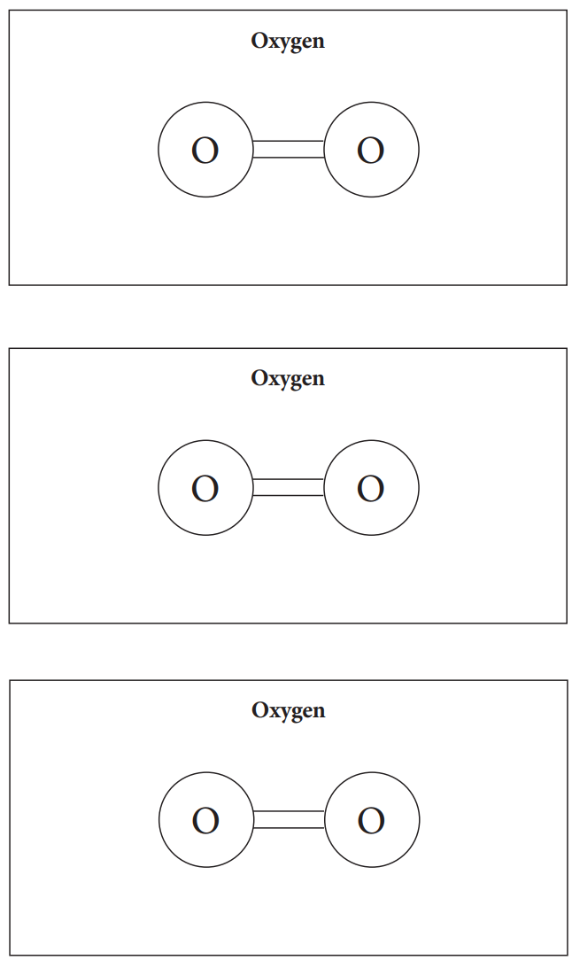
Source: https://agclassroom.org/matrix/lesson/854/
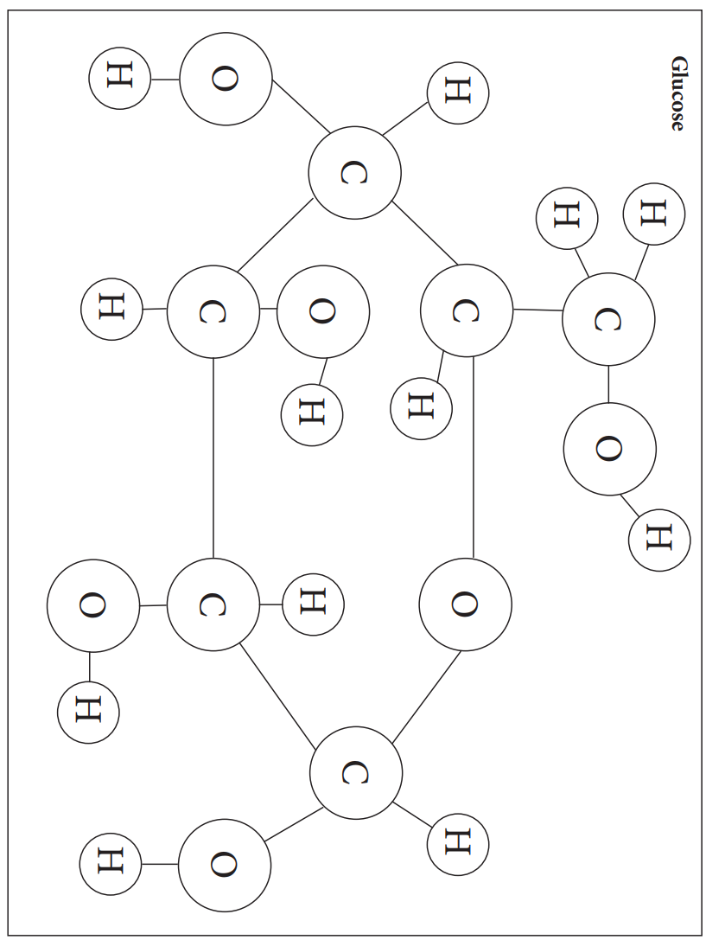
Source: https://agclassroom.org/matrix/lesson/854/

Atom Disks
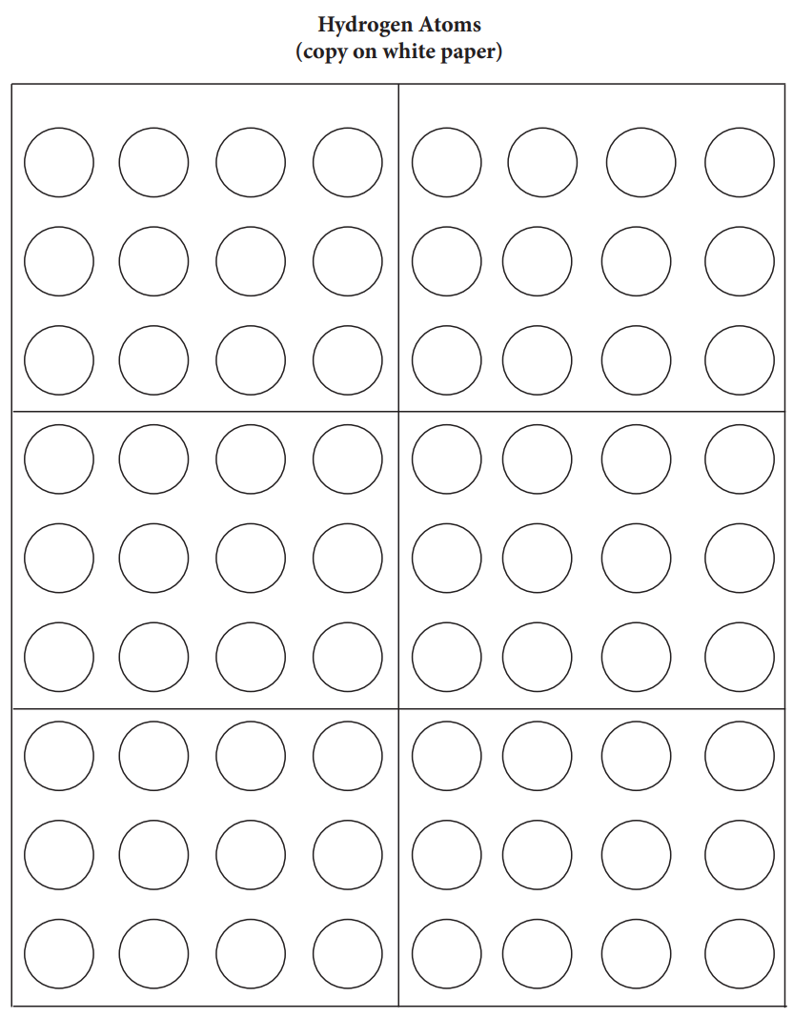
Source: https://agclassroom.org/matrix/lesson/854/

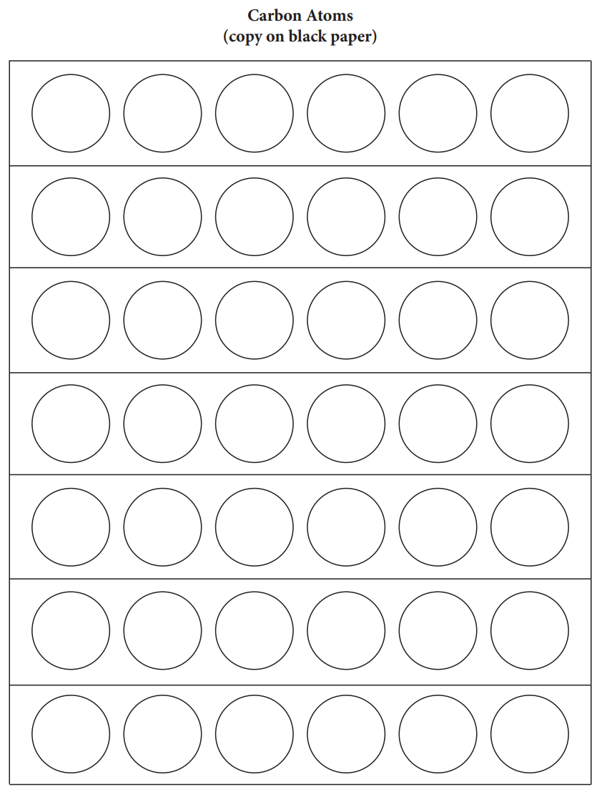
Source: https://agclassroom.org/matrix/lesson/854/

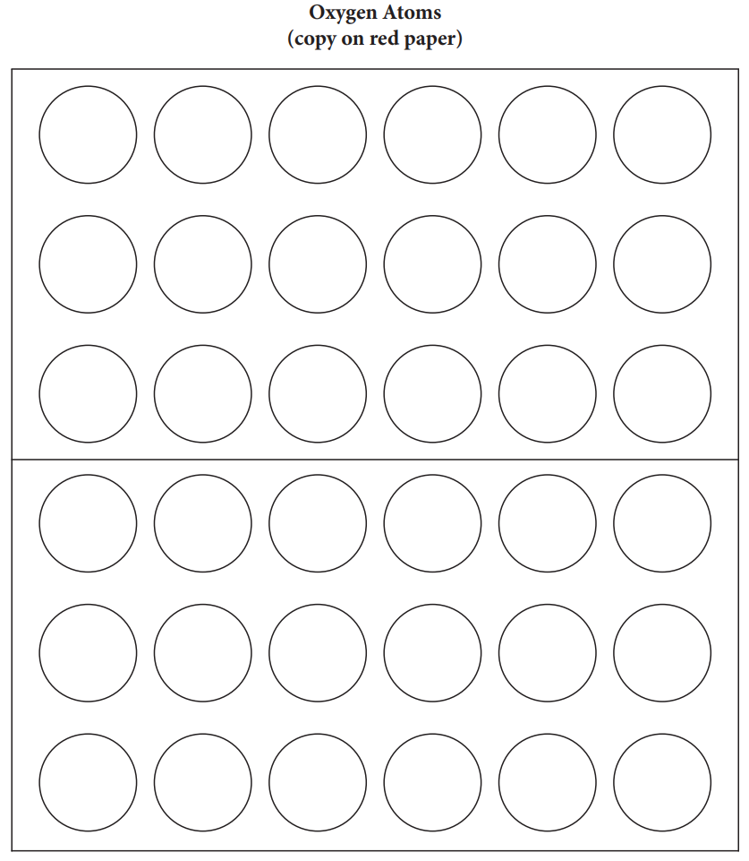
Source: https://agclassroom.org/matrix/lesson/854/

