Examine the role of micro-organisms in composting
Subject(s): Science
Grade(s): 8
Key Stage(s): 3

Learning intention(s)
- Identify the specific roles of bacteria, fungi, and actinomycetes in composting.
- Observe and understand how microbial activity drives decomposition.
- Appreciate the ecological importance of micro-organisms in nutrient cycling and sustainable waste management.
- Link the science of micro-organisms to real-world applications like gardening and agriculture.

Mapping to curriculum
Scope and sequence statement | How it is addressed in the activity
- Micro-organisms: helpful and harmful roles | - Students investigate bacteria, fungi, and actinomycetes, understanding their specific roles in breaking down organic matter during composting.
- Carbon cycle and decomposition | - Students observe microbial decomposition processes and compare decomposition rates in soils with and without microbes, linking to nutrient recycling.
- Human impact on ecosystems and the environment | - Students explore how healthy microbial populations contribute to sustainable waste management and soil health in composting systems.
- Gathering, processing and analysing data | - Students collect observational data on decomposition progress, microbial activity, and environmental conditions influencing compost quality.
- Science as human endeavour | - Students connect microbiological knowledge to practical applications in gardening and agriculture, considering how humans can support compost ecosystems.
- Interactions within food chains and food webs | - Students understand how decomposers fit into food webs by breaking down organic matter and cycling nutrients back into the ecosystem.

Lesson Instructions
Students will investigate the role of micro-organisms in composting by comparing how organic matter decomposes with and without microbial activity and learning about specific types of micro-organisms that contribute to decomposition.

Materials (per group of 3-4 students):
- 2 identical glass jars with lids (e.g., mason jars)
- Organic material (e.g., vegetable scraps, fruit peels)
- Sterile sand or potting mix (for the no-microbe environment)
- Soil (from a garden or compost pile, rich in micro-organisms)
- Gloves
- Spray bottle with water
- Measuring cups
- Sticky labels or masking tape for jar labels
- Access to a microscope (optional, for observing microbes directly)
- Compost Micro-organisms handout
- Observation sheet
- 'Inside a drop of Compost' video: https://www.youtube.com/watch?v=NLpSRQpZfAI

Steps
- Introduction (15 minutes)
  - Begin with a short discussion about micro-organisms:
    - Bacteria: The primary decomposers in composting, breaking down sugars, proteins, and starches.
    - Fungi: Responsible for breaking down tougher materials like cellulose in plant matter.
    - Actinomycetes: Specialized bacteria that decompose complex compounds like lignin, giving compost its earthy smell.
  - Show students the compost micro-organisms handout and watch 'Inside a drop of Compost' video. The following are some questions you can ask student to think about:
    - Why is it important to have a variety of micro-organisms in composting?
    - What do you think would happen to the composting process if one group of micro-organisms (e.g., fungi) were missing?
  - Explain how the following activity will test the role of these microbes in decomposition.
- Setting Up the Experiment (20 minutes):
  - Label the jars: ‘With Microbes’ and ‘Without Microbes’.
  - Fill the ‘With Microbes’ jar halfway with soil.
  - Fill the ‘Without Microbes’ jar halfway with sand.
  - Add equal amounts of organic material (e.g. ½ cup of fruit/veggie scraps) to both jars.
  - Lightly spray water into both jars to moisten the contents. (Ensure it feels damp but not soggy.)
  - Seal the jars loosely to allow air exchange while preventing contamination
- Observing Microbial Activity (Weekly, for 4 Weeks):
Each week, students will:
- Observe and record changes in the organic material (e.g., texture, size, colour) on their observation sheet.
- Note signs of microbial activity, such as fungal growth (white filaments), heat (from bacteria), or earthy smells (from actinomycetes).
- Compare differences between the jars.
- (Optional) Use a microscope to examine a small sample of soil from the “With Microbes” jar. Identify visible structures like fungal hyphae or bacterial colonies.
- Final Analysis and Discussion (30 minutes):
  - After 4 weeks, open the jars and compare the decomposition in each.
  - Discuss:
    - How did microbes in the soil impact decomposition compared to the sand?
    - What types of micro-organisms might have been active in the decomposition process?
    - How do these micro-organisms contribute to nutrient recycling and soil health?
  - Relate findings to real-world composting and the importance of maintaining healthy microbial populations. Discuss:
    - Can you think of ways to ensure that these micro-organisms thrive in a compost bin? What environmental conditions do they need?
    - Have you seen or smelled compost that has gone bad? How might a lack of certain micro-organisms contribute to this?

Extended Learning
- Role of Oxygen and Temperature: Discuss how aerobic bacteria need oxygen to break down materials and how their activity generates heat, creating optimal conditions for thermophilic bacteria.

- Microbial Food Preferences: Research which micro-organisms thrive on different types of organic material (e.g., fungi prefer woody material, while bacteria break down sugars and proteins).

- Human Benefits of Compost Microbes: Explore how these microbes improve soil structure, retain moisture, and support plant growth when compost is added to gardens.
Compost Micro-organisms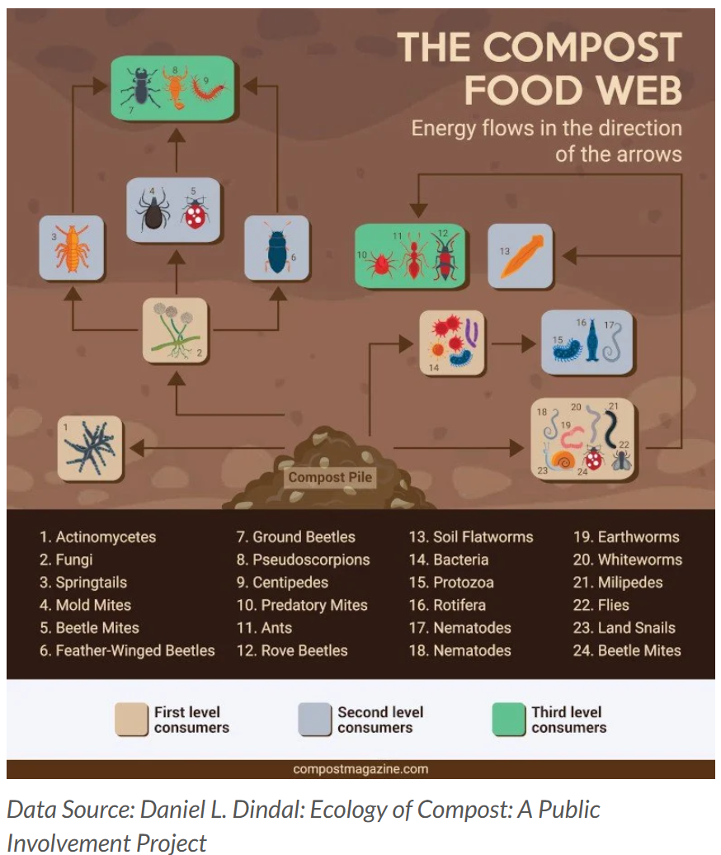
Source: https://www.compostmagazine.com/compost-science/

Observation Worksheet
Record changes: Observe and record changes in the organic material (e.g. texture, size, colour) on the observation sheet.
Note signs of microbial activity, such as fungal growth (white filaments), heat (from bacteria), or earthy smells (from actinomycetes).
Week | Jar 1: With Microbes | Jar 2: Without Microbes
1
2
3
4

