Explore the effects of microbes on soil health
Subject(s): Science
Grade(s): 8
Key Stage(s): 3

Learning intention(s)
Students will understand the concept of interdependence by exploring the relationship between plants and soil microbes. They will investigate how this relationship supports the carbon cycle, enhances soil health, and benefits human life, including food production.

Mapping to curriculum
Scope and Sequence Statement | How it is Addressed in the Activity
- Interactions within food chains and food webs | - Students explore how soil microbes, fungi, and plants depend on each other to exchange nutrients and energy, forming vital links in food webs.
- Carbon cycle and decomposition | - Students learn how microbes break down organic matter, storing carbon in soil and reducing atmospheric carbon through the 'Great Exchange'.
- Micro-organisms: helpful and harmful roles | - Students examine healthy soil teeming with microbes, learning how these microscopic organisms help plants grow and support ecosystems.
- Human impact on ecosystems and the environment | - Students consider how soil health affects food systems and the carbon cycle, and how human practices can enhance or damage these relationships.
- Gathering, processing and analysing data | - Students investigate rich and poor soil samples, recording observations, analysing differences, and drawing conclusions about microbial life.
- Science as human endeavour | - Students reflect on how understanding soil microbes is transforming agriculture, food security, and climate solutions through regenerative practices.

Key Vocabulary
- Biome: A large, naturally occurring community of flora and fauna in a major habitat.
- Decomposers: Bacteria, fungus, and invertebrates that break down organic material.
- Microbes: Microscopic organisms, including those living in the human body and in the soil.
- Interdependence: A relationship in which organisms help one another.

Lesson Instructions

Materials
- 1 old newspaper
- A bucket of plain dirt (e.g. from a dirt road or the side of a parking lot). Students to collect this if possible.
- A bucket of rich soil full of life (e.g. from a garden, organic farm, or compost pile). Students can also collect this if possible.
- Magnifying glasses
- Tweezers
- Slides 1–4 (included in this document)
- Student Handout: Gathering Information About 'The Great Exchange' (included in this document)
- The Living Soil Beneath Our Feet: https://youtu.be/MlREaT9hFCw
Suggested time: 45–60 minutes

Steps
Explore
- Put a sheet of old newspaper on each table. On top, place a handful of plain dirt and a handful of rich soil for each group of 4-6 students.
- Using magnifying glasses and tweezers, have students examine and compare the two samples.
- Each team records their observations and questions about the dirt and soil.
- After several minutes, have students share their findings.
- Discuss the idea: 'Soil is full of life.' Ask if students found any living organisms and share that some are too small to see. Mention that one teaspoon of healthy soil contains more microbes than the people on Earth!
- Explain the concept of a biome (e.g., rainforest, coral reef) and introduce the pedosphere (soil biome) beneath our feet.

Explain
- Introduce Student Handout - Gathering Information About ‘The Great Exchange’ (graphic organiser) and its focus question: How are plants and soil microbes interdependent?
- Show how to use the graphic organiser to collect information from sources (video, slides, observations, and prior knowledge).
- Watch the video The Living Soil Beneath Our Feet (https://youtu.be/MlREaT9hFCw), asking students to note how organisms help each other.
- Discuss evidence of interdependence from the video. For example, trees help fungi and bacteria, and these microbes help trees.
- Have students record their ideas on the handout. They can use pictures, notes, or words.
- Show Slide 1, explaining the ‘Great Exchange,’ where plants and soil organisms work together to stay healthy.
- Show Slide 2, explaining that fungi and bacteria help plants grow by breaking down nutrients in the soil. In return, plants share carbohydrates with the microbes.
- Highlight that fungi and bacteria store carbon from the atmosphere, which stays in the soil when they die.

Elaborate
- Show Slide 3. Have students examine their rich soil for clumps and compare it with the plain dirt. Explain that these clumps are held together by 'glues' from dead fungi and bacteria, which store carbon.
- Show Slide 4 about the carbon cycle. Discuss how 'The Great Exchange' in the soil impacts the carbon cycle. Explain that reducing carbon emissions and storing carbon in the soil are both critical.
- Discuss how 'The Great Exchange' benefits humans:
  - It helps balance the carbon cycle.
  - It makes food more nutritious because fungi and bacteria provide plants with water and nutrients.
  - Fungi extend plant root surface area, enabling plants to absorb more minerals, which benefits our food supply.

Evaluate
- Have students answer the question: What role do soil microbes have in the carbon cycle?

Student Handout - Gathering Information About ‘The Great Exchange’
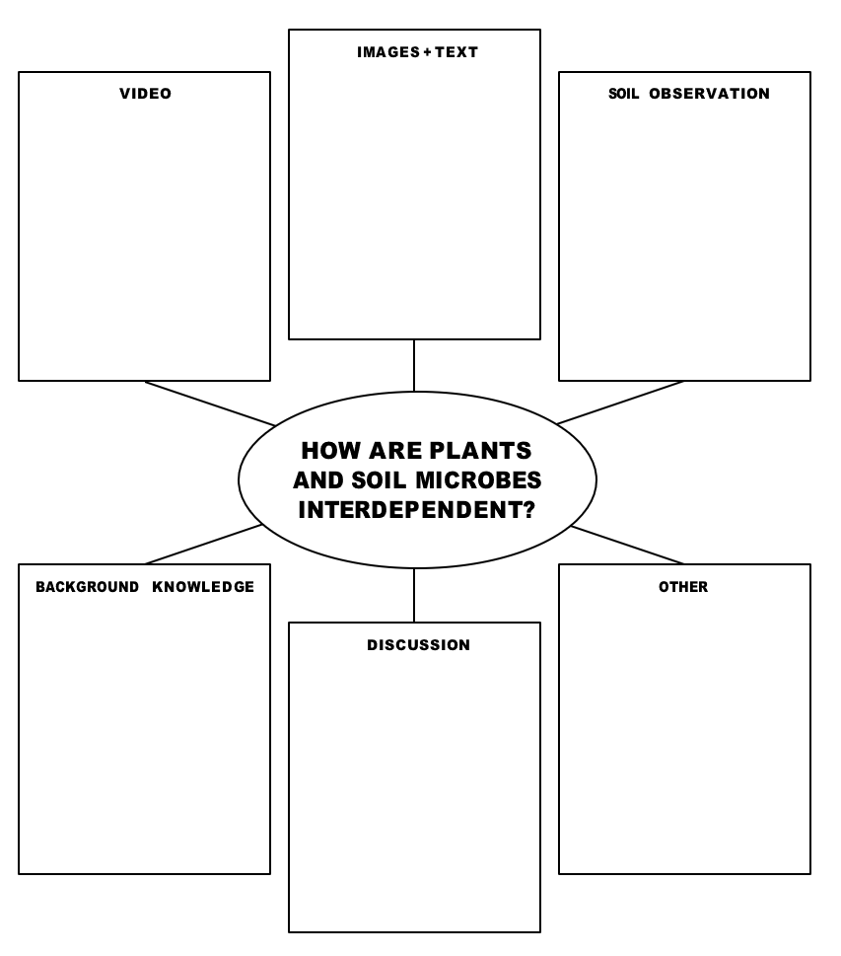

Source: https://kisstheground.com/wp-content/uploads/2020/04/Soil-Story-Curriculum_200212.pdf

Slide 1 – The Great Exchange

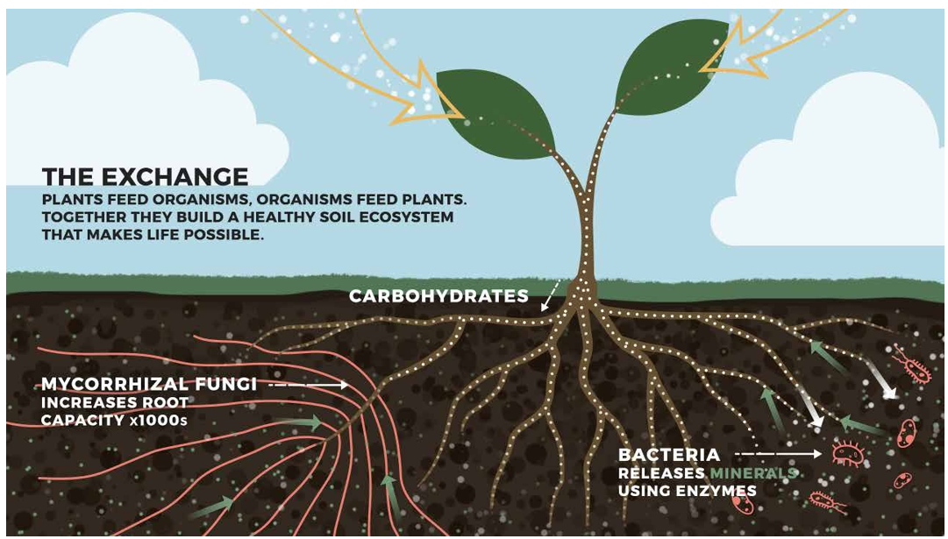
Source: https://kisstheground.com/wp-content/uploads/2020/04/Soil-Story-Curriculum_200212.pdf
Slide 2 - Plants and Microbes: A Mutual Exchange of Nutrients and Energy
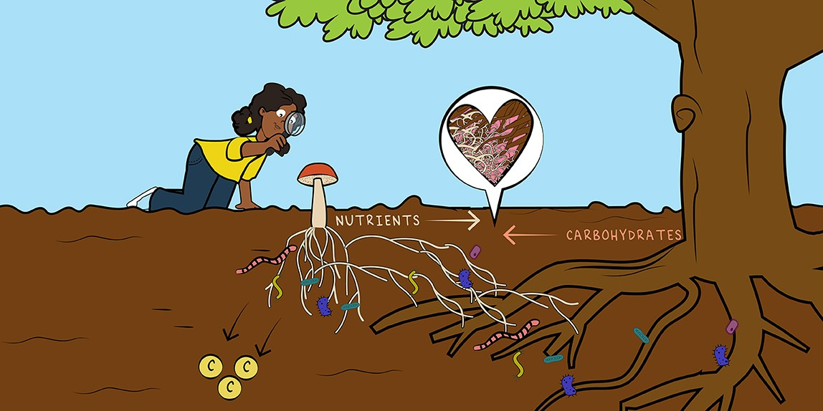
Source: https://kids.frontiersin.org/articles/10.3389/frym.2022.652660

Slide 3 – Sequestering Carbon in Soil

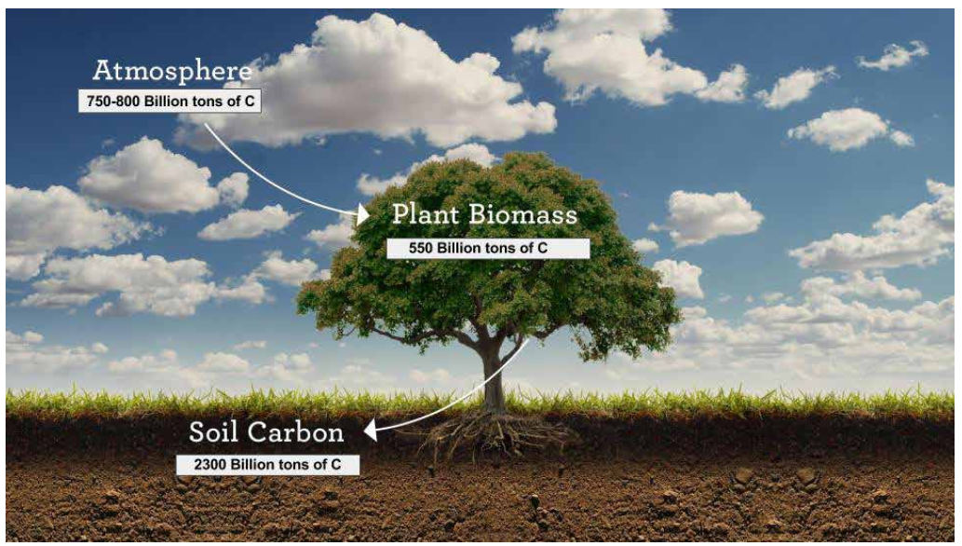
Source: https://kisstheground.com/wp-content/uploads/2020/04/Soil-Story-Curriculum_200212.pdf

Slide 4 – The Carbon Cycle
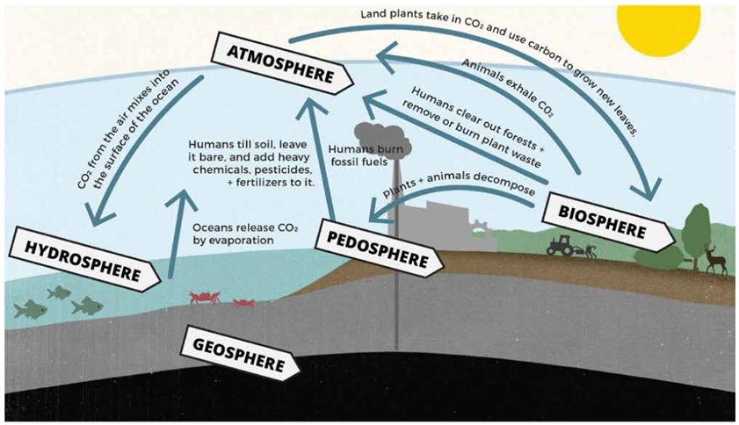
Source: https://kisstheground.com/wp-content/uploads/2020/04/Soil-Story-Curriculum_200212.pdf

