Maximise Crop Production in a School Garden

Subject(s) Basic Science, Mathematics, Basic Technology

Year 9

Learning Intention
Students will investigate, design and implement strategies to maximise crop production within a given garden plot by applying principles of sustainable agriculture, efficient resource use and innovative gardening techniques. They will develop problem-solving, critical thinking and teamwork skills while exploring real-world applications of food production and environmental sustainability.

Teaching Activity

Activity Overview
Your school has a designated garden plot, and your mission is to design and implement a system to maximise crop production within the given space. You will need to research, plan and test different strategies to improve yield while considering factors like soil health, water usage, plant selection and sustainability.

Key Considerations
- How can you optimise space to grow more crops?
- What methods can improve soil health and fertility?
- How can you ensure efficient watering and drainage?
- Which crops are best suited for the climate and soil conditions?
- What role do companion planting and crop rotation play?
- How can natural pest control methods be integrated?

Student Questioning
To guide your thinking and design process, consider these questions:
- What do plants need to grow successfully?
- How can we measure the success of our garden (e.g. yield, plant health, sustainability)?
- What innovative gardening techniques (e.g. vertical gardening, hydroponics) could help increase production?
- How do environmental factors like sunlight, temperature, and rainfall affect crop growth?
- What real-world farming practices could be adapted for a small school garden?
- How can we make the garden sustainable and environmentally friendly?
- What unexpected challenges might arise, and how can we adapt our design to overcome them?

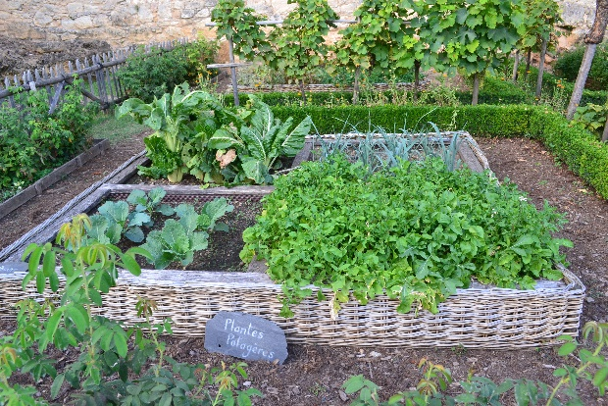
Design and Experimentation Process
Credit: CC0
- Research: Investigate gardening techniques, plant needs and soil improvement strategies.
- Plan: Sketch a layout of your garden and select appropriate crops.
- Prototype and Implement: Set up small test plots with different techniques and compare results.
- Evaluate and Improve: Measure crop yield, analyse what worked best, and refine your design.

Outcome
Present your findings in a report or presentation, showcasing your garden plan and results, and offering recommendations for improvements.

