Measure Photosynthesis with Floating Leaves

Subject(s) Basic Science

Year(s) 7–8, 9–10

Learning Intention(s)
Students will understand how plants use sunlight, water, and carbon dioxide to carry out photosynthesis and produce oxygen. By conducting a leaf floatation experiment, students will observe how oxygen is created during photosynthesis and explore the factors that influence the process.

Teaching Activity

Materials required
- Video: Photosynthetic Floatation 8m44s
- Baking soda (bicarbonate of soda)
- Water
- Dishwashing liquid
- Leaves: for example, bele (local spinach) or rourou (taro leaves); spinach or ivy
- Strong plastic straw or hole punch
- Syringe (no needles), at least 10mL
- Clear cups or beakers (plastic or glass)
- Light source (e.g. a bright lamp)
- Timer (e.g. smartphone app)
- Optional: Foil, thermometer, ice, hot water, coloured filters for lamp

Activity 1: Introducing the experiment
- Explain the concept to students:
Plants use sunlight, water, and carbon dioxide to make food and produce oxygen. You will carry out an experiment to demonstrate how oxygen made during photosynthesis can make small pieces of leaves float in water.
For more information and explanations, see:
  - Measure photosynthesis with floating leaves
  - Photosynthetic Floatation
  - The Floating Leaf Disk Assay (pdf)
- If internet is available, view the video.

Activity 2: Preparing for the experiment
Note: The instructions and photographs for this activity are adapted from ScienceBuddies, Measure photosynthesis with floating leaves
Make sodium bicarbonate solution  - Make a 0.1% bicarbonate solution by mixing 0.5 g baking soda (carb soda) with 300 mL of water in a clear glass or beaker.  Hint: 1 teaspoon of carb soda weighs 4.5g so 0.5g is about 1/8 of a teaspoon.  - Stir gently to dissolve the soda.  - Add 1 drop of dishwashing liquid and VERY GENTLY mix it in. Do not allow bubbles to form. | 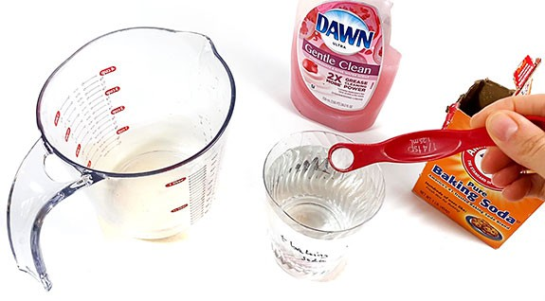
Make leaf disks  - Use a hole punch or strong straw to cut out circles from the leaves. You might find that different techniques work better on different types of leaf. | 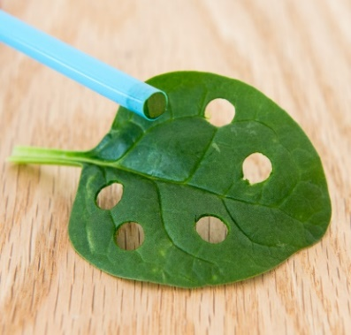
Set-up your light source
- You need a light or lamp that can shine directly on your work surface.

Activity 3: Deoxygenating the leaf circles
Prepare the syringe  - Remove the plunger from the syringe and place 10 leaf disks into the syringe.  - Place the plunger back into the syringe and push it down until only a small volume of air is left in the syringe. Be careful not to crush the leaf disks. | 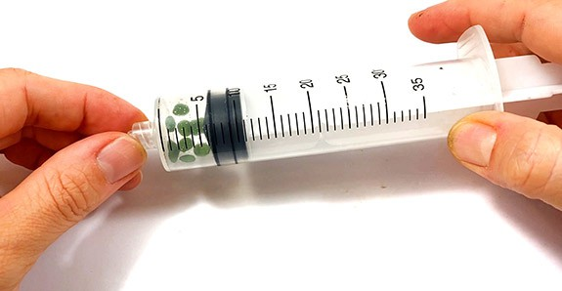
Add the solution  - Draw about 6mL of the solution into the syringe. The leaves will float.  - Carefully push all the air out of the syringe.  - Close the opening of the syringe with a finger and draw back on the plunger to create a vacuum. Hold the vacuum for 10–15 seconds and swirl the leaf disks to suspend them in the solution. | 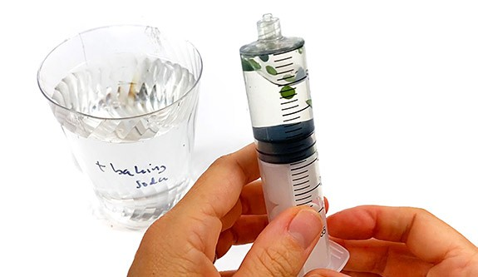
Watch the leaves sink  - Close the opening of the syringe with a finger and draw back on the plunger to create a vacuum. Hold the vacuum for 10–15 seconds and swirl the leaf disks to suspend them in the solution.  - Release the plunger and remove your finger from the syringe opening to release the vacuum. Observe the leaf disks.  - Repeat steps 10–12 until all the leaves have sunk. | 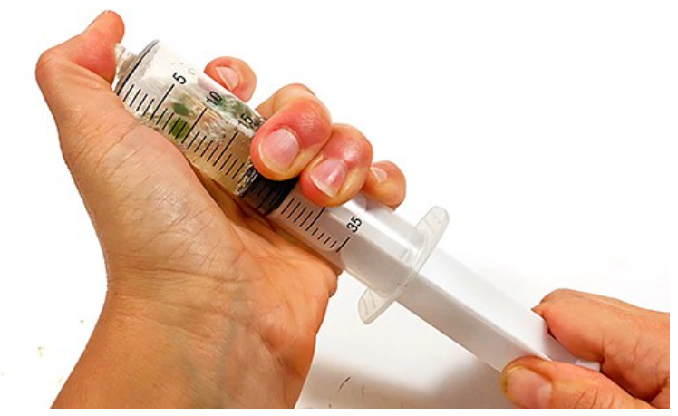
- Empty the syringe into a clear glass and pour in the soda solution, to a depth of about 3mm. Cover the | 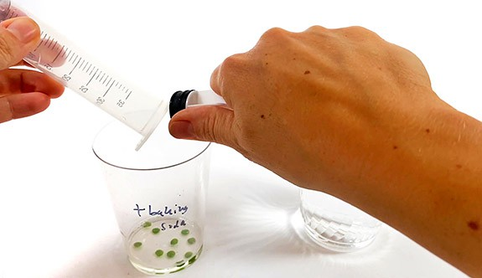

Optional Activity: Repeat Activity 3 using water with just 1 drop the dishwashing liquid.
If you are carrying out the optional activity, cover your first glass with aluminium foil so it is not exposed to light until the second glass is ready.
Other variations: use warm water; use a different concentration of carb soda; use different types of leaf; use different colour light by placing coloured plastic between the glasses and the light. (Note: make sure you are using an LED light source that will not get hot and damage the plastic.)

Activity 4: Causing photosynthesis and recording the results
- Place the glass(es) under the light, with the light source about 30cm above.  - Turn on the light and start a timer.  - Watch for bubbles forming on the leaf disks. Over time, the disks will float to the top as oxygen is produced.  - Observe and record how many leaves are floating at the end of each minute interval.  - When all the leaves are floating, the experiment is finished.  - OPTIONAL: Put the glass in a dark cupboard and check every 5 minutes to see how long until the leaves sink.  - When the experiment is complete, dispose of the solutions in the sink. The leaves can be added to the compost or rubbish. | 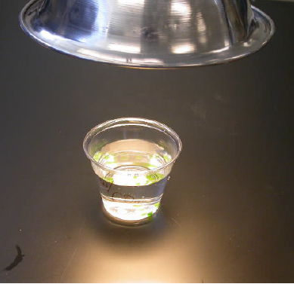

Optional Activity: Graphing the results
Students chart their results by creating graphs showing the results. If multiple variations were used, the graph can allow for comparison between the variations.

Activity 5: Explanations and discussion
- Photosynthesis: Plants use sunlight to make food and release oxygen. The oxygen collects on the leaf disks, making them float.
- Respiration: Plants also use oxygen to produce energy, even in the dark, which causes the disks to sink when no more oxygen is produced.
Lead a class discussion and reflection, covering the following points:
This experiment shows how fast the leaves produce oxygen, which tells us how fast photosynthesis is happening.
At first, the leaf pieces floated because leaves naturally have tiny air pockets to help them exchange gases. When you created a vacuum in the syringe, the air was removed, and the spaces filled with the solution. This made the leaves sink.
When you put the cup with the leaf pieces under the light, photosynthesis began. The chloroplasts in the leaves used the light to create oxygen. Tiny bubbles of oxygen formed on or inside the leaves. These bubbles showed that photosynthesis was happening.
The oxygen bubbles made the leaves lighter, so they started to float. The more bubbles there were, the higher the leaves floated—like how a diver floats when they add air to their vest.
If you used baking soda in the solution, the first leaves should have floated in just a few minutes. Baking soda provides carbon dioxide, which is necessary for photosynthesis. Without baking soda, no leaves would float because photosynthesis can’t happen without carbon dioxide.
How fast the leaves floated depended on different factors. If you tried variations (like more light, higher temperature, or more baking soda), you likely saw photosynthesis happen faster. Leaves with more chlorophyll (the green pigment) also photosynthesise better than others.

