Exploring the Role of Soil Microbes in the Carbon Cycle

Subject(s) Basic Science

Year(s) 9

Learning Intention(s)
Students will understand the concept of interdependence by exploring the relationship between plants and soil microbes. They will investigate how this relationship supports the carbon cycle, enhances soil health, and benefits human life, including food production.

Supporting Information

Time Estimate
Allow 45 minutes to 1 hour.

Key Vocabulary
- Biome: A large, naturally occurring community of flora and fauna in a major habitat.
- Decomposers: Bacteria, fungi and invertebrates that break down organic material.
- Microbes: Microscopic organisms, including those living in the human body and in the soil.
- Interdependence: A relationship in which organisms help one another.

Materials Required
- Newspaper for protecting tabletops
- A bucket of plain dirt (e.g. from near a road or carpark) – students to collect if practical
- A bucket of enriched soil (e.g. from a garden, farm or compost pile) – students to collect if practical Magnifying glasses
- Tweezers – 1 set per student group
- PowerPoint presentation: Copy Slides 1–4 from this document into a presentation
- Handout – ‘Gathering Information about the Great Exchange’ – 1 per student
- Video: The Living Soil Beneath Our Feet (2m49s) https://youtu.be/MlREaT9hFCw

Instructions

Engage: Class discussion on the importance of interdependence
- Ask students to write a brief response to this question:
  - Describe a relationship where you and another person help each other (e.g. family member, friend, teammate).
  - How do you help them?
  - How do they help you?
- Ask students to share their examples in small groups or with the class. Use these examples to explain ‘interdependence,’ which means two or more organisms rely on each other.
- Explain that the activity will explore the interdependence between plants and soil organisms and why that is important to the carbon cycle.

Explore: Examining soil samples
- Students work in table groups of 4 to 6. Each group needs a magnifying glass and set of tweezers.
- Put a sheet of old newspaper on each table. On top, place a handful of plain dirt and a handful of enriched rich soil.
- Using magnifying glasses and tweezers, students examine and compare the two samples.
- In their workbooks or on butchers paper, each team records their observations and questions about the dirt and soil.
- After students have recorded their findings, each table groups shares their information with the class.
  - Elicit information about whether students found living organisms in their samples.
  - Also ask students to compare how the plain and enriched soil samples hold together. Explain:
Clumps are held together by ‘glues’ from dead fungi and bacteria, which store carbon.
- Class discussion and reflection, covering the following points:
  - Soil is full of life.
  - One teaspoon of healthy soil contains more microbes than the people on Earth.
  - Many living organisms are too small to see.

Expand: Class discussion on soil richness and biomes
Explain the concept of a biome (e.g. rainforest, coral reef) and introduce the pedosphere (soil biome) beneath our feet.

Explain: The Great Exchange
- Introduce ‘Gathering Information about the Great Exchange’ graphic organiser handout and its focus question: ‘How are plants and soil microbes interdependent?’
- Show how to use the graphic organiser to collect information from sources (e.g. video, slides, observations, prior knowledge).
- Watch the video The Living Soil Beneath Our Feet (2m49s) (https://youtu.be/MlREaT9hFCw) , asking students to note how organisms help each other.
- Discuss evidence of interdependence from the video. For example:
Trees help fungi and bacteria, and these microbes help trees.
- Ask students to record their ideas on the handout, using pictures, notes and words.
- Show Slide 1: The Great Exchange, explaining the Great Exchange:
Plants and soil organisms work together to stay healthy.
- Show Slide 2: Plants and Microbes– A Mutual Exchange of Nutrients and Energy explaining:
Fungi and bacteria help plants grow by breaking down nutrients in the soil. In return, plants share carbohydrates with the microbes.
Fungi and bacteria store carbon from the atmosphere, which stays in the soil when they die.

Elaborate: Comparing plain and enriched soils
- Show Slide 3: Sequestering Carbon in Soil, reminding students that clumps they may have found in the enriched soil are examples of sequestered, created by ‘glues’ from dead fungi and bacteria, which store carbon.
- Show Slide 4: The Carbon Cycle. Discuss how the Great Exchange in the soil affects the carbon cycle. Explain that reducing carbon emissions and storing carbon in the soil are both critical actions for reducing global warming.
- Discuss how the Great Exchange benefits humans:
  - It helps balance the carbon cycle.
  - It makes food more nutritious because fungi and bacteria provide plants with water and nutrients.
  - Fungi extend plant root surface area, enabling plants to absorb more minerals, which benefits our food supply.

Evaluate: Class discussion on the role of microbes in the carbon cycle
Ask students to reflect on and discuss the following question:
What role do soil microbes in the carbon cycle?

Gathering Information about the Great Exchange

Team members: __________________________________________________
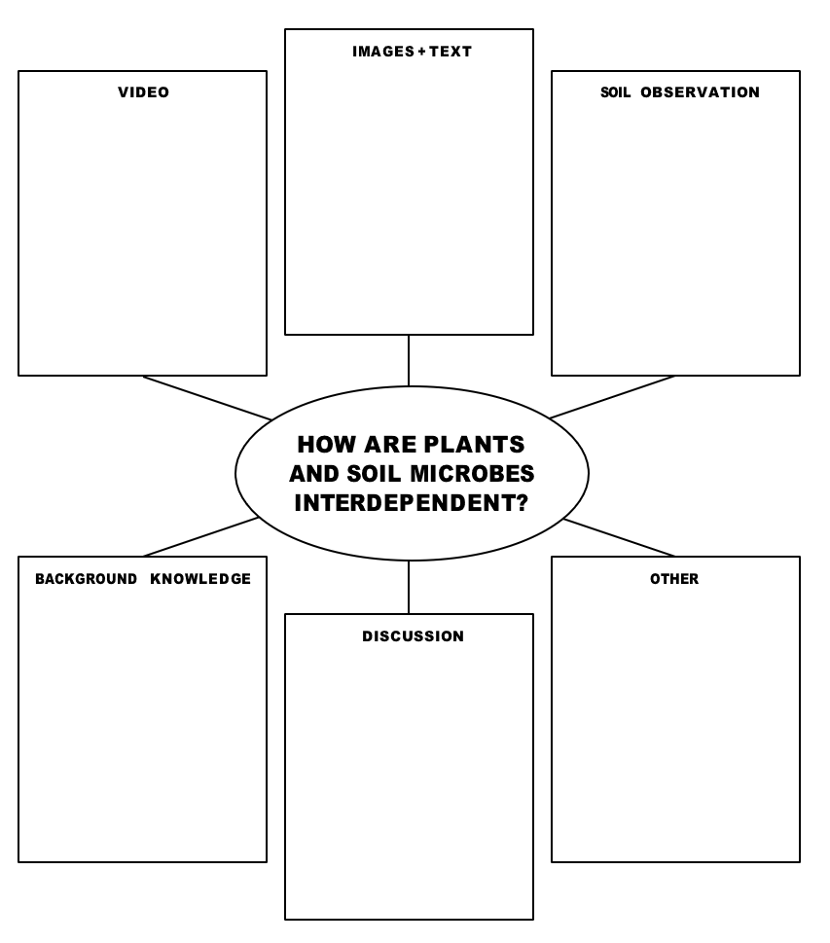

Slide 1: The Great Exchange
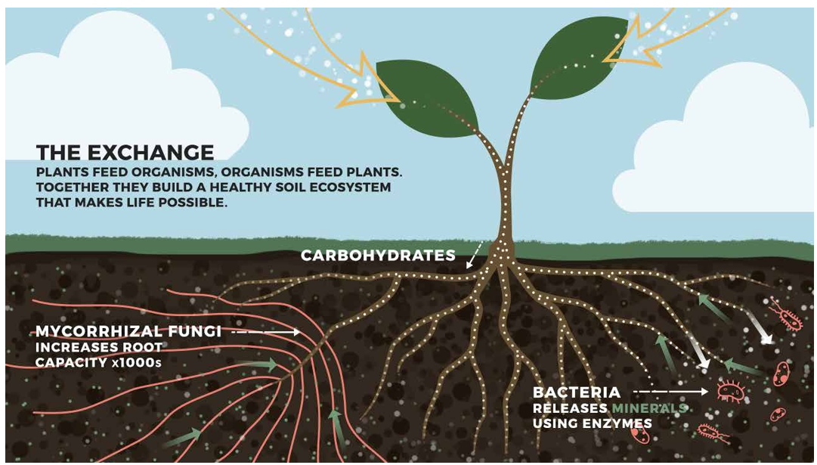
Source: https://kisstheground.com/wp-content/uploads/2020/04/Soil-Story-Curriculum_200212.pdf

Slide 2: Plants and Microbes– A Mutual Exchange of Nutrients and Energy
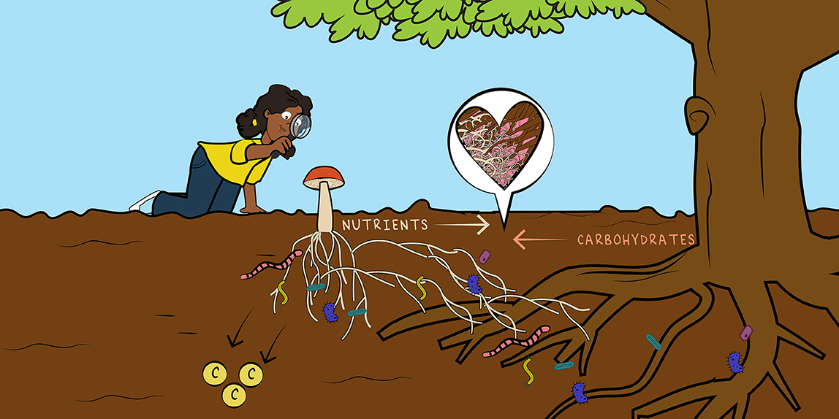
Source: https://kids.frontiersin.org/articles/10.3389/frym.2022.652660

Slide 3: Sequestering Carbon in Soil
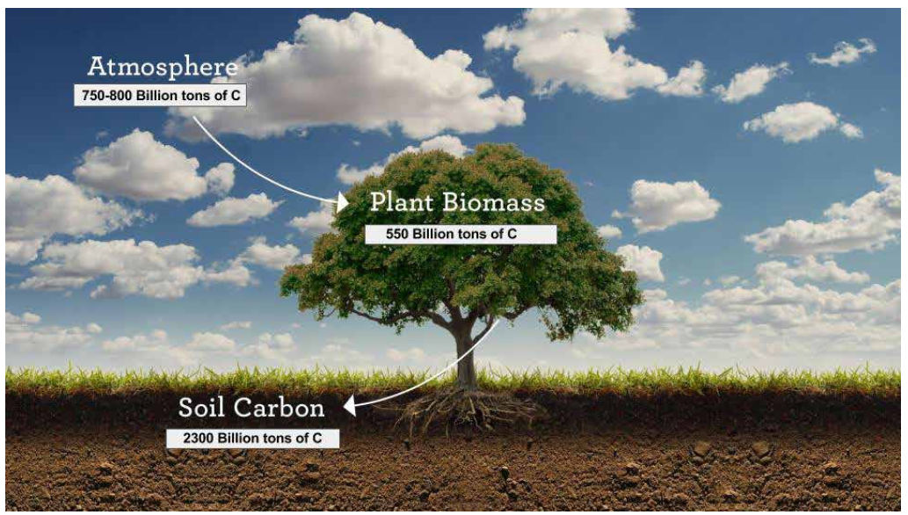
Source: https://kisstheground.com/wp-content/uploads/2020/04/Soil-Story-Curriculum_200212.pdf

Slide 4: The Carbon Cycle
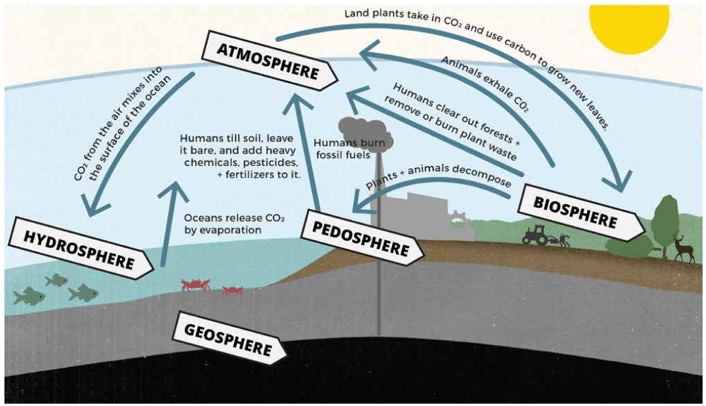
Source: https://kisstheground.com/wp-content/uploads/2020/04/Soil-Story-Curriculum_200212.pdf

