Write an acrostic poem: Food
Subject(s): English – Language and Communication
Year(s): 1–2

Learning intention(s):
Students write an acrostic poem influenced by the garden.

Mapping to curriculum:

FALD
- Languages, Literacy and Communication

Strand
- Creating and Composing Texts - Writing

Strand Outcome
- Compose texts to inform and entertain a familiar audience.

Learning outcome(s):
Literacy/English
- Blend and segment sounds in words and recognise that a syllable must contain a vowel
- Identify syllables and the sounds made by common letter patterns in words.
- Read and write words with short vowels, long vowels, consonant digraphs and consonant blends

Lesson Instructions
An acrostic poem is a type of poetry where the first, last or other letters in a line spell out a particular word or phrase. The most common and simple form of an acrostic poem is where the first letters of each line spell out the word or phrase.
- Pick a topic: Have students choose a one-word topic for their poem and write it vertically down the page. Take students to the garden to think of ideas for their vertical word.
- Write lines: For each letter of the vertical word, students write a word or short sentence starting with that letter. It should relate to the topic or describe it.

Example of an acrostic poem for FOOD
Fruit  Orange  Onion  Dates | 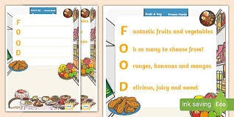
Other examples: FRUIT, SEEDS, PLANTS, FARM, GARDEN (and lots more).

Extension activity
For a harder activity, encourage students to think of words or sentences that fit a theme. For example, if the word is “compost,” they can write about what can and can’t go in the compost. Students can turn their acrostic poem into a poster and display it as a reminder of what belongs in the compost.
This is a fun writing activity and a good way to introduce poetry to students. It helps students learn about the kitchen, garden, or any other topic you choose.

