Understand the three main food groups
Subject(s): Home Economics
Grade(s): 9

Learning intention(s):
Students acquire an understanding of the main Food Groups, Food Guidelines and the relationships between food and healthy living.

Mapping to curriculum:

Strand
- Home Economics: Food and Nutrition

Learning outcome(s):
Home Economics
- Gain understanding of Food Guidelines and classifications
- Recognise main food sources and supplies
- Appreciate the importance of nutrients in food

Lesson Instructions
- Before the class, the teacher prepares a diagram/tale showing the three main food groups
(available on the second-last page of this activity document).
- Start a class discussion about the three main Food Groups:
  - what are the main groups?
  - what are some common foods found in each group?
  - how does each food group contribute to a healthy diet?
  - why is it important to maintain a healthy diet and/or lifestyle?
- Ask students to draw in their exercise books a circle and divide it into three sections as follows OR provide the circle handout (available on the last page of this activity document).
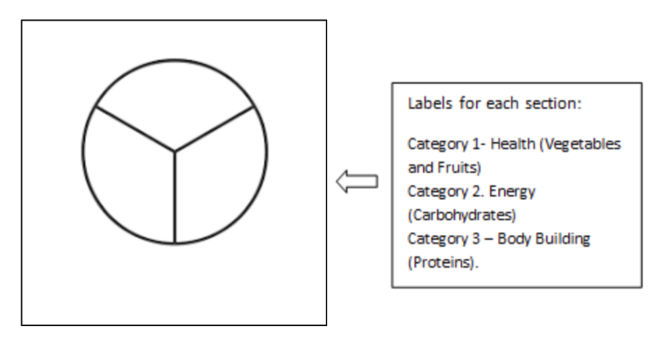
- In each section, students list different foods. Use a different colour pen/pencil to show the food they eat the most (tick or colour) and with another colour show the food they eat the least (tick or colour).
- Write 2 short paragraphs in your exercise book about any proposed change(s) you want to make to your diet and the reasons for wanting to make such a change.

Extension
- The teacher facilitates a class discussion about the types of foods that students commonly eat at home.
- Students are asked to draw a table or circle in their books, divide it into three sections and to label each section as follows:
  - Category 1 – Health (Vegetables and Fruits)
  - Category 2 – Energy (Carbohydrates)
  - Category 3 – Body Building (Proteins).
- Ask students to list as many foods as possible under each category. The teacher records the responses on the board.
- From the responses, the teacher facilitates a class discussion using the following prompts:
  - What are some common patterns of eating among the students’ families
  - What are some reasons that some foods are more commonly eaten than others?
  - If the student had a chance to change some of the eating patterns at home, how would they do this?
  - What would the change look like and how can it affect the family’s health and wellbeing?

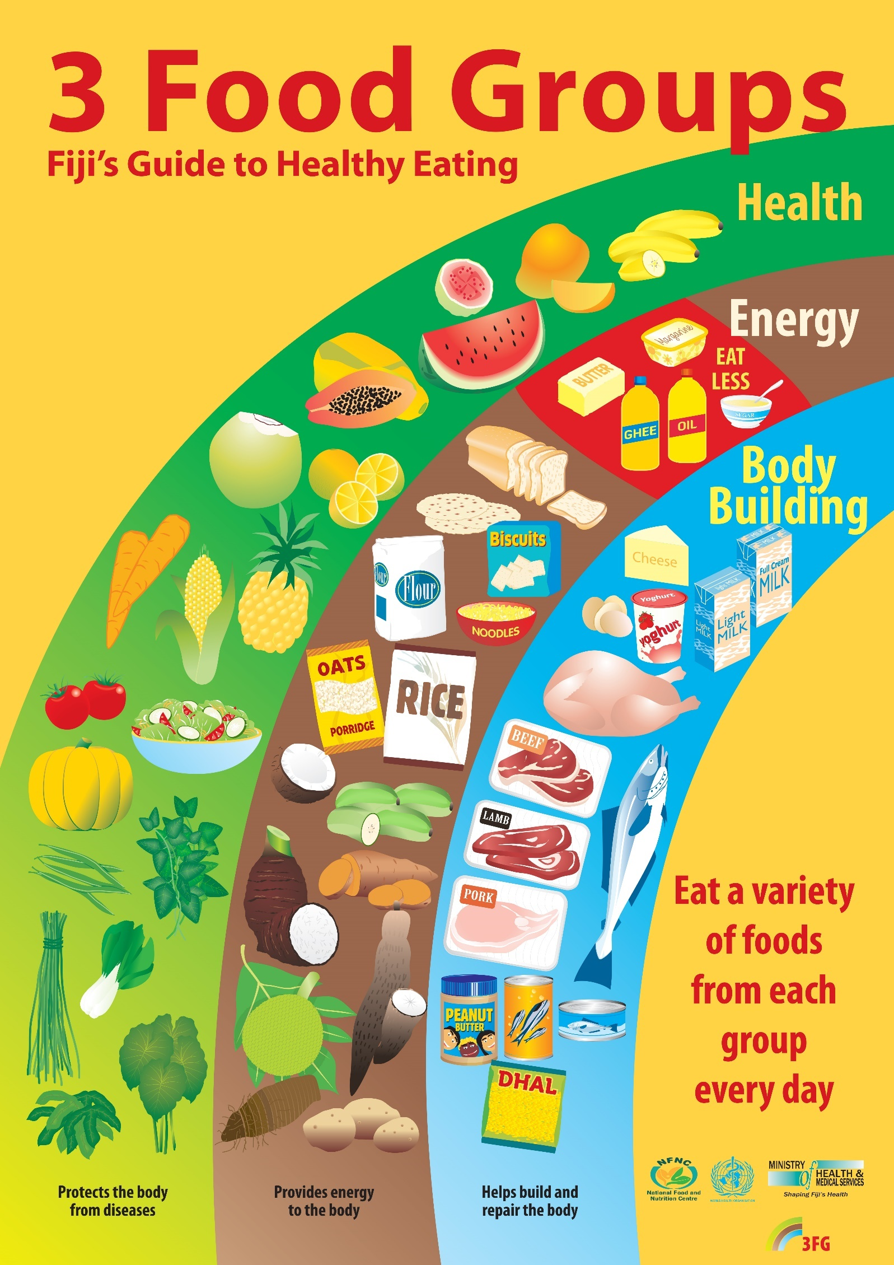

The 3 Food Groups

Name: ________________________

Body Building

Energy

Health

