Use data to plan a garden
Subject(s): Mathematics
Grade(s): 1–2

Learning intention(s):
Students answer yes or no questions to gather and use data to help inform planning decisions for their garden beds.

Mapping to curriculum:

FALD
- Learning to know

Strand
- Early Mathematics (Chance and Data)

Strand Outcome
- Use mathematical concepts and begin to use mathematical language.

Learning outcome(s):
Numeracy/Mathematics
Grade 1:
- Ask and answer simple questions to collect data (Model how to ask a question relating to simple data e.g., how many, how much, how often)
- Practice asking questions and recording tally marks to show numbers
Grade 2:
- Collect data based on practical situations, represent data on a picture graph and interpret the data.

Lesson Instructions
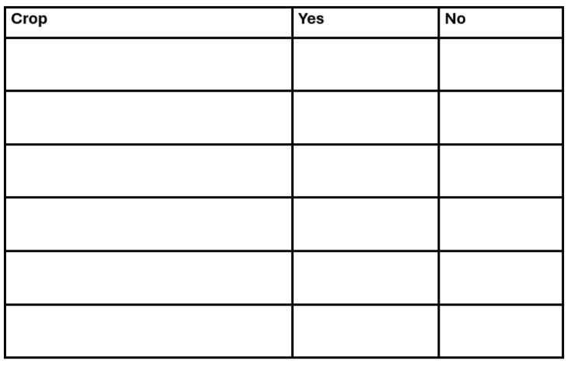
This activity is a useful way to introduce students to statistics, including how to gather data and interpret that data to help inform decision making.
- Set up a chart with three columns
You will use this chart to plan what to plant for the next season.
Add headings to the columns:
- Crop
- Yes
- No
- Brainstorm different crops
In the first column, write down all the crops you could plant, based on your climate and the season.
- Vote on crops
Ask the class if they want to plant each crop. Students vote by raising their hands for Yes or No.
Write the number of Yes and No votes in the second and third columns.
- Count the votes
See how many Yes and No votes each crop gets. Then calculate which crops have the most Yes votes.
- Choose the top crops to plant
Pick the five most popular crops based on the votes. Use this information to decide what to plant.

