Construct a pot pyramid for the garden
Subject(s): Mathematics
Grade(s): 4

Learning intention(s):
Students make a 3D model of a structure for the garden

Mapping to curriculum:

Strand
- Geometry: Shapes

Strand Outcome
- Use mathematical information to analyse and explain spatial characteristics of objects, locations and movements.

Learning outcome(s):
Mathematics
- Recognise, draw, investigate, and compare the properties of two dimensional (2D) and three dimensional (3D) shapes and recognisethese in the environment.
Visual Art
- Create 3D objects from a variety of available materials.

Lesson Instructions
- Students are tasked with designing a new structure for the school’s garden. Their design must include a 3D model. Examples include a dome-shaped greenhouse, a cone-shaped plant trellis, a cube-shaped compost bin, or a spherical garden sculpture. Encourage students to use their knowledge of shapes.
- Students sketch their chosen structure in their workbooks.
- Along with the sketch, students write a short paragraph highlighting the key feature of their design (e.g., dome, cone, cube).
- Using modelling clay or other available materials, students build a 3D version of their structure.
- Display the finished models safely in the classroom for everyone to see.
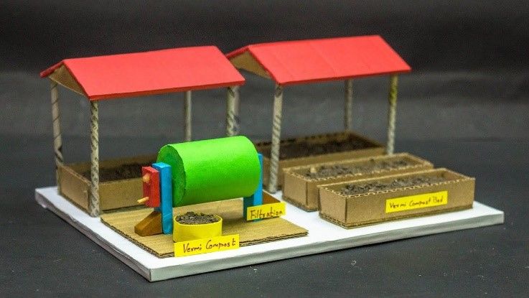
Source: https://www.youtube.com/watch?v=t-Giuapyncc
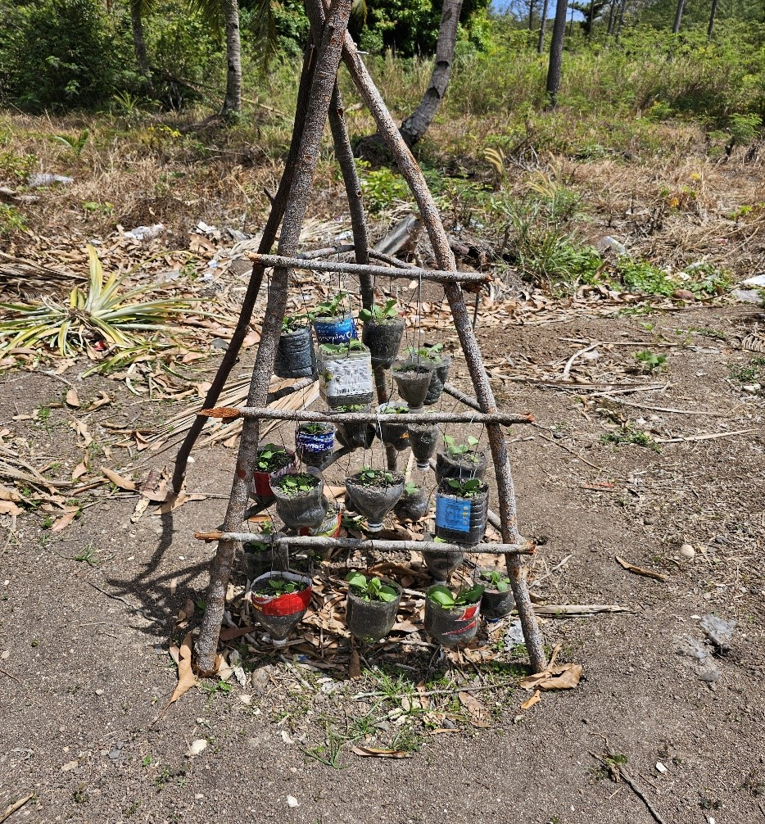
Photo: Rhonda Dibiase

