Measure the perimeter of garden beds
Subject(s): Mathematics
Grade(s): 5–6

Learning intention(s):
Students choose a relevant measuring device to calculate the perimeter of a garden bed.

Mapping to curriculum:

Strand
- Measurement

Strand Outcome
- Use direct and indirect measurements and estimation skills to describe, compare, evaluate, plan and construct.

Learning outcome(s):
Mathematics
- Identify and show the relationship in the units used to measure lengths and distances
- Demonstrate and relate appropriate standard units to measure perimeter and area of regular and irregular shapes
- Demonstrate and estimate the relationship of units in measuring lengths, distance perimeter and the area using metric units for 2D shapes.
- Recognise and use the vocabulary related to perimeter. Calculate the perimeter and solve problems involving perimeter of simple shapes.
- Use the vocabulary related to area. Measure and calculate the area of compound shapes. Explore the relationship between the area of rectangles and squares. Apply and use the appropriate formula to calculate area. Investigate and solve problems involving perimeter and area.

Lesson Instructions
- Discuss with the class why knowing the perimeter of garden beds is important. For example:
  - planning garden space
  - knowing how many plants can fit.
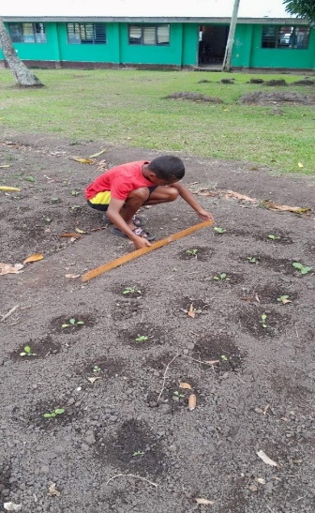
- Students will visit a square or rectangular garden bed, and choose the most appropriate measuring tool (e.g. measuring tape, ruler, string) and unit (centimetres or metres) to measure the garden’s perimeter.
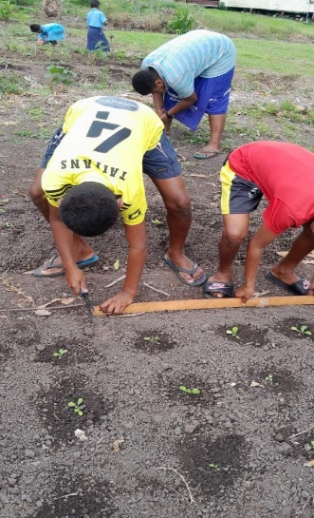
- In groups of three, have students estimate the perimeter of the garden bed:
  - Student 1 measures the length and width
  - Student 2 checks the measurement
  - Student 3 writes down the measurements.
Students then work together to calculate the perimeter of the garden bed.

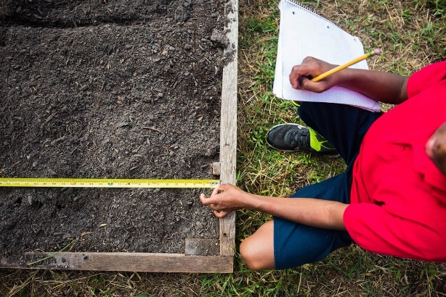
- In their group of three, students measure a second garden bed:
  - Estimate whether the perimeter is larger or smaller than the first
  - Swap roles to measure, check and write down the measurements.
Students then work together to calculate the perimeter of the garden bed.

Source: https://getthekidsoutside.com/square-foot-gardening-for-kids/

Extension activity
Calculate the area of the garden beds by multiplying length and width, and discuss why knowing the area is useful, like determining how much soil or mulch is needed.

