Observe water transport in plants
Subject(s): Science, Social Science, Mathematics
Grade(s): 1–2

Learning intention(s):
Students will understand how water moves through a plant by observing how dye-stained water travels up the plant stem and causes the leaves to change colour.

Mapping to curriculum:

Strand
- Science – Living Together
- Social Science – Relationships
- Mathematics – Early Mathematics

Learning outcome(s):
- Identify different resources used at home, school, and community
- Practise simple habits of reuse, refuse, reduce, and recycle (4 Rs)
- Collect data from familiar situations, such as foods using tally and tables

Lesson Instructions

Materials required
- Leaves
- Scissors
- Clear cups
- Water
- Red food colouring
- Observation sheet

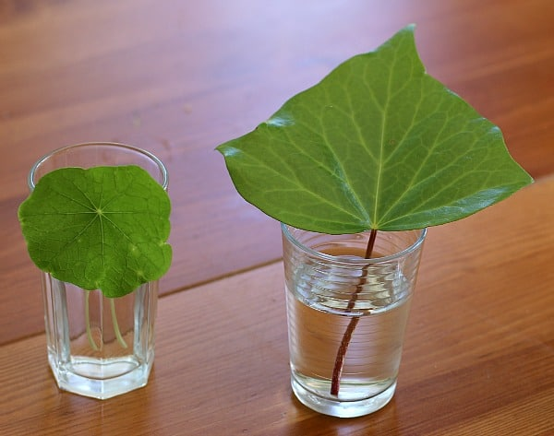
Steps
Source: https://growinghealthykids.co.uk/how-to-make-compost-in-a-bottle/
- Go outside and collect a variety of leaves.
- Cut the bottom of each leaf stem and place the leaves in a clear cup filled one-third with water.
- Add red food colouring to the water. Make the water a dark red to make it easier to see any changes in the leaves.
- Look closely at the leaves and write down what you see on Day 1.
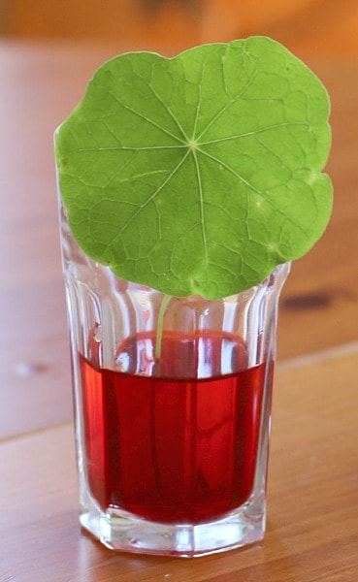
- Keep observing the leaves for the next two days. Record your observations each day on your observation sheet.
Source: https://buggyandbuddy.com/wp-content/uploads/2014/03/round-in-red.jpg

What You Should Notice
You are likely see the red colour slowly move up through the leaf. This happens because the coloured water is traveling through the leaf’s xylem tubes, which transport water and minerals throughout the plant.
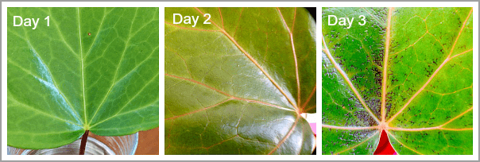
Source: https://buggyandbuddy.com/wp-content/uploads/2014/03/3-close.png

Extension Activity
Make leaf prints or rubbings to compare shapes and patterns: https://www.youtube.com/watch?v=ZendMjhVoMI
Water Transport in Plants
Observation Sheet
Name:
Day 1
Day 2
Day 3

