Give and follow planting instructions
Subject: English
Year(s): 1–2

Learning intention:
Students use seed planting to understand how to give and follow directions.

Links to curriculum

Strand
- Listening and Speaking
- Reading
Sub strands
- 1.3 Language for learning and presenting ideas
- 1.5 Reading to find out facts
- 2.2 Language for talking with others

Learning outcome(s)
- 1.3.3 Participate with growing confidence in class oral activities
- 1.5.1 Recognise short factual/information texts, particularly simple recounts and descriptions
- 2.2.1 Listen and respond appropriately to others for a variety of purposes within the school

Lesson Instructions

Materials/Resources
- Seed packets (enough to share between 2 students, ie, 10 packets if there are 20 students)
- Alternatively, the teacher sources information on packets of seeds from the internet or other texts and makes copies of four or five seed packet instructions to distribute to the students.

Key Vocabulary
Seed: unit of reproduction of a flowering plant or fruit that can develop into another plant
Gloves: a hand covering to protect against dirt or harmful materials
Trowel: a small hand-held tool used to apply or spread soil over an area.

Activity 1: Description
Divide the class into pairs and give each pair a packet of seeds.
- Student 1 reads the seed packet to understand how many seeds to plant, how far apart, and what tools are needed (gloves, trowels, measuring tools, etc.)
- Student 1 gives the planting instructions, and Student 2 follows them.
- At the end of the task, students answer the following questions:
For Student 1 (the one giving instructions):
- Did you find it easy to explain the instructions?
- What part of the instructions did you think was the most important?
- How did you decide which tools were needed?
- If you had to explain the task again, would you change anything?
For Student 2 (the one following instructions):
- Were the instructions easy to follow?
- Was there any part of the instructions that wasn’t clear?
- Did you feel like you had everything you needed to complete the task?
- If you were giving the instructions, would you explain anything differently?

Activity 2: Description
Swap roles with a different packet of seeds.
- Student 1 takes on the role of following the instructions while Student 2 becomes the one giving the instructions.

Task(s)

Year 1 task
Conduct a class discussion with the students about their experiences of instructing and following the instructions about planting seeds. What was interesting about the different roles?
Ask students if they have planted similar seeds at home? How are the instructions on the packets of seeds similar or different from their experiences of planting similar seeds?

Year 2 task
Conduct a class discussion with the students about their experiences of preparing seeds and then planting common vegetables or herbs at home, such as tomatoes, beans, corn or pumpkins. Which vegetables are most commonly planted at home? Ask students to work in pairs to create a set of simple instructions for growing a vegetable from seeds. Provide time in class for students to share the instructions verbally with the whole class.

Teacher Supporting Resource:

Examples of seed packets.
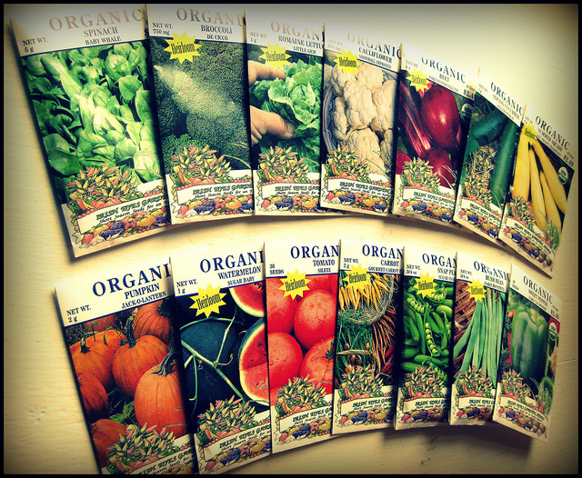
Photo source: https://creativecommons.org/licenses/by-nc/3.0/

