Understand the three main food groups
Subject(s): Health Studies
Grade(s): 7-9

Learning intention(s)
Students acquire an understanding of the main Food Groups, Food Guidelines and the relationships between food and healthy living.

Mapping to curriculum

Strands
Food and Nutrition for Health
- Healthy Communities and Environment

Sub strands
- 7.1 Healthy eating habits and values
- 8.1 Principles of Healthy Eating and diets
- 9. 1 Health and diet-related diseases
- 9.14 Promoting healthy communities

Learning outcome(s)
- 7.1.4.1 Make informed decisions regarding food choices and their health and well-being
- 8.1.2.1 Describe the guidelines for healthy eating and drinking in Solomon Islands
- 9.1.4.2 Establish personal goals that identify positive eating habits and physical activity levels and use these to maintain a healthy lifestyle
- 9.14.3.1 carry out or participate in a community health project, e.g., reduction of plastic litter, improve sanitation and water supplies.

Lesson Instructions

Materials/resources
- Handout on three Food groups from the Fiji Food Guidelines Book (copy for Teacher).
- Copy of Manual ‘3 Food Groups – Fiji’s Guide to Healthy Eating’ produced by the Fiji National Food and Nutrition Centre (optional)
Before the class, the teacher prepares a diagram/table showing the three main food groups (copy available on the second-last page of this activity document).
- Start a class discussion about the three main Food Groups:
  - what are the main groups?
  - what are some common foods found in each group?
  - how does each food group contribute to a healthy diet?
  - why is it important to maintain a healthy diet and/or lifestyle?
- Ask students to draw a circle in their exercise books and divide it into three sections as follows OR provide the circle handout (available on the last page of this activity document).
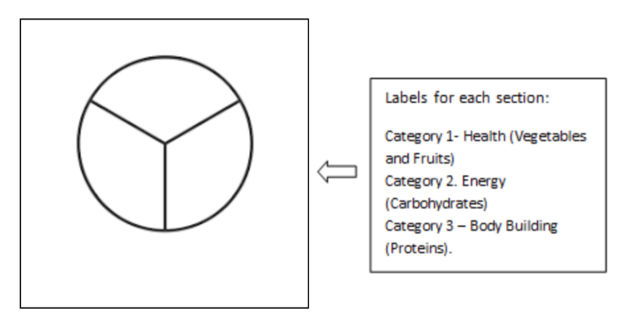
- In each section, students list different foods. Use a different color pen/pencil to show the food they eat the most (tick or color) and with another color show the food they eat the least (tick or color).
- Write 2 short paragraphs in your exercise book about any proposed change(s) you want to make to your diet and the reasons for wanting to make such a change.

Extension
- The teacher facilitates a class discussion about the types of foods that students commonly eat at home.
- Students are asked to draw a table or circle in their books, divide it into three sections and to label each section as follows:
  - Category 1 – Health (Vegetables and Fruits)
  - Category 2 – Energy (Carbohydrates)
  - Category 3 – Body Building (Proteins).
- Ask students to list as many foods as possible under each category. The teacher records the responses on the board.
- From the responses, the teacher facilitates a class discussion using the following prompts:
  - What are some common patterns of eating among the students’ families
  - What are some reasons that some foods are more commonly eaten than others?
  - If the student had a chance to change some of the eating patterns at home, how would they do this?
  - What would the change look like and how can it affect the family’s health and wellbeing?

Teacher Supporting Resource

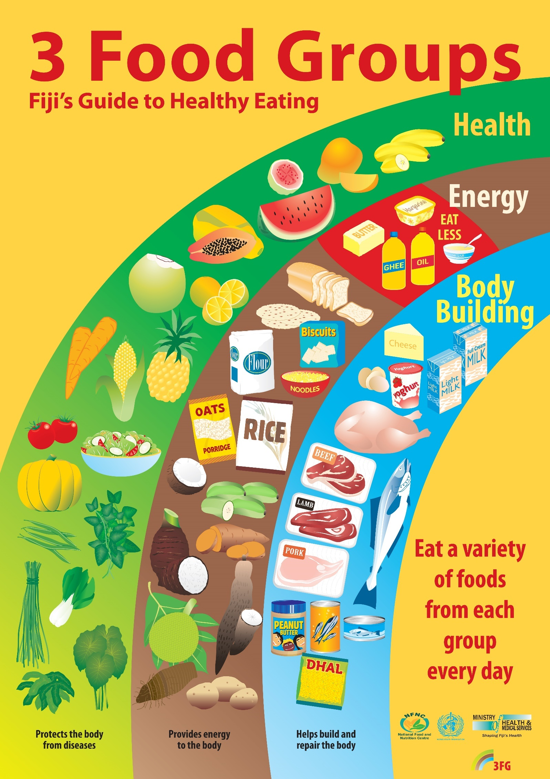

The 3 Food Groups

Name: ________________________

Body Building

Energy

Health

