Growing food from kitchen scraps
Subject(s): Health Studies and Social Studies
Year(s): 5-6

Learning intention(s)
This activity allows students to explore and learn how they can grow plants from food waste.

Mapping to curriculum

Strands
- Health studies - Healthy Communities and Environment
- Social Studies - Resources and Economic Activities
Sub-strands
Health Studies
- 5.5 Pollution and Health
- 6.5 Creating a healthy environment
Social Studies
- 6.5 Using and Managing Natural Resources

Learning outcome(s):
Health Studies
- 5.5.6 Recognise their responsibility for caring for the environment.
- 6.5.2 Recognise that regulations help promote a safe and healthy environment
- 6.6.2.1 Develop simple rules or regulations to ensure care of the school environment.
Social Studies
- 6.5.1 Understand the importance of environmental resources in meeting human needs
- 6.5.4 Know appropriate ways of managing environmental resources in a sustainable manner.

Lesson Instructions
(adapted from Victorian Schools Garden Program, 2021)
Materials/resources
- Fresh or Dried pumpkin seeds
- Planting space (large container or cleared space on the ground.
- soil
Preparation
- Scrape out the membrane and seeds of a pumpkin that has already been cut open (preferably by an adult). Separate the seeds from the membrane, then give the seeds a rinse under cold water and then pat them dry with a paper towel.
- Place seeds on a dry piece of paper towel and leave in a warm, dry, airy spot until they are dry to the touch. This could take 2-5 days.
Planting
- Once the seeds have fully dried, you are ready to plant.
- Choose a spot in the garden that gets 6 to 8 hours of full sun per day. Avoid areas with full shade.
- In your chosen area, make little mounds of soil and place 3-5 seeds in each mound, approximately 5 cm deep.
- Pour some water over each mound and then wait for a few days to see them sprout. Mounding up the soil helps to ensure good drainage.
- Once the seeds have germinated, keep the two healthiest plants and remove the others. This helps you to get the best, strongest plants. Keep them well watered until the plants are big and growing healthy.
- Ensure there is enough space for the pumpkin plant to grow in, as they tend to sprawl or spread. Alternatively, provide an area or wall for them to climb up.
Observation and recording changes
- Each week, record the changes that are observed using the observation sheet below.
- Share your recorded observations with the class after every 2 weeks.

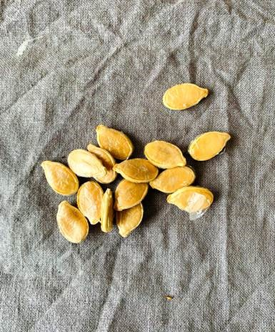
Teacher Supporting Resource

Observation Sheet

Name:
What we planted: Date Planted:
Week | What you did | Observations
1

2

3

4

5

6

7

8

