Area and perimeter of leaves
Subject(s): Mathematics
Year(s): 4-5

Learning intention(s)
Students will explore and compare the area and perimeter of leaves. They will collect leaves, trace them onto graph paper, and measure their area and perimeter. They will compare these measurements and discuss how shape affects area and perimeter.

Mapping to curriculum

Strands
- Measurement and Geometry
- Statistics and Probability
Sub strands
- 4.12 Length and perimeter
- 4.13 Area
- 5.14 Length and Area
- 5.18 Statistics
- 5.19 Probability

Learning outcome(s)
- 4.12.4 Be able to estimate length and distance
- 4.13.3 Know how to find the area of a rectangle
- 5.14.3.1 calculate the area of a simple shape
- 5.18.1.1 collect and record data using tally and graph.
- 5.19.3 Know how to carry out a simple experiment and describe their results

Lesson Instructions
Materials/resources
- Graph paper with 1cm squares
- String
- Pencil/pen
- Centimeter ruler
- Scissors
Key concepts
- Perimeter: The distance around the edge of a shape (measured in cm).
- Area: The space inside a shape (measured in square cm).
Preparation
- Students collect leaves of various sizes and shapes. Avoid hard-to-measure leaves, like very jagged or tiny ones.
- On the whiteboard, draw some leaves and label their area and perimeter as examples.
Getting started
- Discuss:
  - What is the distance around the leaf called? [Perimeter]
  - What is the space inside the leaf called? [Area]
- Use the whiteboard to show examples and define these terms together.
Measuring area
- Explain that area is measured in square units (e.g. square centimeters).
- Demonstrate tracing a leaf onto graph paper.
- Count the squares inside the tracing, including partial squares, to find the area.
Example: Area= _____square centimeters.
- Students work with a partner to trace their own leaves and calculate the area.
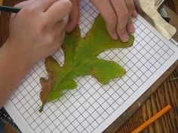
Source: https://resources4rethinking.ca/en/resource/area-and-perimeter-of-leaves
- Compare results by organising tracings from smallest to largest area. Discuss:
  - Were you surprised by the order?
  - What do leaves with large areas have in common?
  - What shapes help plants survive?
Measuring perimeter
- Demonstrate how to use a string to measure the perimeter of a leaf. Wrap the string around the edge, cut it, and measure its length with a ruler.
Example: Perimeter = _____ centimeters.
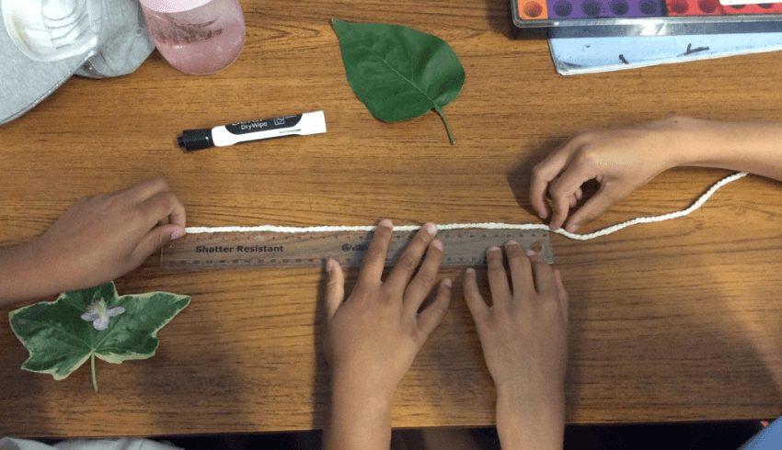
Source: https://www.teachwire.net/news/area-and-perimeter-worksheets-and-resources-for-ks2-maths/
- Students work in pairs to measure and record perimeter of their leaves.
- Compare perimeters by organising string from shortest to longest. Discuss:
  - Does the leaf with the longest perimeter always have the largest area? Why or why not?
- Show that different shapes can have the same perimeter but different areas by reshaping a loop of string.
Creative challenges
- Maximising Area: use a string perimeter to create a shape with the largest area and another with the smallest area. What patterns do you notice?
- Comparing Perimeters: use the same area to create shapes with different perimeters. What shapes work best?
Reflection
Discuss what students learned about the relationship between shape, area, and perimeter. How might this knowledge help us understand plants and their environment?

