Construct a pot pyramid for the garden
Subject(s): Mathematics
Year(s): 4

Learning intention(s)
Students make a 3D model of a structure for the garden

Mapping to curriculum

Strand
- Measurement and Geometry
Sub strands:
- 4.8 Two-dimensional shapes
- 4.9 Three-Dimensional Shapes

Learning outcome(s):
- 4.8.3.1 Recognise and name different types of triangles
- 4.9.3.1 Construct a 3-dimensional shape such as a cuboid or prism from their net.

Lesson Instructions
Materials/resources
This activity requires students to be creative in the design and building of their structures so a variety of materials can be used, including:
- pieces of timber
- small twigs or sticks
- string or twine, or glue
- cardboard boxes, egg cartons
- Empty cans or containers
- Students are tasked with designing a new structure for the school’s garden. Their design must include a 3D model. Examples include a dome-shaped greenhouse, a cone-shaped plant trellis, a cube-shaped compost bin, or a spherical garden sculpture. Encourage students to use their knowledge of shapes.
- Students sketch their chosen structure in their workbooks.
- Along with the sketch, students write a short paragraph highlighting the key feature of their design (e.g., dome, cone, cube).
- Using modelling clay or other available materials, students build a 3D version of their structure.
- Display the finished models safely in the classroom for everyone to see.
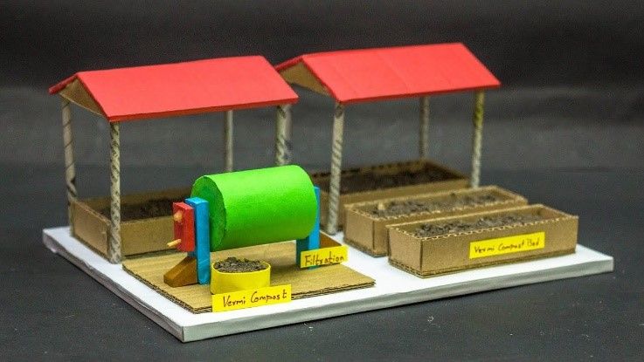
Source: https://www.youtube.com/watch?v=t-Giuapyncc
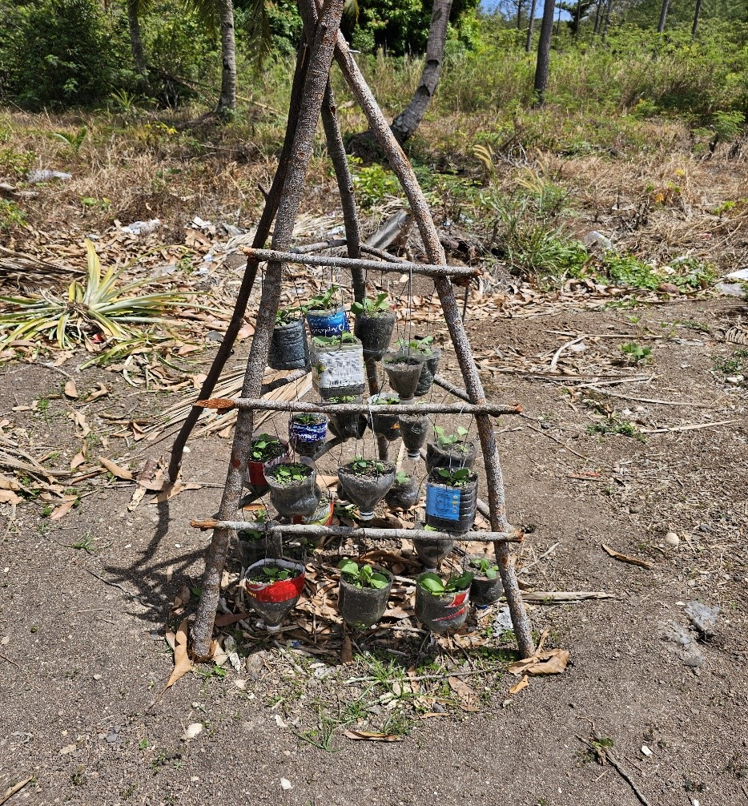
Photo: Rhonda Dibiase

