Construct a pot pyramid for the garden
Subject(s): Mathematics
Year(s): 5-6

Learning intention(s)
Construct a 3D pyramid structure to support plants in the garden.

Mapping to curriculum

Strands
- Measurement and Geometry
- Statistics and Probability
Sub strands
- 5.14 Length and Area
- 6.9 Shapes
- 6.11 Angles
- 6.18 Statistics

Learning outcome(s)
- 5.14.2 Use strategies or calculation to find the perimeter of a compound shape
- 6.9.1 Know the properties of different types of triangles.
- 6.10.3 Understand scale factor
- 6.11.1Know how to measure, draw, name and compare angles
- 6.18.1 Know how to collect and record data in an appropriate way (s)

Lesson Instructions

Materials/resources
- 3–4 long bamboo canes or sticks (per student group)
- heavy twine
- scissors

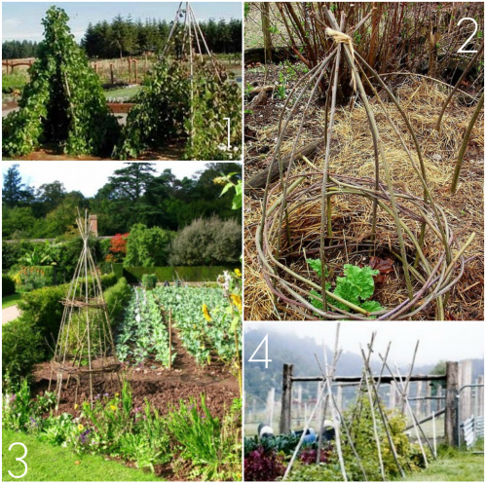
Source: https://www.17apart.com/2012/03/pinterest-challenge-diy-bean-teepee.html

Key Vocabulary
Pyramid: An object that has a square or triangular base with sloping sides that meet at the top.
Structure: An object that is put together using several different parts.
Twine: string or thread that is strong and sturdy.
Model: An object or structure that is used as an example to follow.

Activity 1: Description
- Prepare the garden structure
  - Divide the class into groups of 4-5 students.
  - Get materials: Each group will need 3–4 long bamboo canes or sticks, heavy twine, and scissors.
  - Arrange the canes/sticks: Place the canes on the ground, parallel and touching each other.
  - Tie the canes/sticks: Tie the canes together about 30 cm from one end.
  - Put in position: Pick up the canes by the tied end, stand them up in the garden, and spread the untied ends apart to form a pyramid.
  - Make the structure stable: Push the ends of the canes deep into the ground, then weave twine between them to make the structure sturdy.
  - Plant around it: Sow climbing plant seeds or plant seedlings around the base. Over time, they’ll grow up and around the structure.

Activity 2: Description
- Measure the canes and twine to ensure they will fit properly.
  - Ask students to measure the canes and twine to ensure everything is evenly spaced.
  - Inform students to plan and design a garden structure that can support plants while adding height to the garden.
  - Provide examples of photos or pictures of garden structures.

Task(s)

Year 5 and 6 task
Divide the students into groups of 4-5 and ask them to design a garden structure that can support pot plants or other climbing vegetables such as beans, tomatoes or pumpkins. Use the next 3-4 lessons to construct a practical garden structure to use in the school garden.

Teacher Supporting Resource:
Examples of garden structures
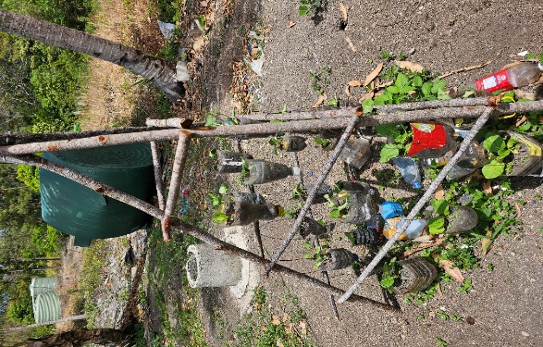 | 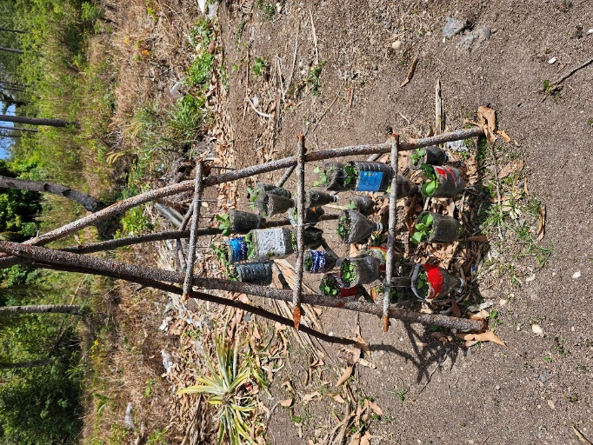
Photos: Rhonda Di Biase

