Build a soda bottle composter
Subject(s): Science, Social Science
Grade(s): 3-4

Learning intention(s)
Students will learn about the process of composting and understand how organic materials break down to create nutrient-rich soil. Through this hands-on activity, they will observe decomposition, identify the role of moisture and airflow in composting, and gain a basic understanding of sustainable waste management and soil health.

Mapping to curriculum

Strands
- Science – Life and Living
- Social Studies – Place and Space
Sub strands
Science
- 3.1 Plant and animal groups
- 3.5 Growing plants in a nursery
- 4.1 organisms in their Environment
Social Studies
- 4 2 The land around us

Learning outcome(s)
Science
- 3.1.3 Use simple classification keys to identify animals and plants.
- 3.2.5 Appreciate that energy is essential for all aspects of human life and activity.
- 4.1.6.1 Identify sources of food in the environment for which the living things can survive on.

Social Studies
- 4.2.3 Understand that changes to the landscape of our islands are caused by nature and people.
- 4.2.3.2. Identify and explain ways in which human activities affect the physical environment and ecosystem.

Lesson Instructions

Materials/resources:
- An empty, clean plastic soda bottle (2 litres works best)
- Soil
- Food scraps (like fruit and vegetable peels)
- Garden waste (like fallen leaves and flowers)
- Water
- Scissors
- Cello tape
- A stick or spoon

How to make your composter
- Prepare the Bottle: Cut off the top of the soda bottle (just below where it starts to curve). This will make it easier to add materials. Save the top piece—you’ll use it as a lid.
- Make small holes in the top piece of the bottle (lid) for airflow. 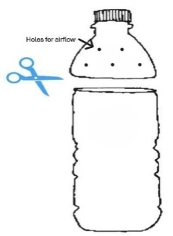
- Layer your materials. Start by adding a layer of soil to the bottom of the bottle. This introduces the bacteria needed to make black nutritious compost. Then add some food scraps, followed by some garden waste. Keep adding layers until the bottle is about three-quarters full.
- Finally add another layer of soil and a layer of garden waste.
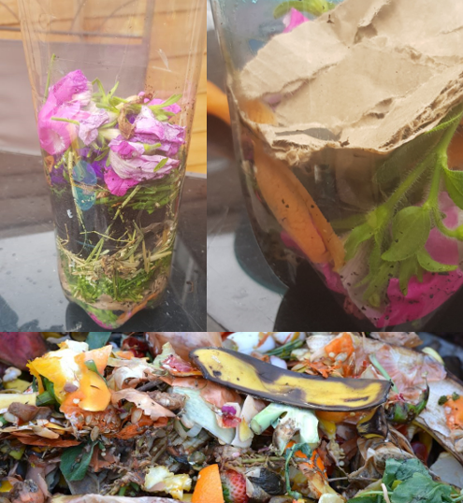
Source: https://growinghealthykids.co.uk/how-to-make-compost-in-a-bottle/
- Add water. Lightly spray or sprinkle water over the layers to keep them moist. Don’t soak the layers – just make sure they are damp.
- Put the top of the bottle back on and cello-tape it in place.
- Make a mark on the side on the bottle where the top of your bottle comes to so you can see how much it changes. Every two weeks you can draw a new line to mark the “new” top of the compost as it breaks down. Date each line so you can track the progress.
- Place your composter in a warm, sunny spot, like a windowsill or high shelf or table.
- Over the next few weeks, you’ll see the food scraps and yard waste slowly turn into compost. Use the observation sheet to record your observations every two weeks. In about 1-2 months, you’ll have rich compost to use in your school garden!
- Check and Stir: Every few days, use the stick or spoon to stir the materials. This helps everything break down faster. Keep it moist by adding a little water if it dries out.

Books to read about growing seeds
Tiny Creatures: The World of Microbes YouTube read-aloud

Teacher Supporting Resources:
Composting Observation Sheet
Week 2
Week 4
Week 6

Extension activity

Ask students to write a paragraph summarising their observations of the soil change over the six weeks. What were the main changes? What was interesting about the changes?

