Construct a pot pyramid for the garden
Subject(s): Mathematics, Art and Culture
Year(s): 5-6

Learning intention(s)
Construct a 3D pyramid structure to support plants in the garden.

Mapping to curriculum :

Strands
- Mathematics – Measurement and Geometry
- Art and Culture – Visual Art and Craft

Sub strands

Mathematics
- 5.12 Three-Dimensional Shapes
- 5.13 and 6.11 Angles
- 5.14 and 6.14 Length and Area.
- 6.9 Shapes
Visual Arts
- 5.1 Introduction to creativity in Art and craft
- 6.1 Created Arts and Crafts integrated project

Learning outcome(s)

Mathematics
- 5.12.4.1 Construct and use the net for a prism, pyramid or cylinder
- 5.13.1 Know how to use a protractor to measure and draw angles
- 5.14.3 Calculate the area of a simple shape
- 6.11.1 Know how to measure, draw, name and compare angles

Creative Art and Culture
- 5.1.2.1 Develop an original integrated design or sculpture from your local environment and other regions.
- 6.1.1.1 Develop an original form of traditional visual art using modern or local materials.

Lesson Instructions

Materials required
- 3–4 long bamboo canes or sticks (per student group)
- heavy twine
- scissors

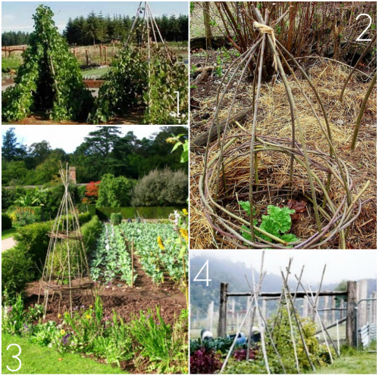
Source: https://www.17apart.com/2012/03/pinterest-challenge-diy-bean-teepee.html

Key Vocabulary
Pyramid: An object that has a square or triangular base with sloping sides that meet at the top.
Structure: An object that is put together using several different parts.
Twine: string or thread that is strong and sturdy.
Model: An object or structure that is used as an example to follow.

Activity 1: Description
- Prepare the garden structure
  - Divide the class into groups of 4-5 students.
  - Get materials: Each group will need 3–4 long bamboo canes or sticks, heavy twine, and scissors.
  - Arrange the canes/sticks: Place the canes on the ground, parallel and touching each other.
  - Tie the canes/sticks: Tie the canes together about 30 cm from one end.
  - Put in position: Pick up the canes by the tied end, stand them up in the garden, and spread the untied ends apart to form a pyramid.
  - Make the structure stable: Push the ends of the canes deep into the ground, then weave twine between them to make the structure sturdy.
  - Plant around it: Sow climbing plant seeds or plant seedlings around the base. Over time, they’ll grow up and around the structure.

Activity 2: Description
- Measure the canes and twine to ensure they will fit properly.
  - Ask students to measure the canes and twine to ensure everything is evenly spaced.
  - Inform students to plan and design a garden structure that can support plants while adding height to the garden.
  - Provide examples of photos or pictures of garden structures.

Task(s)

Year 5 and 6 task
Divide the students into groups of 4-5 and ask them to design a garden structure that can support pot plants or other climbing vegetables such as beans, tomatoes or pumpkins. Use the next 3-4 lessons to construct a practical garden structure to use in the school garden.

Teacher Supporting Resource:
Examples of garden structures

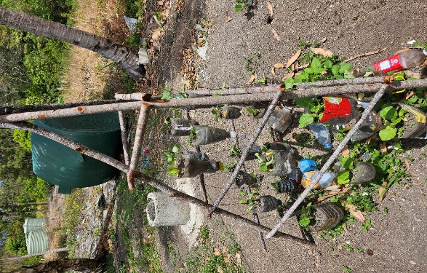 | 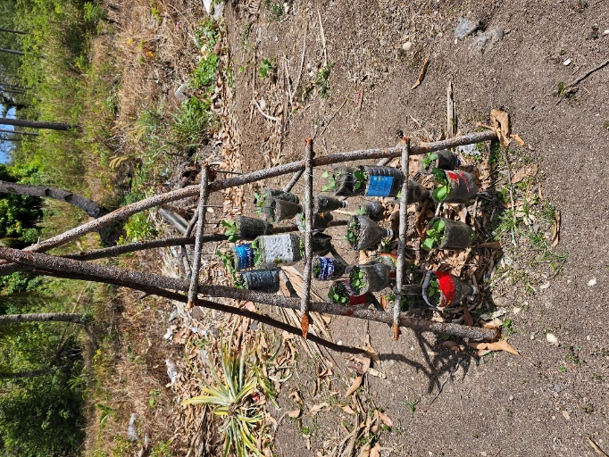
Photos: Rhonda Di Biase

