Food and farming – what role do farmers play in the carbon cycle?
Subject(s): Science, Social Studies
Year(s): 7-9

Learning intention(s)
Students will understand the role of microbes in human and soil health, how agricultural practices impact soil, and the benefits of composting.

Mapping to curriculum
Strands:
- Life and Living
- Environment and Population
Sub Strands:
Science
- 7.9 Natural Resources of Solomon Islands
- 7.12 Ecosystems
- 8.5 Plant Processes and Marine Ecosystems
- 8.Carbon Crops and Production
Social Studies
- 7.10 Land Use and Resources - Small-Scale Farming
- 9.7 Climate Change and El Niño
- 9.9 World Population Trends
Learning Outcome(s)
Science
- 7.12.1 Know that an ecosystem is made up of living and non-living things that interact with each other in a particular area
- 7.12.3 Know that abiotic factors influence the survival of organisms within an ecosystem
- 8.5.7 Understand that the different ecosystems support different types of organisms
- 8.5.8 Be able to show that pollution affects species diversity and abundance
Social Science
- 7.9.2.1 Identify and explain the different ways people use and abuse the natural resources and their associated impacts in Solomon Islands
- 7.9.4 Appreciate the need to preserve natural resources
- 7.10.2.3 define small-scale, cash farming, intensive farming, small-holding and market gardens
- 9.7.2 Understand the causes of Global warming, Climate Change, its impacts and measures to reduce it.

Lesson Instructions
Materials/resources
- Slide: Microbes in Our Gut
- Paper
- Handout: Agricultural Practice Cards
- 2 or more pieces of different local, fresh fruits or vegetables for each student, such as: vegetables that can be enjoyed raw, like sugar snap peas, sliced carrots, or cherry tomatoes and unique fruits like sliced kiwi, persimmon, or figs
- The Compost Story: https://www.youtube.com/watch?v=k7DyYlK5ihs

Suggested time 30-45 minutes

Key Vocabulary
- Humus: An organic component of soil created by the decomposition of leaves and plant material by microorganisms.
- Organic Matter: Carbon-based compounds, including all matter that comes from the remains of plants and animals and their waste.
- Upcycling: Reusing a material for a purpose that has a higher value than the original material.

Activity 1: Description
- Introduce the objective of the lesson.
  - Explain that, just like soil, our bodies have microbes living inside them!
  - Show Slide 1: Microbes in Our Gut and ask students to interpret the image. After hearing some responses, explain that each circle represents the number of microbes in different parts of our gut. Highlight that our stomachs and other body parts act as small 'habitats' for billions of microbes. Together, these microbes weigh about 1.4kg -the same as our brains!
  - Ask students: How might these microbes be similar to those found in the soil? How might they be different?
  - Explain that while these microbes are different from soil microbes, they also promote health. Soil microbes help plants stay healthy, and gut microbes help our bodies stay healthy. Scientists are continually discovering how these microbes benefit us. Ask: Have you heard of eating yogurt or other foods high in probiotics to stay healthy, especially after taking antibiotics? Yogurt is full of probiotics-beneficial microbes that can replace those damaged or killed by antibiotics. Many believe future medicines could include helpful microbes and the foods they need to thrive, promoting our health by supporting theirs.
  - Introduce the purpose of the upcoming Mindful Tasting activity: Eating fresh, nutritious food supports both our health and the health of our microbes.
  - Remind students: Some microbes make us healthy, but others can make us sick. For example, some soil microbes can cause illness, which is why we wash our produce and hands before eating. Have students thoroughly wash their hands before starting the Mindful Tasting activity.

Activity 2: Description
- Introduce the guidelines for the Mindful Tasting activity:
  - Show the fresh produce and share any details you know about it, like where it was grown or who grew it. Ask students: How do you think soil microbes helped this produce grow?
  - Explain that they will be tasting fresh foods, focusing on the unique flavours and textures of each item.
  - Before tasting, encourage students to explore the produce with all their senses except taste. Ask them: What does it look like? How does it feel? What does it smell like? Does it make a sound if you rub the skin or tap it?
  - Demonstrate how to focus on taste. Take a piece of produce, close your eyes, and pay close attention to how it tastes and feels. Then, share your reactions using descriptive language.
  - Let students know they are encouraged to try everything, but they don’t have to finish anything they don’t enjoy.
  - Discuss polite ways to respond if they don’t like something. For example, they could discreetly spit it into a napkin and dispose of it, or say, “Thanks, but this isn’t my favourite.”
  - Pass out the produce one at a time and guide students as they taste and explore each piece.

Activity 3: Description
- Introduce the guidelines for the Mindful Tasting activity:
  - Talk about the tasting activity. Ask students which foods they liked the most and why. If they mention liking foods because they were ‘sweet,’ explain how some plants (like strawberries) naturally have more sugar than others (like kale). Point out the connection between the part of the plant and its sugar content.
  - Ask students if they could taste any nutrients in the foods they tried. Explain that while nutrients don’t have a taste, freshness can affect flavour, and fresher foods are often more nutritious.
  - Pose a question for small group discussion (3-4 students): How do farmers grow nutritious food for us to eat? Listen to their ideas. If no one mentions it, remind them about soil microbes and their role in providing nutrients to plants.
  - Introduce The Compost Story video. Invite students to share any personal experiences they have with composting. Explain that they should take notes on the main message while watching the video.
  - Watch the video together. Pause at key points to discuss what they have learned so far.
Year 7
After the video, discuss with the class the following questions:
- Why do the actors in the video argue that we are crazy not to compost? Do you agree or disagree? Support your answer with evidence.
- Did they find the video’s argument convincing. Why or why not?
- Are We Building or Depleting Soil? Explain that farmers use different methods in farming. Some of these methods harm the soil, while others help restore it.
- Explain the next activity: Students will receive cards with pictures of different farming methods. They need to use their knowledge of soil, farming, and carbon to decide whether each practice harms or improves the soil.
- Give each group of 3–4 students a set of Handout 1: Agricultural Practice Cards. Have the students work together to sort the cards into two categories: Soil-Building Practices and Soil-Depleting Practices, based on what they know.

Year 8
- Give each group of 3–4 students a set of Handout 1: Agricultural Practice Cards.
- Ask students to think about the different farming methods and talk about the challenges that stop farmers from using practices that build soil. Some possible reasons include the extra cost of switching to new methods, not knowing about other options, and the influence of chemical companies' ads and information.
- Make sure students understand that farmers are not trying to harm the Earth. Until recently, scientists did not fully understand the important role soil plays or the negative effects of traditional farming methods.
- Let students know that composting is not just for farmers - anyone can do it!

Teacher Supporting Resource
Handout – Agriculture Practice Cards

Soil-Building Practices | Soil-Depleting Practices

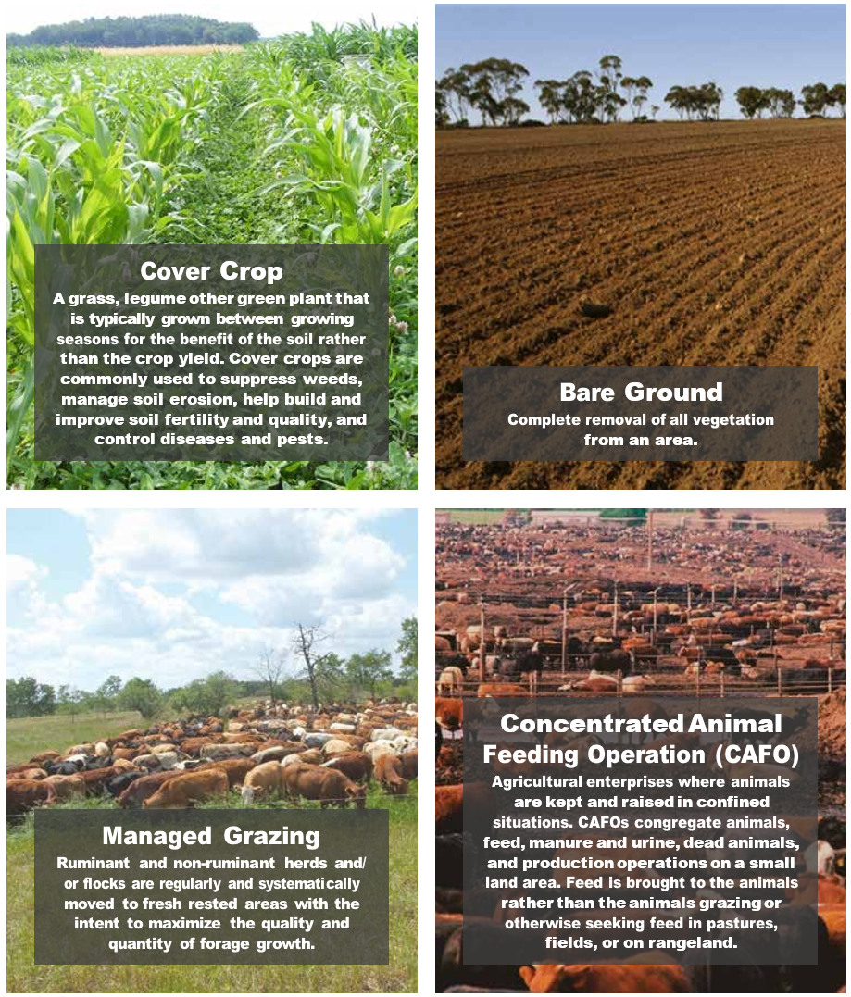
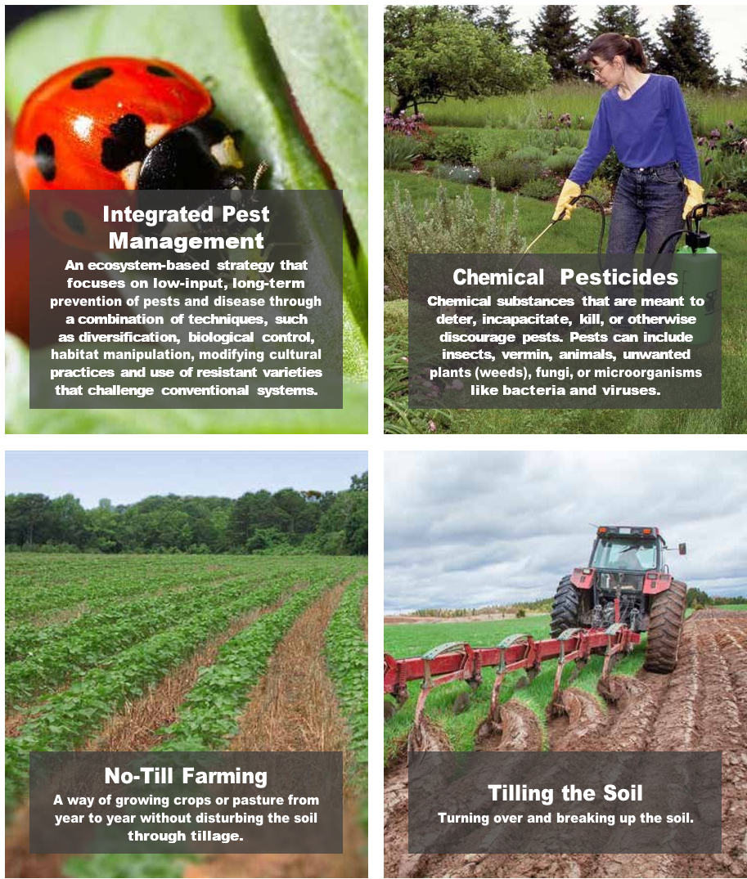
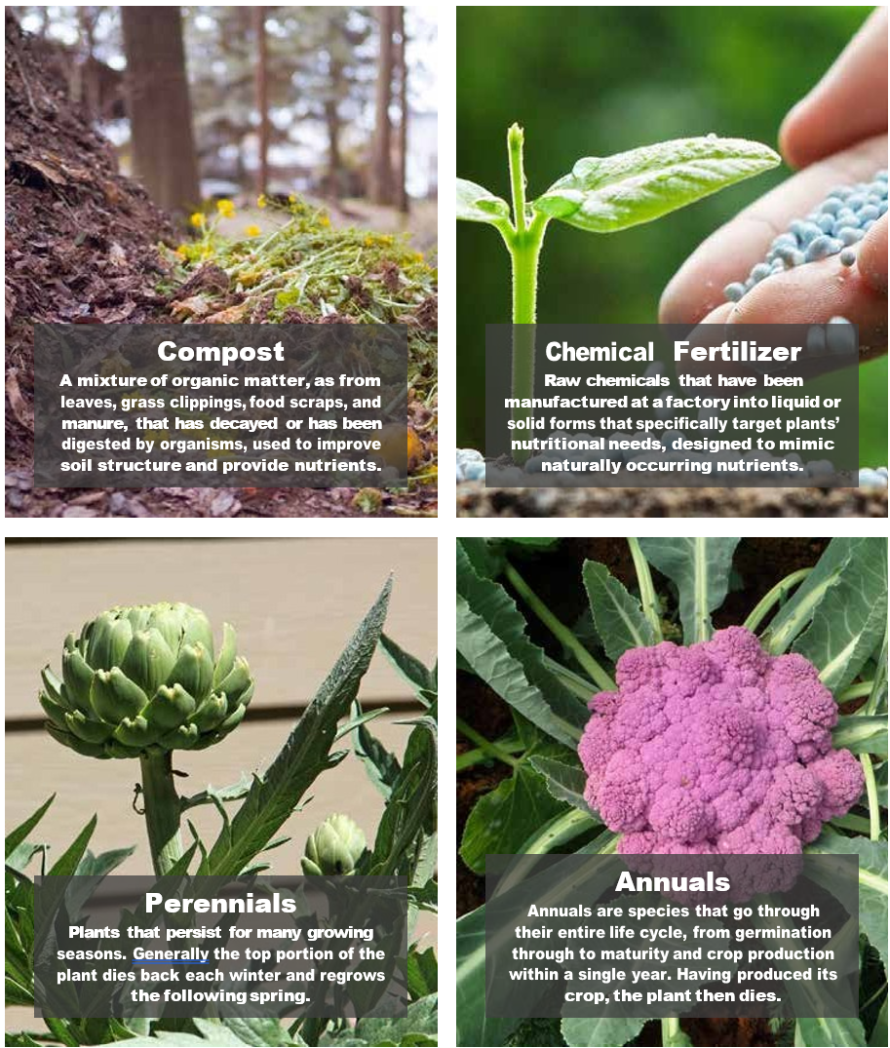
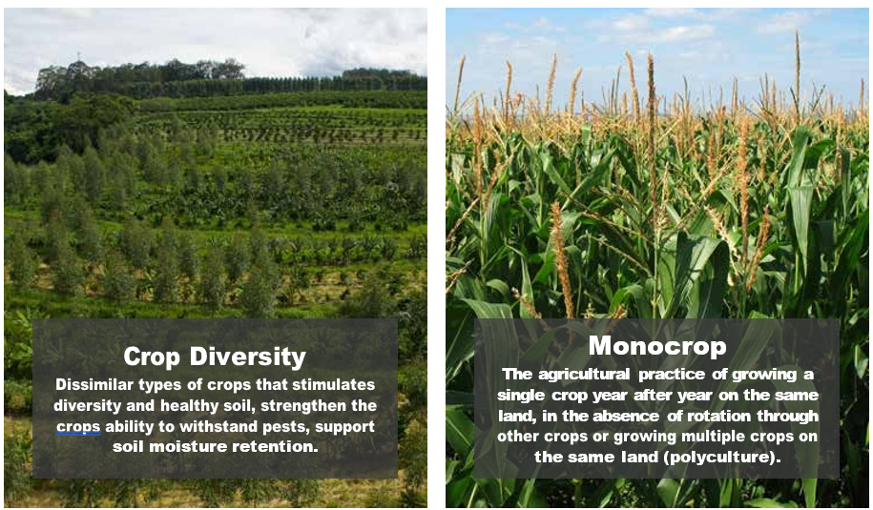
Source: https://kisstheground.com/wp-content/uploads/2020/04/Soil-Story-Curriculum_200212.pdf

Slide – Microbes in Our Gut

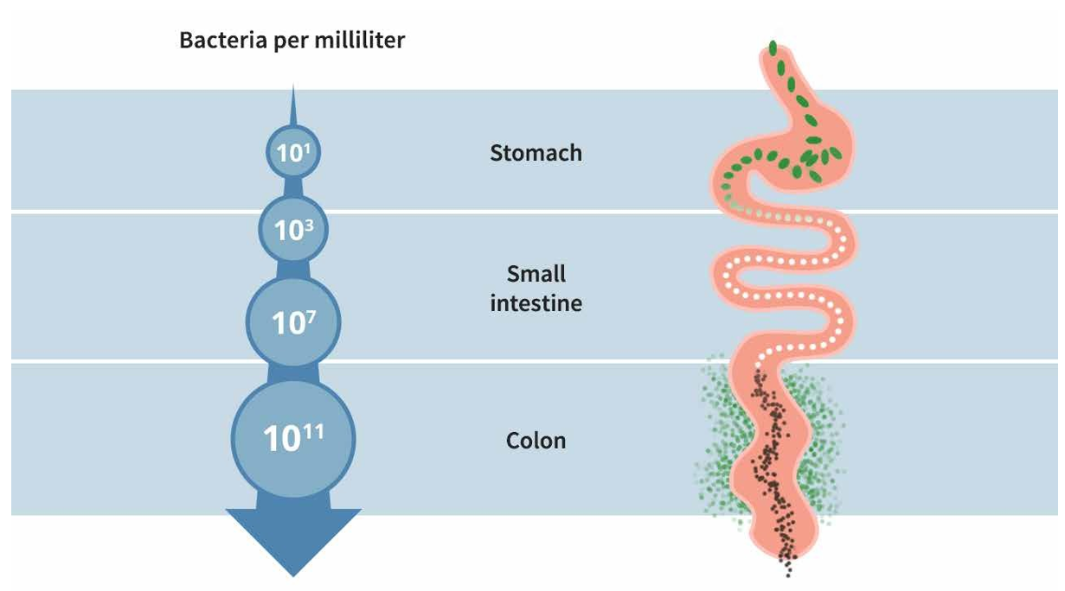
Source: https://kisstheground.com/wp-content/uploads/2020/04/Soil-Story-Curriculum_200212.pdf

