Observe water transport in plants
Subject(s): Science
Year(s): 1–5

Learning intention(s)
Students will understand how water moves through a plant by observing how dye-stained water travels up the plant stem and causes the leaves to change colour.
Mapping to curriculum
Strands
- Life and Living
- Energy and Change
Sub strands
- 1.1 Living and Non-Living Things
- 2.4 Gardening
- 3.2 Energy sources
- 4.2 Cycle of Life
- 5.1 Plant Growth
Learning outcome(s)
- 1.1.1 Know that living things need air, water and food.
- 2.4.1 Understand that good soil, water and sunlight are needed for successful gardening
- 3.2.1 Know a range of sources of energy – sun, food
- 4.2.1 describe the main stages of reproduction in flowering plants
- 5.1.2 Understand that green plants need water, light energy and carbon dioxide for the process of photosynthesis
- 5.1.4 understand that the green plant uses the food from photosynthesis by respiration.

Lesson Instructions
Materials/resources
- Leaves
- Scissors
- Clear cups
- Water
- Red food colouring
- Observation sheet

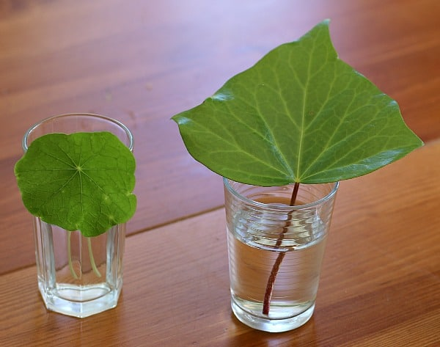
Steps
Source: https://growinghealthykids.co.uk/how-to-make-compost-in-a-bottle/
- Go outside and collect a variety of leaves.
- Cut the bottom of each leaf stem and place the leaves in a clear cup filled one-third with water.
- Add red food colouring to the water. Make the water a dark red to make it easier to see any changes in the leaves.
- Look closely at the leaves and write down what you see on Day 1.
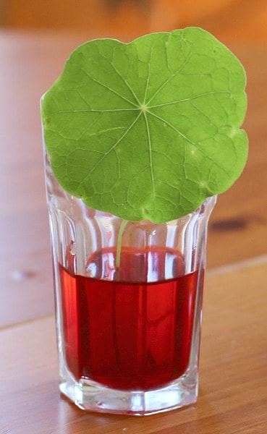
- Keep observing the leaves for the next two days. Record your observations each day on your observation sheet.
Source: https://buggyandbuddy.com/wp-content/uploads/2014/03/round-in-red.jpg

What You Should Notice
You are likely see the red colour slowly move up through the leaf. This happens because the coloured water is traveling through the leaf’s xylem tubes, which transport water and minerals throughout the plant.
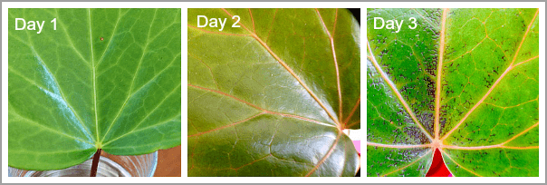
Source: https://buggyandbuddy.com/wp-content/uploads/2014/03/3-close.png

Extension Activity
Make leaf prints or rubbings to compare shapes and patterns: https://www.youtube.com/watch?v=ZendMjhVoMI

Teacher Supporting Resource

Water transport in plants
Observation Sheet
Name:
Day 1
Day 2
Day 3

