Growing healthy plants
Subject(s): Science
Year(s): 4–5

Learning intention(s)
Students will learn how light affects the growth of seeds by conducting an experiment to observe the differences between seeds grown in light and in darkness. Through this experiment, students will understand the role of light in seed germination and plant development, particularly in the formation of leaves.

Mapping to curriculum

Strands
- Life and Living
- Energy and Change
Sub strands:
- 4.2 Cycle of Life
- 5.1 Plant Growth
- 5.3 Energy Sources and Energy Changes

Learning outcome(s)
- 4.2.2 Describe the main stages of reproduction in a flowering plant
- 5.1.1 Understand that the different parts of a plant have specific functions
- 5.1.2 Understand that green plants need water, light energy and carbon dioxide for the process of photosynthesis
- 5.3.2 Know that the sun is the primary source of light and heat energy

Lesson Instructions

Materials required
- 2 plastic cups
- Dirt or potting soil
- Seeds
- Water
- A small box (large enough to hold one cup)
- Labels or markers (to label the cups ‘light’ and ‘dark’)
- Table near a window or another spot with natural light

Key Vocabulary
Light: the natural agent that makes things visible, ie, allow people to see something
Dark: having little or no light
Sprout: a shoot of a plant when it starts to grow.
Wit: a condition where the plant dries up or becomes shriveled

Activity 1: Description
- Prepare the Cups:
  - Take two plastic cups and fill them with equal amounts of dirt or potting soil.
  - Label one cup ‘light’ and the other ‘dark’.

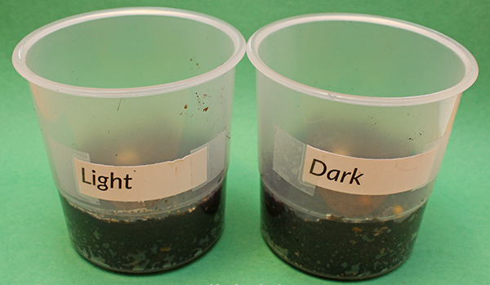

Activity 2: Description
- Plant the seeds and set up the light and Dark conditions
  - In each cup, plant three seeds. Make sure the seeds are planted at the same depth in both cups.
  - Place the ‘dark’ cup inside a box, sealing the box tightly to prevent any light from getting in.
  - Leave the ’light’ cup uncovered.

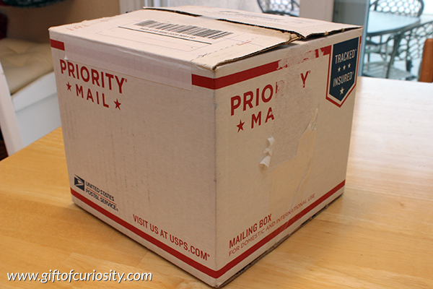
Image source: www.giftofcuriosity.com

Activity 3: Description
1. Position the Cups, water the seeds and wait and observe.

  - Place both the ’light’ cup and the sealed box (containing the ‘dark’ cup) on a table near a window or in an area that receives natural light.
  - Water both cups as needed, ensuring the soil stays moist but not soaked. Check every few days to see if more water is needed.
  - After one week, open the box and compare how the seeds in the ’light’ and ‘dark’ cups have grown.
  - Record your observations using words and/or drawings, noting any differences in sprouting, height, and whether leaves have formed.

Activity 4: Description
1. Conclude the experiment and analyse the results.
  - After observing the plants in both cups, expose the ‘dark’ cup to light. Check to see if the seeds develop leaves once, they have access to light and record any changes over the next 24 hours.
  - Analyse the results.

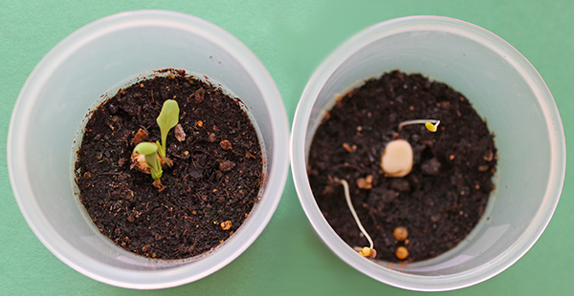
Image source: www.giftofcuriosity.com

Task(s)

Year 4-5 task
Discuss with the whole class the findings from the experiment. Did the seeds sprout in both cups? What happened to the leaves in each condition? What does this experiment teach about the importance of light for growing plants?
Write your answers in your exercise book.

Teacher Supporting Resources:
Books to Read about Growing Seeds:
- The Tiny Seed by Eric Carle: https://www.youtube.com/watch?v=LlDOMQPptOM
- From Seed to Plant by Gail Gibbons: https://www.youtube.com/watch?v=TLEns2oCd6U

Handout 1:
Do Plants Need Light to Grow? – Plant Growth
Student Observation Sheet – Write and record your observations in the space provided below.
Light Cup After 1 Week
Dark Cup After 1 Week
Dark Cup After 24 Hours Exposed to Light

