Classify common types of plants in an ecosystem
Subject(s): Science
Year(s): 4–5

Learning intention(s)
Students learn about the different kinds of plants that live within their school environment or ecosystem.

Mapping to curriculum

Strand
- Life and Living

Sub Strands
- Organisms in their Environment
- Plant Growth

Learning outcome(s)
Science
- 4.1.2.1 Identify different environments within their school or community/village
- 4.1.3.1 Plan and carry out a survey on a selected local environment to identify living and non-living things present
- 4.1.4.1 State some characteristics of plants and animals.
- 5.1.1.1 Draw a diagram of a plant, labelling the parts and noting their functions.

Lesson Instructions

(adapted from SAKG Foundation, Tools for Teachers 4, Years 3 and 4, page 16)

Materials/resources
- ‘Coloured pencils or pens’ for drawing – The Teacher can provide these or students can bring their own.
- ‘A4 Blank paper’ – 1 sheet per student (Alternatively, students can draw the pictures in their exercise books).
- ‘Cello tape or Blue tack’ – 1 or 2 to share with the whole class.
- ‘Samples of common plants’ Sheet – I copy for the teacher.

Key Vocabulary
Ecosystem: Geographic area where plants, animals and other organisms, as well as the weather and landscape, work together to form a healthy place to live in.
Edible: foods or products that can be safely eaten by human beings.
Native: Plants, animals and organisms that live naturally in the environment.
Introduced: Plants, animals and organisms that have been brought into the country from outside sources or other countries.
Species: A group of living organisms that share similar characteristics, including the ability to interbreed or exchange genes with each other.

Activity 1: Description
- Identify the types of plants that can be found within the school environment.
  - The teacher outlines the objective of the lesson, which is for the students to identify the kinds of plants and vegetation that are found within the school environment.
  - He/she explains that the students will need to go outdoors for this lesson. They will walk around the schoolyard/ school garden and observe the different kinds of plants and vegetation that are growing there.
  - Each student must collect at least 4 types of plants or leaves of plants. They will need to identify if a plant is a native or introduced species, edible (can be eaten) or inedible, weed or grass or tree and whether the plant is poisonous.
  - The students bring back samples (for example, leaves, bark, fruit or seeds) of plants to class.
  - The teacher then conducts a discussion with the class about the plants that they have collected and help students to identify whether the plants are edible/inedible/poisonous or native/introduced and whether it is a weed/plant or tree.

Activity 2: Description
- Study pictures of some common plants to determine their origins and functions.
  - In pairs, look at the pictures to determine if each plant is a local or introduced species, edible or inedible or a weed, grass or tree.
  - Select a plant that you are familiar with or select one from the samples provided by your teacher to research and answer the following questions: 1. What is the scientific name of your selected plant? 2. Where did the plant originate from (ie is it local or introduced)? 3. What are the common uses of this plant? 4. Why did you select this particular plant and what is its significance to your daily life?
  - Write the answers in your exercise book.

Task(s)

Year 4 -5 task
  - Draw an imaginary garden and select 5 - 6 plant or vegetable species to grow in your garden. Include a mixture of plants that are native or introduced species, edible or inedible and/or grass or tree. Think carefully about which plants to include to ensure the plants can grow well together.
  - Be creative and use colored pencils to decorate your garden to make it look real.
  - Display the garden drawings on the classroom wall. The teacher then asks a few students to volunteer to tell the story about their imaginary garden to their peers.

Teacher Supporting Resource:
[Samples of plants for Student Research]
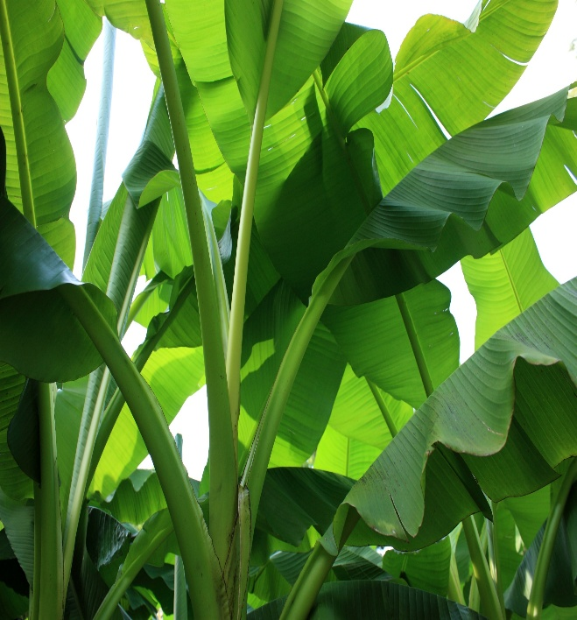
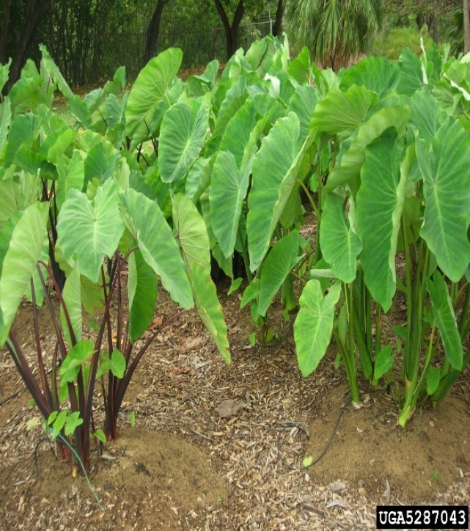
Choose one of these plants to conduct a simple research as outlined in Activity 2.
