Do plants need light to grow?
Subject(s): Science
Grade(s): 4-5

Learning intention(s)
Students will learn how light affects the growth of seeds by conducting an experiment to observe the differences between seeds grown in light and in darkness. Through this experiment, students will understand the role of light in seed germination and plant development, particularly in the formation of leaves.

Mapping to curriculum
Strand
- Life and Living

Sub strands
- 4.2 Cycle of Life
- 5.1 Plant growth

Learning outcome(s)
- 4.2.1 Describe the main stages of reproduction in flowering plants.
- 4.2.2.1 Illustrate pollination, fertilisation and seed dispersal in plant reproduction by identifying real plant parts in the environment.
- 5.1.2 Understand that green plants need water, light energy and carbon dioxide for the process of photosynthesis
- 5.1.4 Understand that the green plant uses food from photosynthesis by respiration.

Lesson Instructions
Materials/resources(s)
- 2 plastic cups
- Dirt or potting soil
- Seeds
- Water
- A small box (large enough to hold one cup)
- Labels or marker (to label the cups ‘light’ and ‘dark’)
- Table near a window or another spot with natural light
Activity
- Prepare the Cups:
  - Take two plastic cups and fill them with equal amounts of dirt or potting soil.
  - Label one cup ‘light’ and the other ‘dark’.
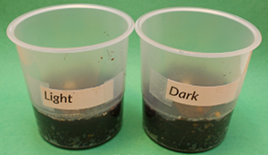
Image source: www.giftofcuriosity.com
- Plant the Seeds:
  - In each cup, plant three seeds. Make sure the seeds are planted at the same depth in both cups.
- Set up the Light and Dark conditions:
  - Place the ‘dark’ cup inside a box, sealing the box tightly to prevent any light from getting in.
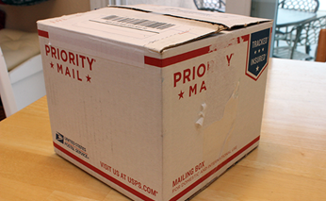
Image source: www.giftofcuriosity.com
  - Leave the ‘light’ cup uncovered
- Position the cups
  - Place both the ’light’ cup and the sealed box (containing the ‘dark’ cup) on a table near a window or in an area that receives natural light.
- Water the seeds
  - Water both cups as needed, ensuring the soil stays moist but not soaked. Check every few days to see if more water is needed.
- Wait and observe
  - After one week, open the box and compare how the seeds in the ’light’ and ‘dark’ cups have grown.
  - Record your observations using words and/or drawings, noting any differences in sprouting, height, and whether leaves have formed.
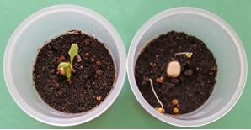
Image source: www.giftofcuriosity.com
- Conclude the experiment
  - After observing the plants in both cups, expose the ‘dark’ cup to light. Check to see if the seeds develop leaves once, they have access to light and record any changes over the next 24 hours.
- Analyse the results
  - Discuss or write about the findings. Did the seeds sprout in both cups? What happened to the leaves in each condition? What does this experiment teach about the importance of light for growing plants?
Books to read about growing seeds
- The Tiny Seed by Eric Carle: https://www.youtube.com/watch?v=LlDOMQPptOM
- From Seed to Plant by Gail Gibbons: https://www.youtube.com/watch?v=TLEns2oCd6U

