Mini greenhouse
Subject(s): Science
Grade(s): 5-6

Learning intention(s)
Students will understand how a greenhouse functions to support plant growth by creating a mini greenhouse using a plastic bottle. They will learn how temperature, moisture, and light contribute to plant development, and observe the germination process and early plant growth in a controlled environment. Through this activity, students will also develop observation and inquiry skills by recording changes in the plants over time and exploring how different variables affect growth.

Mapping to curriculum

Strands
- Life and Living
- Energy and Change
- Farming

Sub strands
- 5.1 Plant Growth
- 5.3 Energy sources and energy changes
- 5.7 Gardening skills
- 6.1 Food Chain

Learning outcome(s)
- 5.1.2 Understand that green plants need water, light energy, and carbon dioxide for the process of photosynthesis
- 5.1.3 Understand how nutrients from the soil are absorbed and transported to the parts of the plant
- 5.1.4 Understand that the green plant uses food from photosynthesis by respiration.
- 5.7.1 Learn how to do the necessary soil preparation, care for tools, care for plants, nursery and transplanting in a practical setting.
- 6.1.1.1 Recognise the three consumer levels in a food chain – producers, herbivores, and carnivores.

Lesson Instructions
Materials/resources(s)
- Clear plastic bottle (2 litres is ideal)
- Sharp scissors (for teacher to use)
- Potting soil
- Seeds (e.g. sunflowers, beans, peas)
- Water

Activity
- Clean the bottle
  - Remove the label from your plastic bottle and rinse it out to make sure it’s clean.
- Cut the bottle
  - Ask your teacher to cut the plastic bottle in half using sharp scissors.
  - Cut small slits along the edges of the top half of the bottle so it fits snugly over the bottom half. (See the image below for reference.)
  - Poke a few small drainage holes in the bottom of the bottle.
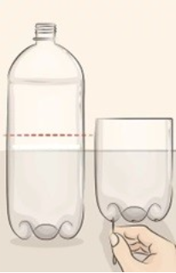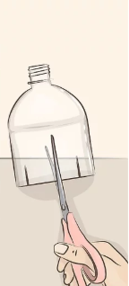
Source: https://www.wikihow.com/Make-a-Mini-Greenhouse
- Add soil and seeds
  - Fill the bottom part of the bottle with soil
  - Make 1-3 small holes in the soil and place a seed in each hole. Cover the seeds with soil and lightly water the soil.
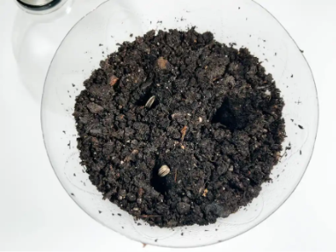
Source: https://intheplayroom.co.uk/diy-miniature-greenhouse/

- Cover with top half of the bottle
  - Put the top part of the bottle on the bottom to form your greenhouse.
- Find a sunny spot
  - Place your mini greenhouse on a window sill with good sunlight. You can put a plastic tray under the greenhouse to catch any water that drains.
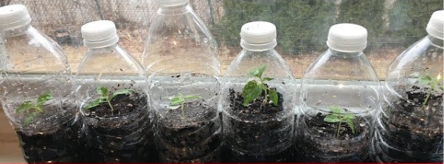Source: https://www.youtube.com/watch?v=G4sColu-aFE
- Watch and wait
  - Over the next few days, check the soil moisture and look for signs of growth! Keep a journal of daily observations and drawing pictures of the plant’s growth.
- Transplant seedlings
  - Once your plants are big enough, you can carefully move them to a larger pot or an outdoor garden to keep growing.
Reflection
- What changes did you observe in your plants over time, and what do you think caused these changes?
- How did the mini greenhouse help create a better environment for your plant to grow compared to the outside?
- If you were to grow another plant, what would you change in your mini greenhouse to help it grow even better?

