Identifying the Importance of Pollinators

Subject(s): Science

Year(s): 7-8

Learning intention(s)
Students will understand the crucial role of pollinators, such as bees and butterflies, in the growth of plants and food production. Through hands-on activities in the school kitchen garden, they will explore how pollination works, observe its impact on plant life cycles, and design habitats that support pollinators, fostering awareness of their importance in sustaining ecosystems and food systems.
Mapping to curriculum
Strand:
- Life and Living
Sub strands
- 7.10. Living Structures and Processes
- 7.12 Ecosystems
- 8.5 Plant processes and marine ecosystems
Learning outcome(s)
- 7.10.5 Identify a range of seed dispersal methods – wind, insects, animal, water and explosion
- 7.10.7.1 Draw the sequence of events in the life cycle of a plant – flowering, pollination and fertilisation, seeding, germination and new young plant develops.
- 7.12.4 Understand how everything is transferred in food chains and food webs in an ecosystem
- 8.5.2 Know that plants carry out the process of photosynthesis and respiration.

Teaching Activity
Materials/resources
- Video: The Power of Pollinators, 6m16s, YouTube
- A variety of flowering plants from the school kitchen garden (e.g. tomatoes, cucumbers, peppers, fruit trees)
- Bee identification guide or insect identification chart
- Magnifying glasses or microscopes
- Garden tools: gloves, trowels, watering cans
- Cardboard or paper to create pollinator habitats (e.g. bee hotels)
- Soil, sticks, twigs, and other natural materials for building habitats

Activity overview
In this task, students will:
- Investigate the role of pollinators (e.g. bees, butterflies, birds) in the ecosystem.
- Examine the different plants in the school kitchen garden that rely on pollination.
- Conduct a pollination activity to observe the process and understand its importance for food production.
- Design and create a pollinator-friendly habitat within the school garden.
- Reflect on the significance of preserving pollinators for a sustainable food system.
Activity 1: Introduction to pollination (15 minutes)
- Display a short presentation or video about the role of pollinators, focusing on bees, butterflies, and other insects/ Video: The Power of Pollinators, 6m16s, YouTube
- Discuss the process of pollination and how it is crucial for the reproduction of many plants, particularly food crops.
- Explain how bees and other pollinators transfer pollen from flower to flower, enabling fertilization and the growth of fruits and seeds.
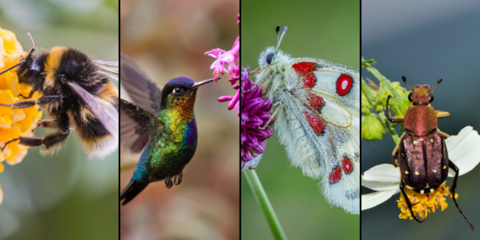
Credit: CCE-Monroe County

Activity 2: Observation and exploration (30 minutes)
- Divide students into small groups and assign each group a plant or set of plants in the kitchen garden that require pollination.
- Have students observe and document the different stages of flowering and look for pollinators visiting the plants.
- Key questions for student observations:
  - Which plants are attracting bees or other insects?
  - What kind of insects can you identify?
  - How do pollinators interact with the flowers?
  - Are any plants showing signs of fruiting or seed formation after pollination?

Activity 3: Pollination experiment (20 minutes)
Set up a simple pollination experiment where students use brushes (or their fingers) to transfer pollen from one flower to another on a plant that requires insect pollination.
- Task: Students will mimic the pollination process and then compare the fruiting of these plants to those that were not pollinated manually.
- Discuss how this experiment helps illustrate the role of natural pollinators.

Activity 4: Creating pollinator habitats (45 minutes)
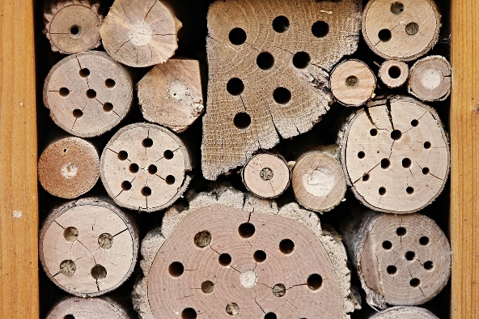
Explain to students that they will be designing and creating a habitat that supports pollinators, like bees and butterflies.
- Students will create bee hotels using natural materials such as twigs, bamboo, and cardboard tubes, and place them in a quiet, sheltered area of the garden. Drilling deep holes in logs and stacking them together is another simple way to create a bee hotel.
- Alternatively, students can plant additional pollinator-friendly flowers (e.g. lavender, sunflowers, marigolds) around the garden to attract more pollinators.

Credit: manfredrichter Pixabay

Activity 5: Reflection and discussion (15 minutes)
- After completing the tasks, gather students for a class discussion on what they learned.
- Key discussion points:
  - Why are pollinators essential for our food system?
  - How does the school garden benefit from having pollinators?
  - What could happen to food production if pollinators were not present?
  - What other ways can we support and protect pollinators in our community?
- Students can then write a short reflection in their exercise book on the importance of pollinators in the garden and how they can contribute to protecting them.

Extension
- Bee-watching activity: Introduce students to local beekeeping practices or take a field trip to a local farm with beehives.
- Community awareness campaign: Students could create posters or digital presentations to raise awareness about the importance of pollinators in local communities.

