Understand the Importance of Organic Farming

Subject(s) Agriculture, English

Year(s) 7-9

Learning Intention
Understand the importance of organic farming and gardening in developing sustainable agriculture.
Links to Curriculum
Strands
- Agriculture – Introduction to Food Crops, Food security, Introduction to sustainable land management
- English – Research and Study skills, Listening, Speaking
Sub Strands
Agriculture
- 7.4 Improving agricultural production
- 7.16 Preparing to grow food crops
- 8.1 What is Food security?
- 9.5 Key issues in sustainable land management
English
- 7.17 Using the library/internet
- 8.5 Communication and Interaction
Learning Outcomes
Agriculture:
- 7.4.1 Understand contributions of improved agricultural practices
- 7.5.2.1 Explain the importance, functions and uses of soil.
- 7.12.3 Show skills in selecting different cropping methods to grow food.
- 8.1.2 Appreciate the importance of food security
- 9.6.3.1 Apply sustainable land management practices
English
- 7.17.4 Appreciate the use of a library as a place for study and research
- 7.17.5 Use a guide to surf the internet for information.
- 8.5.3 Demonstrate skills in using language creatively to describe an event, person or place competently in storytelling and conversations.
- 9.3.2 Listen to and understand a wide variety of speaking situations in both formal and informal situations and critically respond in other forms.

Teaching Activity
Note: This activity is adapted from FAO 2009, Setting up and Running a School Garden: Teaching Tool kit, p. 27.

Materials
- Poster paper – 1 sheet per pair

Activity 1: Introducing Organic Farming and Gardening
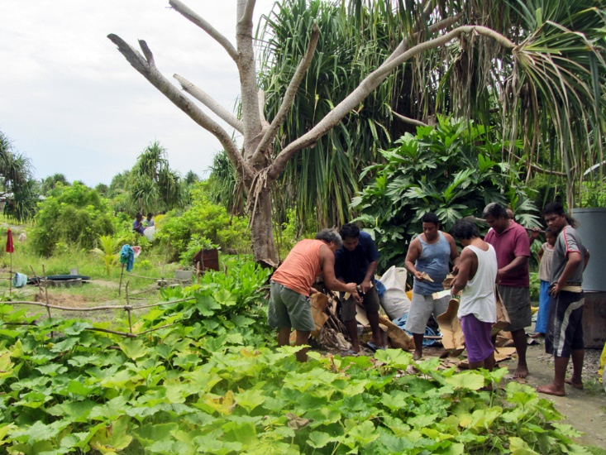
- Introduce the concept of organic gardening/farming. Elicit students' current understanding of organic gardening – what examples of organic gardening have they seen practiced at school or at home?
Credit: Flickr (ACIAR, CC BY-NC-SA 2.0)
- Introduce and define key terms:
  - composting
  - green manure
  - crop rotation
  - insecticides and pesticides
  - mulching
  - watering
Ensure students write the terms and definitions in their workbooks

Activity 2: Researching Organic Farming and Gardening
- Arrange students into pairs or small groups to complete the research activity.
- Choose the structure of the activity:
- Each pair or group researches and answers all the questions.
- Each pair or group researches and answers one question and presents their findings to the class.
- Assign the question(s) to each pair. Student research may include:
  - school library
  - internet
  - family discussion
  - interviews with local farmers and gardeners.

Activity 3: Posters and Presentations
Student pairs create and display a poster answering their question(s). Optionally, pairs present their work to the class.

