Understanding Food Groups and Healthy Eating

Subjects Home Economics, Family Life Education, English

Year 9

Learning Intentions
Students will acquire an understanding of the main food groups, food guidelines and the relationships between food and health y living. Students recognise the importance of eating nutritional foods to keep healthy.

Curriculum links

Home Economics

Strand: HEC 9.2 Food and Nutrition

Sub-strand:

9.2.2 What is food?

9.2.3 Diet and Health

Learning Outcome
- 9.2.2.1 Discover food concepts and food classifications.
- 9.2.2.2 Discuss the importance of nutrients in the body; including water and dietary fibre

Family Life Education

Strand: FLE 9.4 Health

Sub-strand:

FLE 9.4.2 Community Health

Learning Outcome
- 9.4.2.1 Describe ways to promote healthy nutritional choices.

English

Strand: EN9.3. - Writing and Shaping

Sub-strand:

EN 9.3.1 Text types: everyday communication and literary texts

Learning Outcome
- 9.3.1.1 Distinguish specific purposes for various writing texts to demonstrate effective writing skills.
- 9.3.1.2 Demonstrate in depth planning skills for writing of various types of texts.

Teaching Activity

Materials required
- ‘3 Food Groups: Fiji’s Guide to Healthy Eating’ poster – print or display in the classroom
(Source: MHMS Fiji https://www.health.gov.fj/healthy-eating)

Activity 1: Home Economics – Introducing the 3 Food Groups
- Introduce the concept of the 3 Food Groups. Display or project the poster, ‘3 Food Groups – Fiji's Guide to Healthy Eating.’
(Poster is included at the end of this lesson, and also available online at https://www.nutrition.gov.fj/publication.php)
- Identify the 3 groups:
  - Group 1: Health
  - Group 2: Energy
  - Group 2: Body Building
Write on the board the 3 groups, and elicit student suggestions for food in each group, writing the suggestions under the appropriate heading.
ALTERNATIVE: Students work in pairs to create their own lists and share with class. These may be integrated with the Family Life Education task, with students identifying foods they eat often.
- Discuss:
  - how each food group contributes to a healthy diet
  - why it is important to maintain a healthy diet and lifestyle

Activity 2: Family Life Education Task – Analysing Personal Food Preferences
Guide students through the following activity:
- Students imagine a meal they would like to eat, then write down all the food that is included in the meal.
- From the full list of foods, the student selects 6 foods to study in more detail and groups them into the following groups:
  - Group 1: Health – Vegetables and Fruits
  - Group 2: Energy – Carbohydrates
  - Group 2: Body Building – Proteins
- Students present their lists to the rest of the class, explaining why they want to eat those foods. For each of the 6 foods, they answer the following questions:
  - whether the food is locally grown or imported
  - how much packaging the food comes with
  - which foods have more nutritive value than others
  - why and how the food contributes towards a healthy diet
Facilitate a discussion about the importance of including foods from each food group in individual and family meals. Also discuss the importance of nutrients such as water and dietary fibre, vitamins and minerals.
Provide students with a copy of the ‘The 3 Food Groups’ handout (divided circle) or ask them to draw in their workbooks a circle divided into 3 (see handout).
- In each section, students list different foods. Use a different colour pen/pencil to show the food they eat the most (tick or colour) and use another colour show the food they eat the least (tick or colour).
Have students write 2 short paragraphs in their workbook about any proposed food changes they might want to make and the reasons for wanting that change.

OPTIONAL Activity: Family Foods
Note: If conducting this activity, take care that students do not feel shamed or embarrassed by family food choices, which are likely outside their control.
Arrange students in pairs or small groups to discuss the following questions:
- What are some common foods at home?
- What are some reasons why some foods are more commonly eaten than others?
- If you could change some of the eating patterns at home, what would you like to change, how might you change it, and how might it affect the family’s health and wellbeing?

Activity 3: English Task – ‘Healthy Foods’ Letter
Students write a half-page letter to a friend, outlining the benefits of eating foods from each food group.

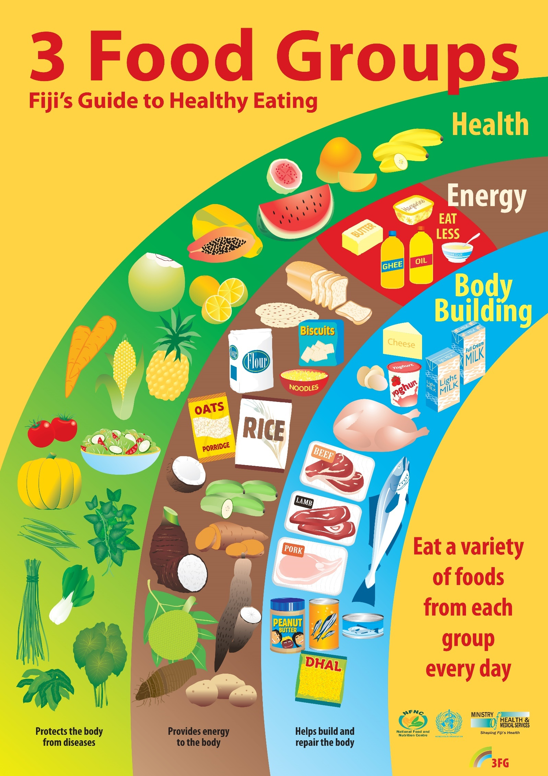

The 3 Food Groups

Name: ________________________

Body Building

Energy

Health

