Identify materials for basic composting
Subject(s): Science, Social Studies
Grade(s): 1-2

Learning intention(s):
Students will practice the simple habits of reuse, refuse, reduce and recycle (4 Rs) through gaining an understanding of the composting process. They will learn about the types of materials suitable for creating nutrient-rich soil. Through this hands-on activity, they will learn about reusing and recycling materials found around the school and learn how composting can help keep the environment clean and safe.

Mapping to curriculum:

Strands
- Farming
- Place and Space

Sub-Strands

Science
- 1.1 Living things and non-Living Things
- 1.4 Food from the garden
- 2.4 Gardening

Social Studies
- 2.1 Place and Spaces in our Villages or Settlements

Learning outcome(s):
Science
- 1.1.3.2 Identify and sort living things and non-living things according to their groups
- 2.4.1 understand that good soil, water and sunlight are needed for successful gardening
- 2.4.2 Know some soils can be improved
- 2.4.2.1 add compost to soils to improve them
Social Studies
- 2.1.3.1 Explain the different ways in which people care for the environment.

Lesson Instructions
Materials
- A large (1 metre height x 1 metre wide) empty garbage can or an old plastic bin or bucket
- 4 empty cardboard boxes or paper bags, labelled ‘Greens’, ‘Browns’, ‘Soil’, and ‘Rubbish’
- Garden waste (like fallen leaves and flowers)
- General rubbish around the school yard or in the classrooms
Activity
- The teacher introduces the topic by asking some guiding questions about the 4Rs and composts as follows:
  - Have any of you heard about the 4 R’s (reuse, refuse, reduce and recycle)?
  - What is the importance of practising the 4Rs in our school or at home?
  - How does practising the 4Rs help keep the environment clean and safe?
  - What are some things that you can do to keep the environment clean?
  - Have you heard of or seen a compost?
  - How do composts help to keep the environment safe and clean?
  - How can composts help to enrich garden soil?
- After the discussion, the teacher informs the students that the lesson will focus on getting them to learn about the basic components of a compost.
  - Composts are a good way of reusing and recycling materials from the garden or from home to provide good quality soil to plant vegetables and herbs.
  - A compost is made up of three types of ingredients: 1) Dead plants from the garden, 2) Household waste, including food scraps and 3) Soil.
  - When mixed together in the right portions, these materials can turn the soil into rich nutrient soil or “black gold’.
  - Materials from the garden include dry leaves, twigs and sticks. These materials are commonly called ‘browns’, as they are normally brown in colour, because they have been dried. The brown materials are rich in carbon.
  - Materials from household use include fresh fruit and vegetable scraps. These materials are called ‘greens’ as they contain a higher content of water and are rich in nitrogen.
  - Soil is an important component of a compost because it provides earthworms and other organisms that break down other materials and improves the soil quality.
  - Add water from time to time to stir the contents of the compost.
  - Do not put meat, fat or dairy products or pet waste in the compost bin.
- Ask students to work in pairs. Together, each pair walks around the school compound to collect 4 items that they find lying around. They bring back the items and put the items in front of them/or on their desk.
- The teacher asks each pair to name each item collected and say which category the item belongs to – ‘Greens’, ‘Browns’, ‘Soil’ and ‘Rubbish’.
- At the end of the lesson, ask the students to dispose of the contents of each box or bag in the right bins. Ask the students to dispose of the contents of Box 1, 2 and 3 in the compost bin or bucket. All other materials (or rubbish) collected can be thrown into the garbage bin.

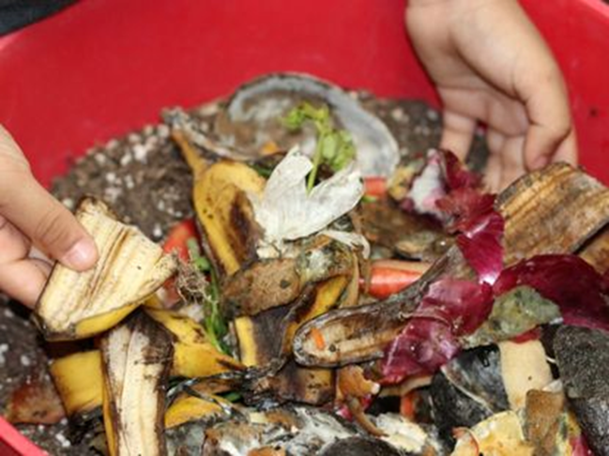
Source: https://futureplc.com/

Follow-up Activity
(adapted from thoughtfullysustainable.com, 2022)
- The teacher writes a list of items on the board and asks each student to classify the items under the correct labels using the table below.
Items: potato peels, cardboard, newspaper, dried leaves, apple core, paper, plastic straw, empty water bottle, empty can, weeds, lemon rind, grass clippings, plastic bag, chicken bones, rocks, banana peels, mud, tea leaves, pet waste, rotten vegetables
- Ask students to draw a table with 4 columns (see example below) and allocate the above items in the correct category.
- Discuss with students the reasons for placing items in the categories they have selected:
GREENS (Nitrogen-rich) | BROWNS  (Carbon-rich) | SOIL | RUBBISH

