Build a soda bottle composter
Subject(s): Science
Year(s): 1-2

Learning intention(s):
Students will practise the simple habits of reuse, refuse, reduce and recycle (4 Rs) through gaining an understanding of the composting process. They will learn about organic materials and how these break down to create nutrient-rich soil. Through this hands-on activity, they will learn about recycling and observe decomposition, identify the role of moisture and airflow in composting, and gain a basic understanding of sustainable waste management and soil health.

Mapping to curriculum:

Strand
- Life and Living
- Farming

Sub strands
- 1.1 Living and non-living things
- 2.4 Gardening

Learning outcome(s):
- 1.1.1 know that living things need air, water and food
- 1.1.3.2 Identify and sort living things and non-living things according to their groups
- 2.4. 1 Understand that good soil, water and sunlight are needed for successful gardening.
- 2.4.2 Know some soils can be improved
- 2.4.2.1 Add compost to soil to improve them.

Lesson Instructions
Materials
- An empty, clean plastic soda bottle (2 litres works best)
- Soil
- Food scraps (like fruit and vegetable peels)
- Garden waste (like fallen leaves and flowers)
- Water
- Scissors
- Cello tape
- A stick or spoon
How to make your composter
- Prepare the Bottle: Cut off the top of the soda bottle (just below where it starts to curve). This will make it easier to add materials. Save the top piece—you’ll use it as a lid.

- Make small holes in the top piece of the bottle (lid) for airflow. 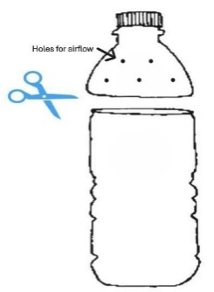
- Layer your materials. Start by adding a layer of soil to the bottom of the bottle. This introduces the bacteria needed to make black nutritious compost. Then add some food scraps, followed by some garden waste. Keep adding layers until the bottle is about three-quarters full.
- Finally add another layer of soil and a layer of garden waste.
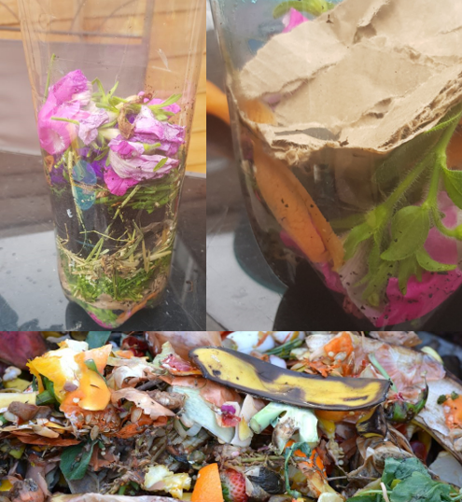
Source: https://growinghealthykids.co.uk/how-to-make-compost-in-a-bottle/
- Add water. Lightly spray or sprinkle water over the layers to keep them moist. Don’t soak the layers – just make sure they are damp.
- Put the top of the bottle back on and cello-tape it in place.
- Make a mark on the side on the bottle where the top of your bottle comes to so you can see how much it changes. Every two weeks you can draw a new line to mark the “new” top of the compost as it breaks down. Date each line so you can track the progress.
- Place your composter in a warm, sunny spot, like a windowsill or high shelf or table.
- Over the next few weeks, you’ll see the food scraps and yard waste slowly turn into compost. Use the observation sheet to record your observations every two weeks. In about 1-2 months, you’ll have rich compost to use in your school garden!
- Check and Stir: Every few days, use the stick or spoon to stir the materials. This helps everything break down faster. Keep it moist by adding a little water if it dries out.
Books to read about growing seeds:
Tiny Creatures: The World of Microbes: https://www.youtube.com/watch?v=I9I3kEFOoG4

Composting Observation Sheet
Week 2
Week 4
Week 6

