Understanding the Importance of Organic Farming

Subject(s) Agricultural Science, English

Year(s) 10

Learning Intention
Understand the importance of organic farming and gardening in developing sustainable agriculture.

Curriculum links

Agricultural Science

Strand: AS 10.3 Agronomy

AS10.1 Agricultural Concepts

Sub-strand:

AS 10. 1.1 General Agriculture

AS 10.3.1 Soils

Learning Outcome(s)
- 10.1.1.3 Recognise the importance of organic farming towards sustainable agriculture
- 10.3.1.1 Demonstrate cultivation practices to maintain soil sustainability

English

Strand: EN 10.3 Writing and Shaping

Sub-strand: EN10.3.1 Text types – media, everyday communication, literary text.

Learning Outcome(s)
- EN10.3.1.1 Write and present for a wide range of purposes and audiences with understanding.

Teaching Activity
Note: This activity is adapted from FAO 2009, Setting up and Running a School Garden: Teaching Tool kit, p. 27.

Materials required
- Poster paper – 1 sheet per pair

Activity 1: Introducing Organic Farming and Gardening
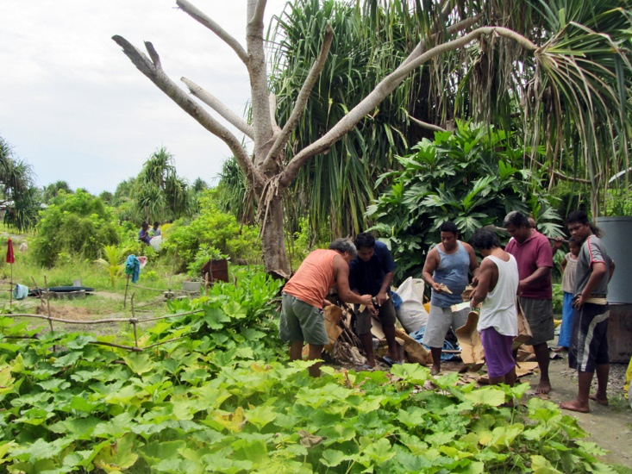
- Introduce the concept of organic gardening/farming. Elicit students' current understanding of organic gardening – what examples of organic gardening have they seen practiced at school or at home?
Credit: Flickr (ACIAR, CC BY-NC-SA 2.0)
- Introduce and define key terms:
  - composting
  - green manure
  - crop rotation
  - insecticides and pesticides
  - mulching
  - watering
Ensure students write the terms and definitions in their workbooks

Activity 2: Researching Organic Farming and Gardening
- Arrange students into pairs or small groups to complete the research activity.
- Choose the structure of the activity:
- Each pair or group researches and answers all the questions.
- Each pair or group researches and answers one question and presents their findings to the class.
- Assign the question(s) to each pair. Student research may include:
  - school library
  - internet
  - family discussion
  - interviews with local farmers and gardeners.

Activity 3: Posters and Presentations
Student pairs create and display a poster answering their question(s). Optionally, pairs present their work to the class.

